**Accelerated CSX Cybersecurity Practitioner Certification**

04 PROTECT CHALLENGE 3

4.1 Windows Active Directory 4

4.1.1 Login to Windows 4

4.1.2 Server Manager 4

4.1.3 Orientation Fileshare 5

4.1.4 Configuring Permissions I 5

4.1.5 Configuring Permissions II 6

4.2 Firewall Rules 8

4.2.1 Login to Kali 8

4.2.2 Login to Pfsense 8

4.2.3 Mail Server Rule 9

4.2.4 Web Browsing Rule 9

4.2.5 Download Configuration 10

05 VULNERABILITY ANALYSIS 12

5.1 Equipping OpenVAS 12

5.1.1 Logging in to Kali 12

5.1.2 Opening a Terminal 12

5.1.3 Interface Configuration 12

5.1.4 Mapping the Network 13

5.1.5 Editing the Report 13

5.1.6 Starting OpenVAS 13

5.1.7 Printing Network Connections 13

5.1.8 Checking Setup 14

5.2 Scanning Vulnerabilities in GSA 15

5.2.1 Opening a Web Browser 15

5.2.2 OpenVAS Web UI 15

5.2.3 Learning GSA 15

5.2.4 Creating a Target 15

5.2.5 Starting a Task 1 16

5.2.6 Starting a Task 2 16

5.2.7 Running the Scan 17

5.2.8 Adding Credentials 1 17

5.2.9 Adding Credentials 2 17

5.2.10 Creating Second target 18

5.2.11 Starting Second Task 1 18

5.2.12 Starting Second Task 2 18

5.2.13 Running the Second Scan 19

5.2.14 Saving Scans 19

5.3 Observing Scan Results 20

5.3.1 Noting LAN results 1 20

5.3.2 Noting LAN results 2 21

5.3.3 Noting LAN results 3 21

5.3.4 Noting UBUNTU results 1 24

5.3.5 Noting UBUNTU results 2 24

5.3.6 Noting UBUNTU results 3 25

06 DETECT CHALLENGE 27

6.1 Detect Challenge 27

6.1.1 Starting Services 27

6.1.2 Creating a File 28

6.1.3 Opening the Web UI 28

6.1.4 Conducting a Scan 28

07 NOTIFICATION AND ESCALATION 30

7.1 Escalation 30

7.1.1 Login to SecOnion 30

7.1.2 Open SGUIL 30

7.1.3 Login to SGUIL 31

7.1.4 Select Sensor 31

7.1.5 Review Attacks 31

7.1.6 Escalate Attacks 32

7.1.7 Add Comments 33

7.1.8 View Escalated Alerts 33

7.2 Report 34

7.2.1 Open the Template 34

7.2.2 Date 34

7.2.3 Wireshark 34

7.2.4 MAC Address 35

7.2.5 IP Address 35

7.2.6 Host-Name 36

7.2.7 Port/Service 36

7.2.8 Exploit/Scanner 36

7.2.9 Exploit Continued 37

7.2.10 Save the Report 38

08 RESPOND CHALLENGE 39

8.1. Respond Challenge 39

8.1.1 Adding IDS Rules 39

8.1.2 Login to Kali 41

8.1.3 Utilizing Kali via SSH 41

8.1.4 Tripping the IDS 41

8.1.5 Checking SGUIL 43

8.1.6 Scanning for Virus 44

8.1.7 Exiting 45

09 RE-IMAGING 46

9.1 Full Server Restore 46

9.1.1 Clonezilla DVD 46

9.1.2 Reset CentOS Machine 46

9.1.3 Boot Clonezilla Live 47

9.1.4 Select Language 47

9.1.5 Keymap 47

9.1.6 Start Clonezilla 47

9.1.7 Device to Image 48

9.1.8 Connect to Windows File Server 48

9.1.9 Setup Network 48

9.1.10 Static 48

9.1.11 IP Address 49

9.1.12 Subnet 49

9.1.13 Default Gateway and DNS 49

9.1.14 Connect to File Server 49

9.1.15 Domain 49

9.1.16 Username 50

9.1.17 Image Directory 50

9.1.18 Security Mode 50

9.1.19 Password 50

9.1.20 Connection Confirmation 51

9.1.21 Beginner Mode 51

9.1.22 Restore Disks 51

9.1.23 Choose the Image 51

9.1.24 Select Drive 51

9.1.25 Skip Checking 52

9.1.26 Skip Checksum 52

9.1.27 Select Reboot 52

9.1.28 Final Options 52

9.1.29 Wait 52

9.1.30 Completed 52

10 RESTORE POINTS AND PASSWORD RECOVERY 53

10.1 Windows Restore Point 53

10.1.1 Login 53

10.1.2 Open Restore Point 53

10.1.3 System Restore 53

10.1.4 Restore Selection 54

10.1.5 Confirmation 54

10.1.6 Restoration 55

10.1.7 Turning off the firewall 55

10.2 Windows Password Recovery 56

10.2.1 Login to Kali 56

10.2.2 Review the files 56

10.2.3 samdump2 56

10.2.4 Extracting Hashes 57

10.2.5 Redirecting Output 57

10.2.6 Crack the Hash 57

10.2.7 Analyze 57

10.3 LINUX Password Recovery 57

10.3.1 Review the Files 57

10.3.2 shadow Files 58

10.3.3 unshadow 58

10.3.4 Redirecting Output 58

10.3.5 Crack the Hash 58

10.3.6 Analyze 58

10.3.7 Shadow File Permissions 58

Appendix 59

INDEX 60

# 04 PROTECT CHALLENGE

|  |  |
| --- | --- |
| TASK | KEY PERFORMANCE INDICATORS |
| Set ITadmin's permissions correctly for Orientation Share | **S0067**: Skill in identifying, modifying, and manipulating applicable system components within Windows, Unix, or Linux (e.g., passwords, user accounts, files).  **S0097**: Skill in applying security controls.  **S0121**: Skill in system, network, and OS hardening techniques. (e.g., remove unnecessary services, password policies, network segmentation, enable logging, least privilege, etc.).  **T0358**: Design and develop system administration and management functionality for privileged access users.  **K0167**: Knowledge of system administration, network, and operating system hardening techniques |
| Set ITintern's permissions correctly for Orientation Share | **K0167**: Knowledge of system administration, network, and operating system hardening techniques.  **T0358**: Design and develop system administration and management functionality for privileged access users.  **S0121**: Skill in system, network, and OS hardening techniques. (e.g., remove unnecessary services, password policies, network segmentation, enable logging, least privilege, etc.) |
| Created IT Projects Share | **S0121:** Skill in system, network, and OS hardening techniques. (e.g., remove unnecessary services, password policies, network segmentation, enable logging, least privilege, etc.).  **T0358:** Design and develop system administration and management functionality for privileged access users.  **K0167:** Knowledge of system administration, network, and operating system hardening techniques |
| Created FW Rule for SMTP to Intern | **K0049:** Knowledge of information technology (IT) security principles and methods (e.g., firewalls, demilitarized zones, encryption).  **K0202:** Knowledge of the application firewall concepts and functions (e.g., Single point of authentication/audit/policy enforcement, message scanning for malicious content, data anonymization for PCI and PII compliance, data loss protection scanning, accelerated cryptographic operations, SSL security, REST/JSON processing).  **K0487:** Knowledge of network security (e.g., encryption, firewalls, authentication, honey pots, perimeter protection).  **K0516:** Knowledge of physical and logical network devices and infrastructure to include hubs, switches, routers, firewalls, etc. |
| Created FW Rule for Intern Web Browsing | **K0516:** Knowledge of physical and logical network devices and infrastructure to include hubs, switches, routers, firewalls, etc.  **S0076:** Skill in configuring and utilizing software-based computer protection tools (e.g., software firewalls, antivirus software, anti-spyware).  **S0084:** Skill in configuring and utilizing network protection components (e.g., Firewalls, VPNs, network intrusion detection systems).  **S0170:** Skill in configuring and utilizing computer protection components (e.g., hardware firewalls, servers, routers, as appropriate) |

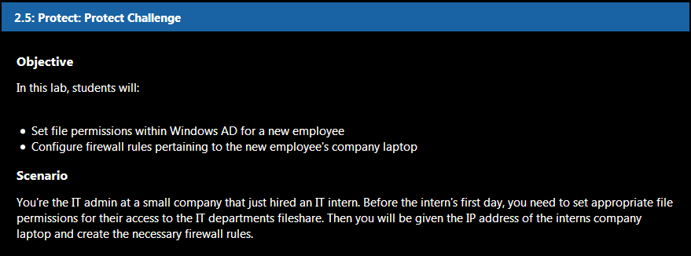

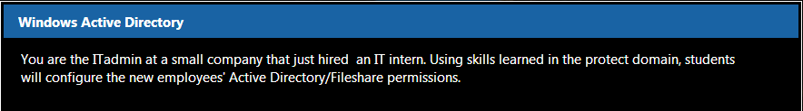

## 4.1 Windows Active Directory

### 4.1.1 Login to Windows

Log in to the Windows Server. User: **itadmin** Password: **IamanIT!**

### 4.1.2 Server Manager

Open **Server Manager** (If it doesn't open upon login). Click on **File and Storage Services**.

|  |  |
| --- | --- |
|  |  |
|  |  |

|  |  |
| --- | --- |
|  |  |

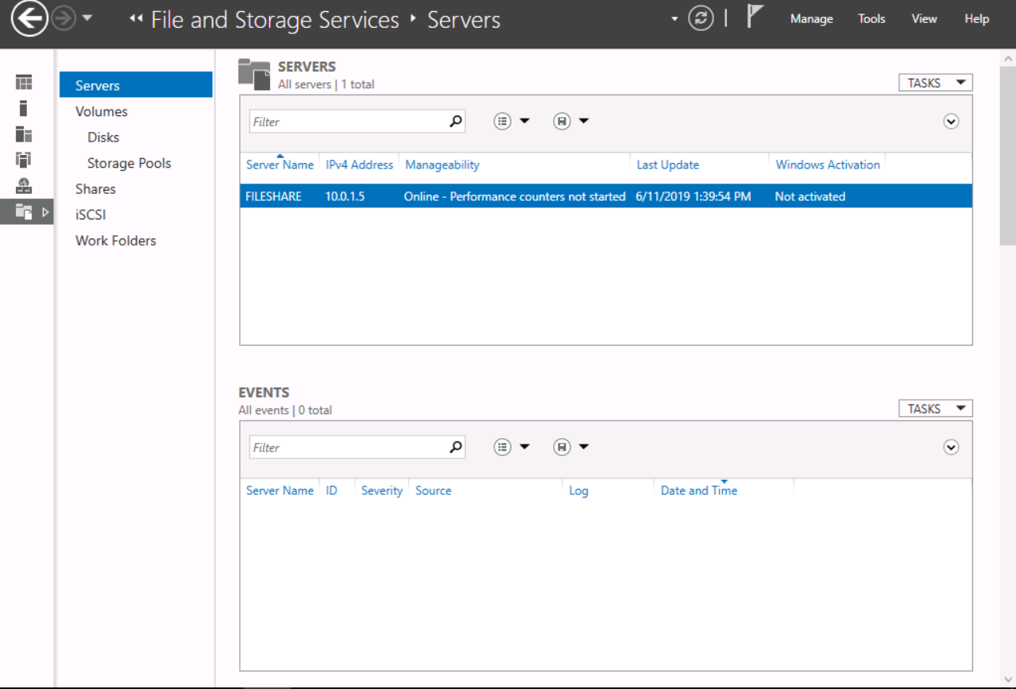

### 4.1.3 Orientation Fileshare

In preparation for their newest team member, the IT team shared an Orientation folder which will contain important documents for their intern's first week. Click **Shares**.

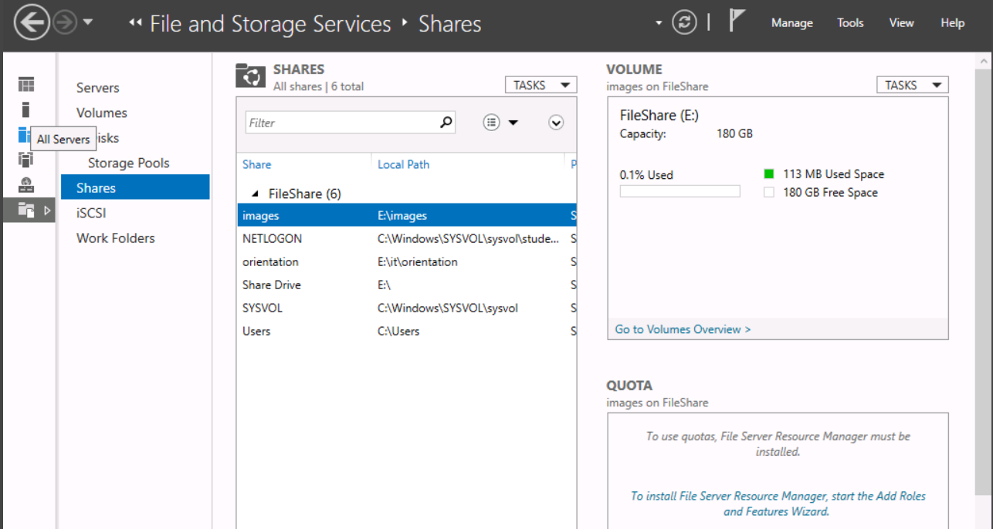

### 4.1.4 Configuring Permissions I

For the **E: --> IT --> Orientation** fileshare, give **ITintern Read** and **Execute** permissions. Give **ITadmin full control**.

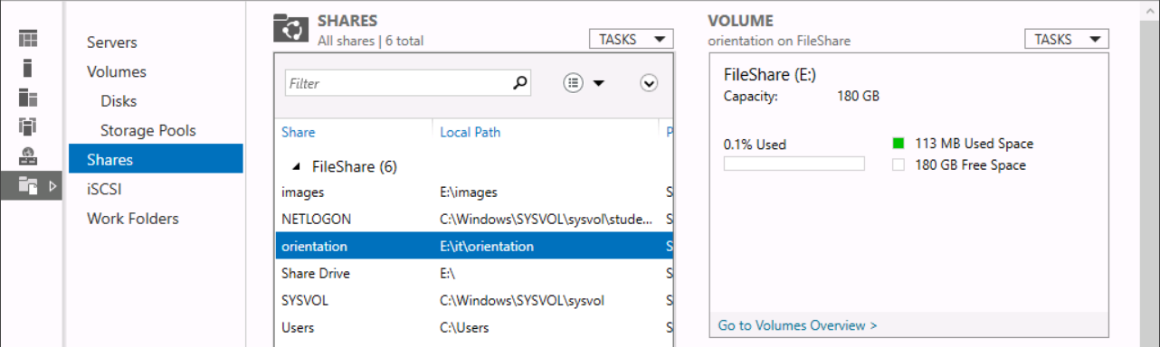

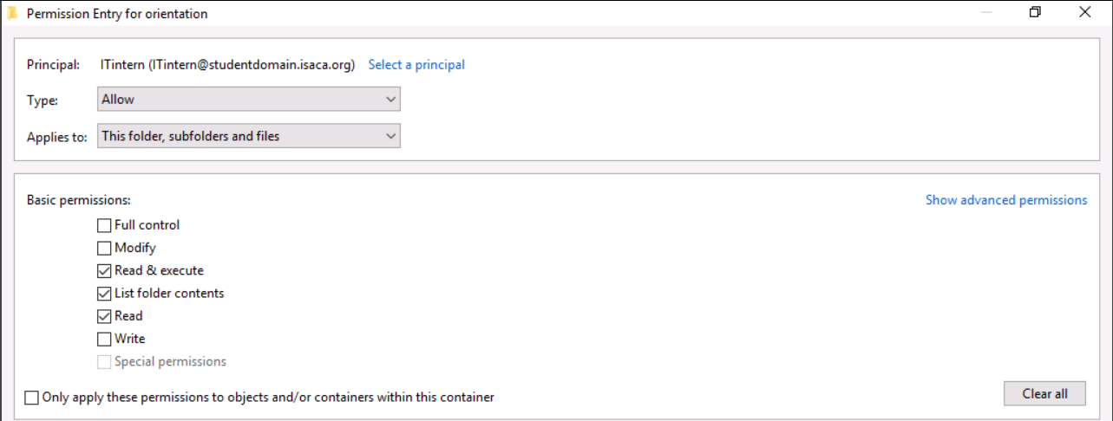

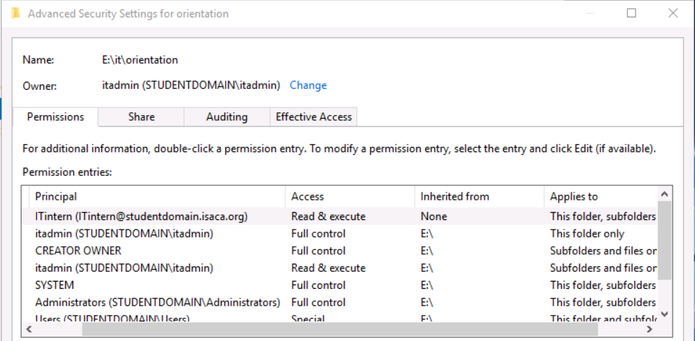

### 4.1.5 Configuring Permissions II

Create a share for the **IT projects folder** within the **IT directory**. Give **ITintern** **read-only** permissions.

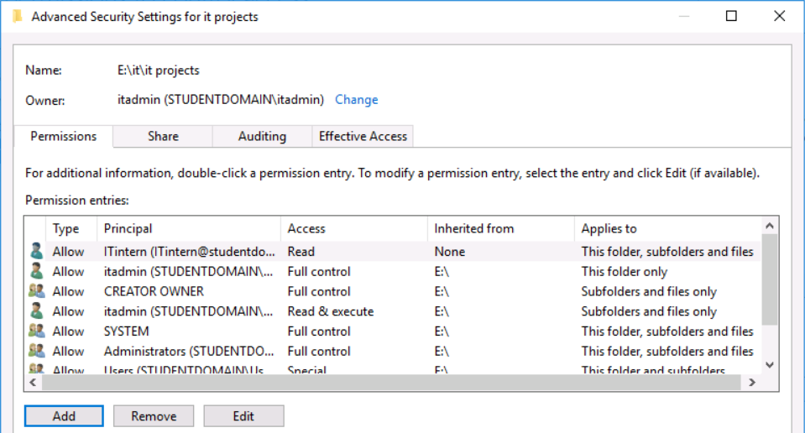

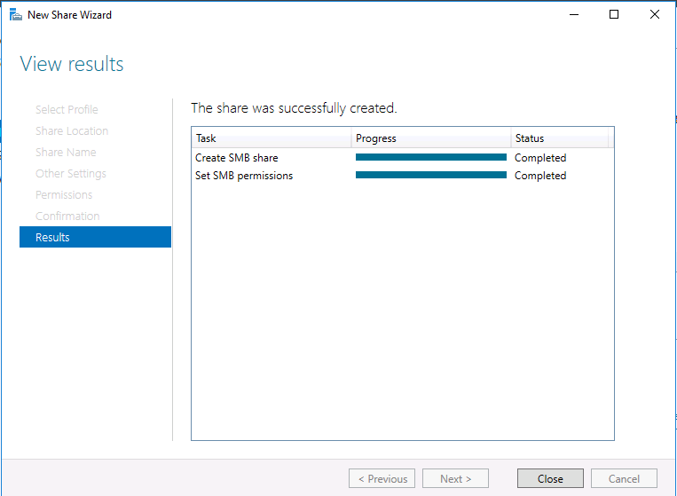

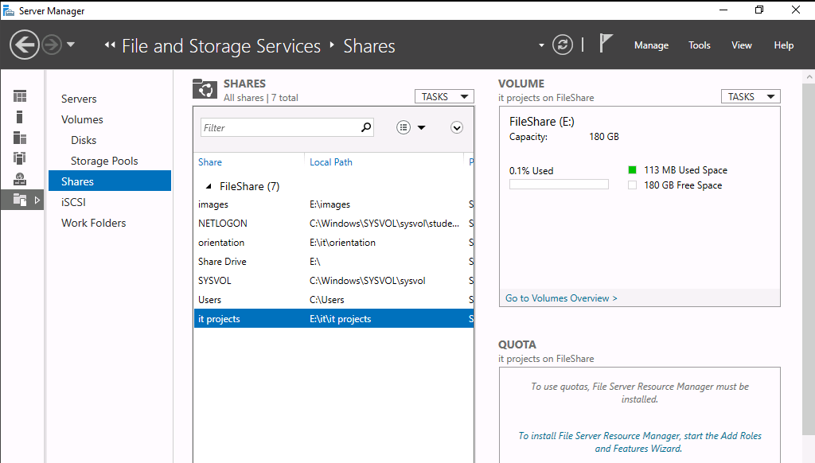

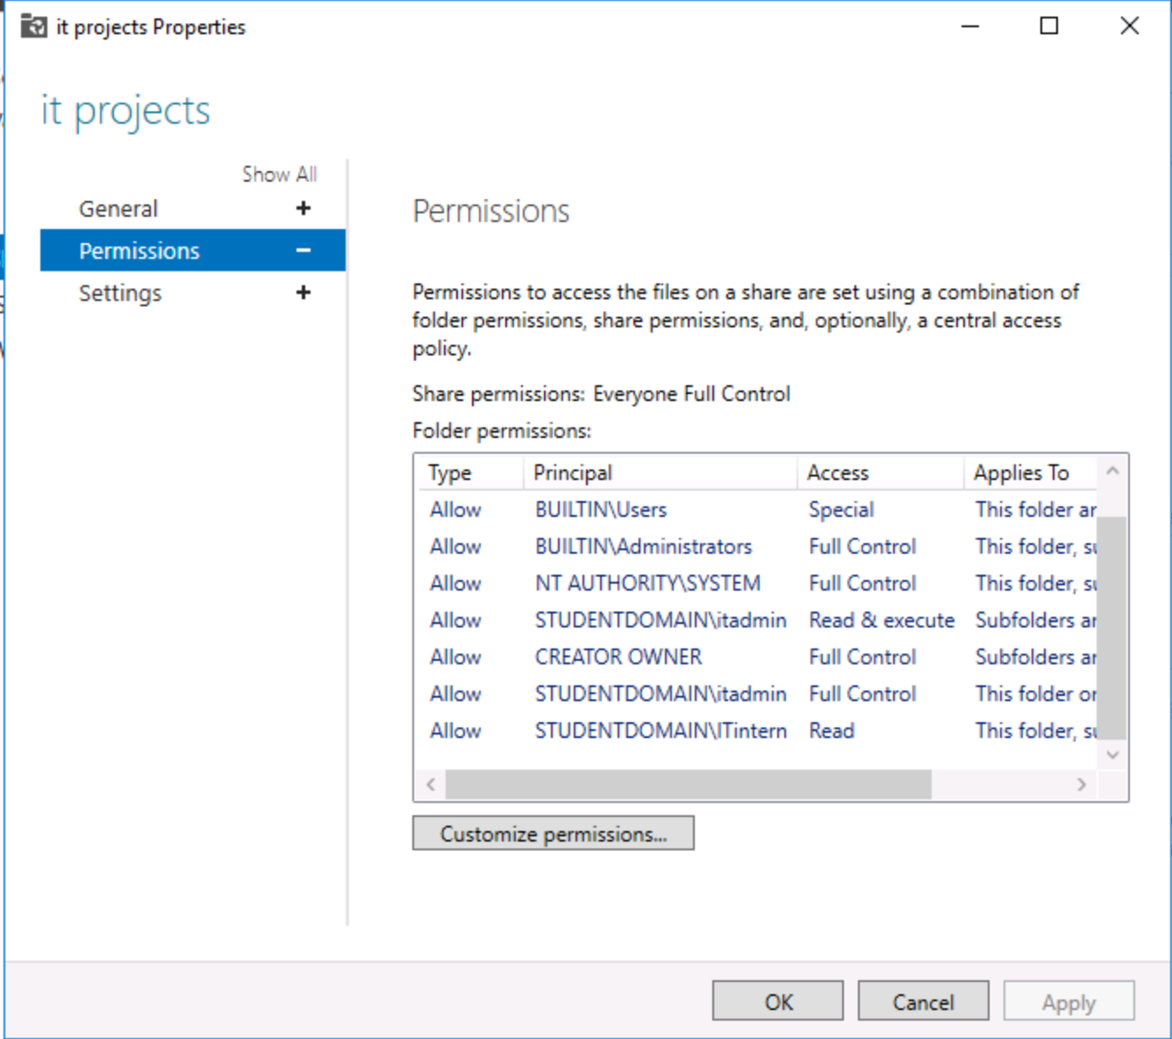

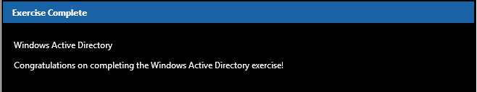

## 4.2 Firewall Rules

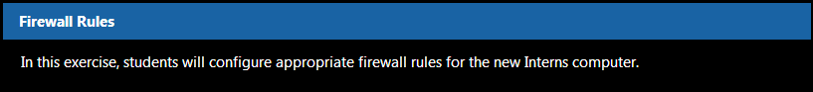

### 4.2.1 Login to Kali

Login to Kali with username **root** and password **isaca**., Then, open a browser and navigate to **http://10.0.1.1**

### 4.2.2 Login to Pfsense

Login to Pfsense with username **admin**, and password **pfsense**

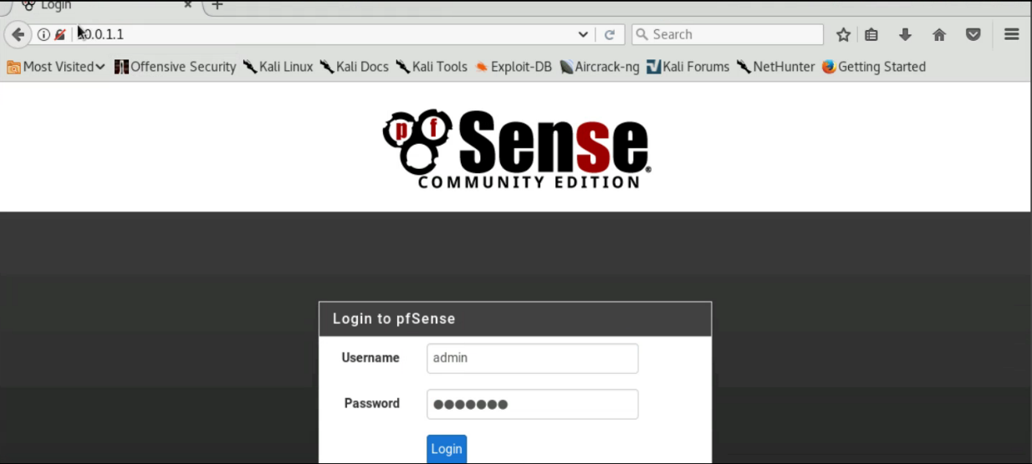

### 4.2.3 Mail Server Rule

Click **Firewall --> Rules**. Then create a LAN rule allowing the Interns computer to receive mail from our mail server. The mail server is on the **DMZ** with an IP of **10.0.2.5** and uses **SMTP (port 25)** to relay emails. The Intern's new computer has a static IP address of **10.0.1.6** and is on the **LAN**. Set the description as "**SMTP to Intern**".

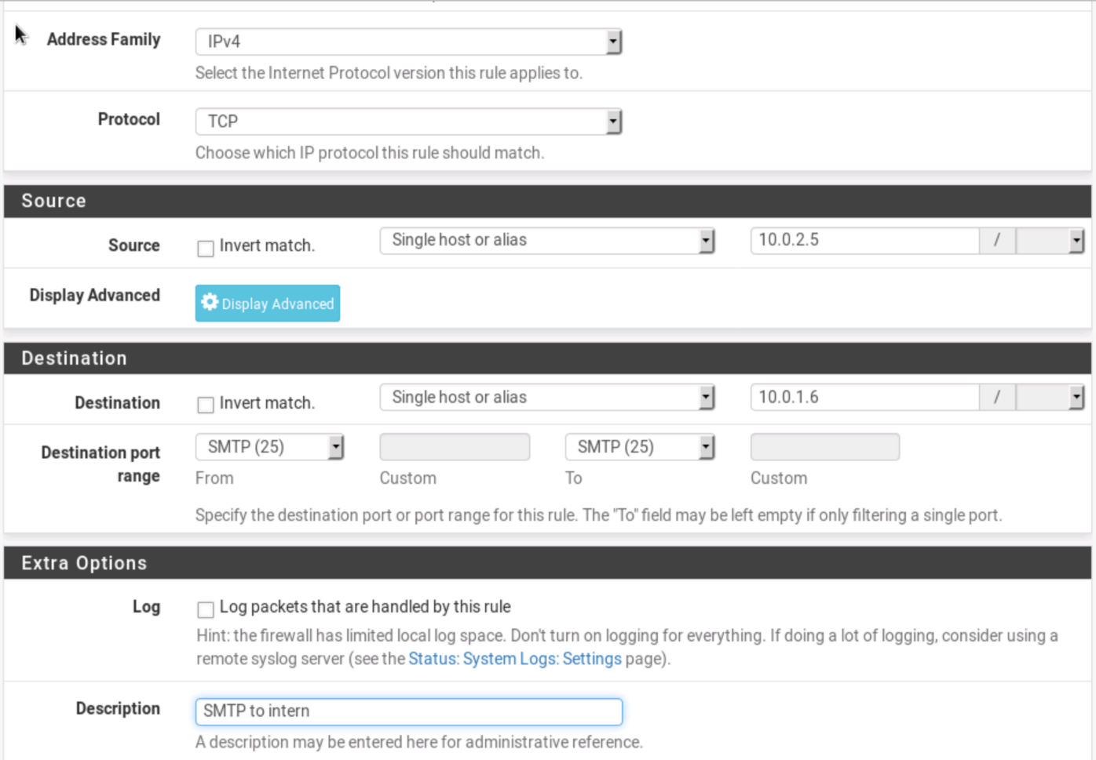

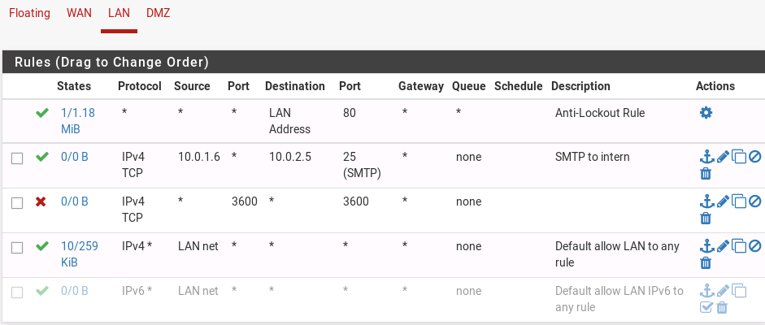

### 4.2.4 Web Browsing Rule

Create another LAN rule, this time allowing the intern to browse the web using **HTTPS**. Set the description as "**Intern Web Browsing**".

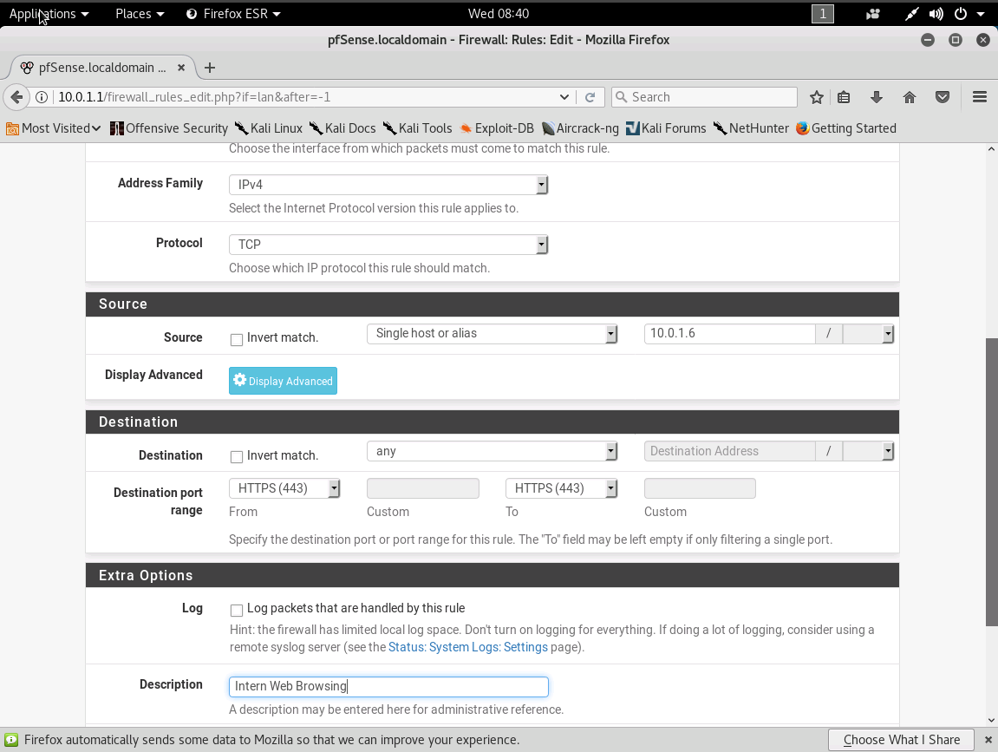

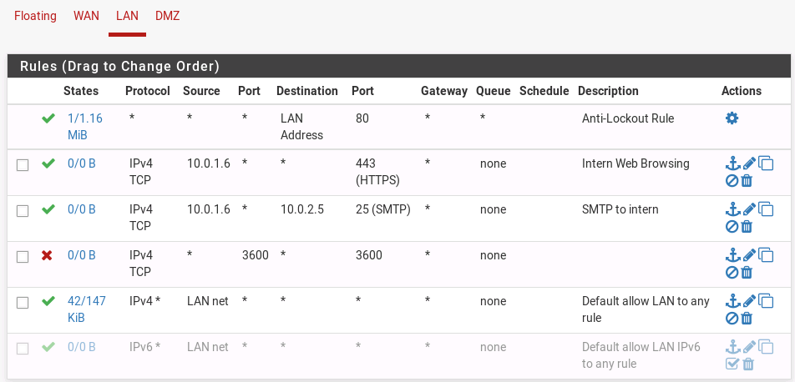

### 4.2.5 Download Configuration

Download your firewall configuration by clicking **Diagnostics --> Backup & Restore**. Then click "**Download configuration as XML**", and rename the file "**InternRules.xml**" and save it to your Desktop.

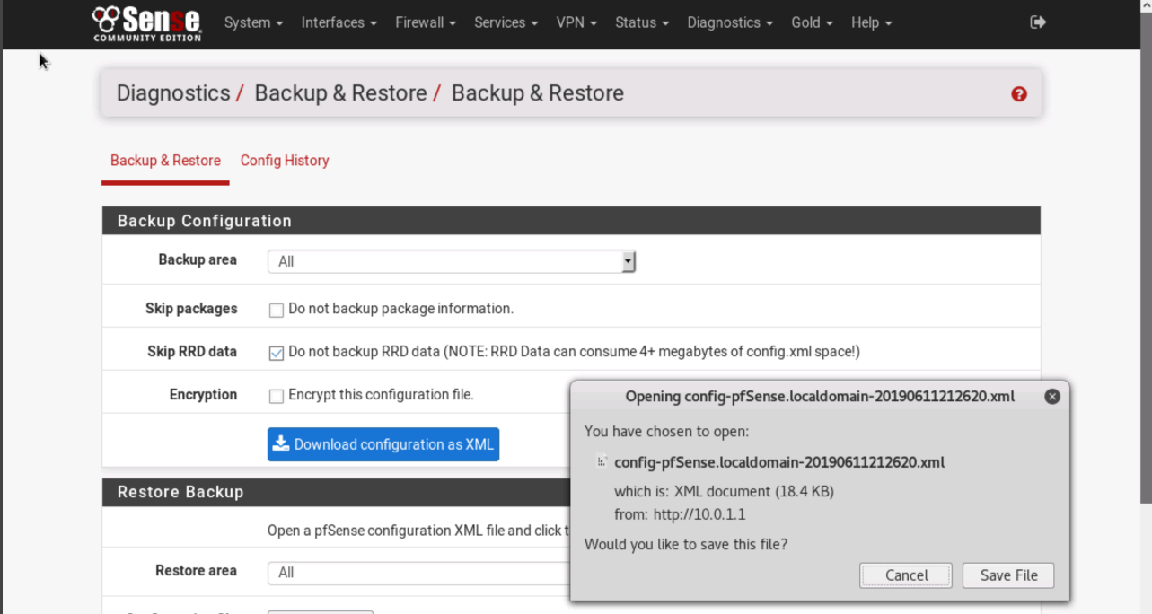

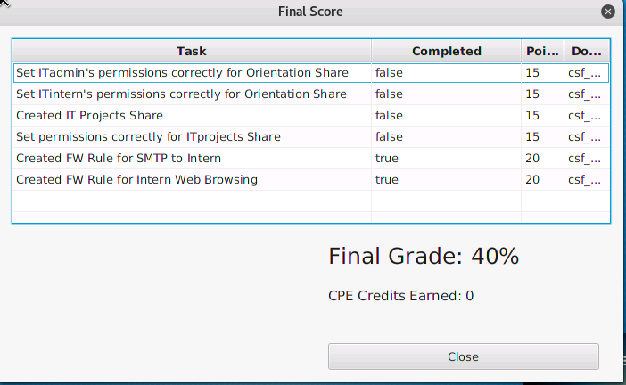

# 05 VULNERABILITY ANALYSIS

|  |  |
| --- | --- |
| TASK | KEY PERFORMANCE INDICATORS |
| Mapped the network | **K0300**: Knowledge of network mapping and recreating network topologies.  **T0299**: Identify network mapping and operating system (OS) fingerprinting activities.  **T0850**: Perform or support technical network analysis and mapping. |
| Ran OpenVAS services | **T0124**: Incorporate cybersecurity vulnerability solutions into system designs (e.g., Cybersecurity Vulnerability Alerts). |
| Saved LAN results | **S0001: Skill in conducting vulnerability scans and recognizing vulnerabilities in security systems.**  **S0167: Skill in recognizing vulnerabilities in security systems. (e.g., vulnerability and compliance scanning).**  **A0015: Ability to conduct vulnerability scans and recognize vulnerabilities in security systems.**  **T0549: Perform technical (evaluation of technology) and nontechnical (evaluation of people and operations) risk and vulnerability assessments of relevant technology focus areas (e.g., local computing environment, network and infrastructure, enclave boundary, supporting infrastructure, and applications).**  **T0616: Conduct network scouting and vulnerability analyses of systems within a network.** |
| Saved Ubuntu results | **T0724: Identify potential points of strength and vulnerability within a network.**  **S0001: Skill in conducting vulnerability scans and recognizing vulnerabilities in security systems.**  **S0242: Skill in interpreting vulnerability scanner results to identify vulnerabilities.** |

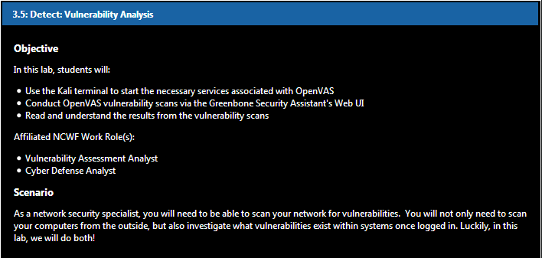

## 5.1 Equipping OpenVAS

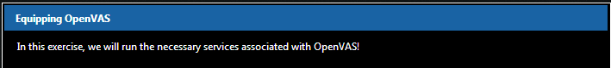

### 5.1.1 Logging in to Kali

Logging into our Kali virtual machine with the following credentials: Username: **root**, Password: **isaca**

### 5.1.2 Opening a Terminal

Open a terminal session by clicking the icon on the left-hand taskbar.

### 5.1.3 Interface Configuration

Before we begin our data flow identification, type **ifconfig** to take a look at our network interface card (NIC).

It looks like our **eth0** interface's IP address is **10.0.1.2** netmask **255.255.255.0**.

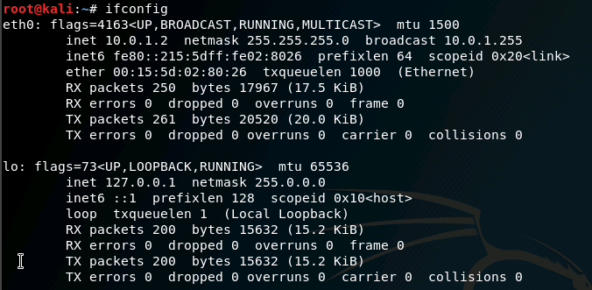

### 5.1.4 Mapping the Network

In order to scan our network for vulnerabilities, we have to map it first. Type **nmap -sn 10.0.1.0/24 > Desktop/nmap.txt** to redirect the output to a new report on the Desktop.

### 5.1.5 Editing the Report

On the Desktop, double-click **nmap.txt** and delete everything in the file except for the live hosts on the LAN so that the file looks like this. Then save and close the new version of the report.

10.0.1.1

10.0.1.2

10.0.1.3

10.0.1.4

10.0.1.5

10.0.1.6

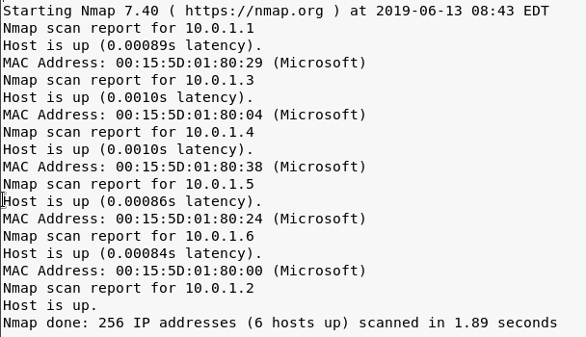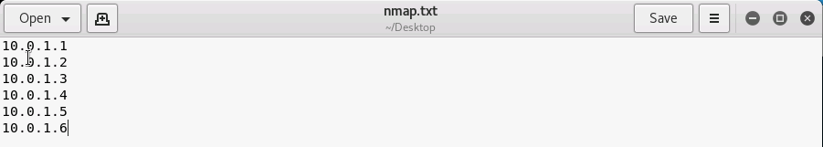

### 5.1.6 Starting OpenVAS

**OpenVAS** stands for **Open Vulnerability Assessment System**. It is free. Type **openvas-start** to run the services.

### 5.1.7 Printing Network Connections

Make sure our OpenVAS services are listening. Type **netstat –antlp.** Check the **Greenbone Security Assistant Daemon (gsad)** and **OpenVAS Manager Daemon (openvasmd)** listening. Note **gsad's local IP address/port (127.0.0.1:9392).**

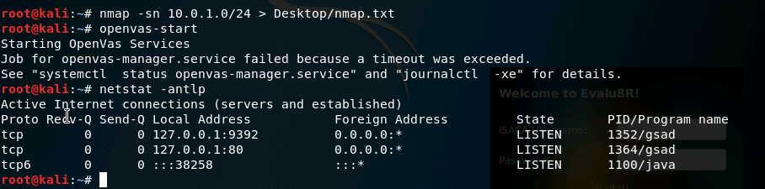

### 5.1.8 Checking Setup

Finally, let's run the command **openvas-check-setup** to ensure that the OpenVAS installation and setup has been implemented correctly. The command's output says "It seems like your OpenVAS-9 installation is OK", so we are good to go! Type exit to close the terminal.

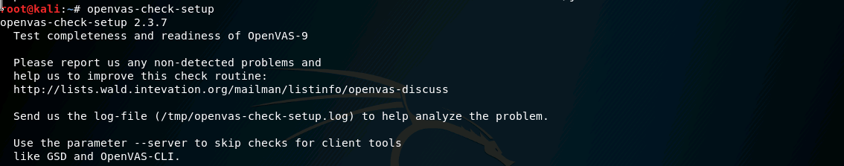

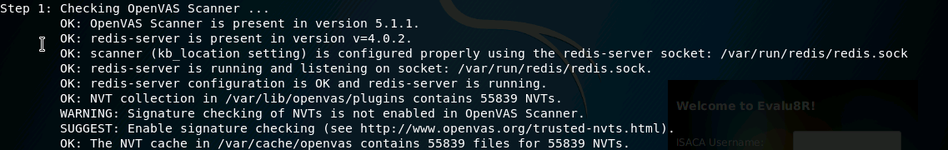

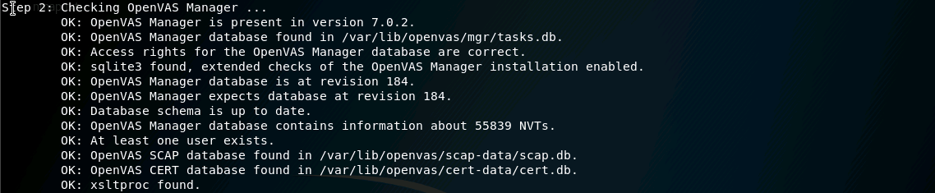

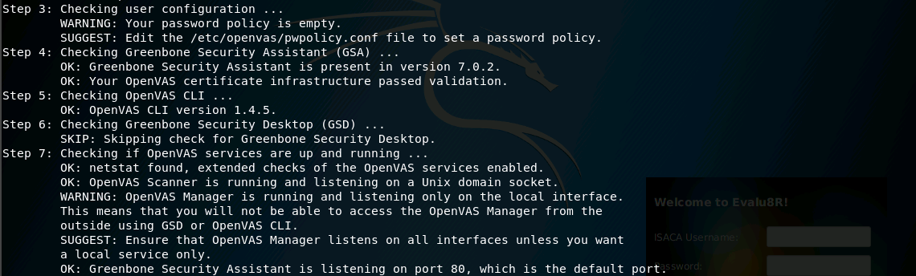

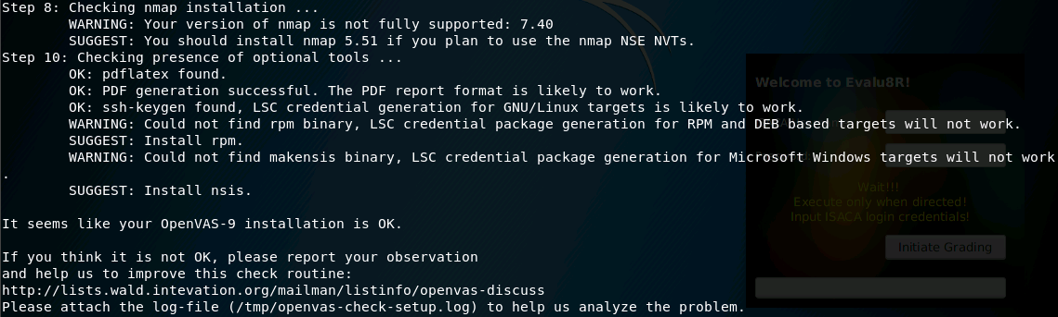



## 5.2 Scanning Vulnerabilities in GSA



### 5.2.1 Opening a Web Browser

Open a new web browser by clicking on the **Firefox ESR** icon on the Favorites bar.

### 5.2.2 OpenVAS Web UI

Do you remember the IP address and the port number of Greenbone Security Assistant taken from the netstat command? Type **https://127.0.0.1:9392** to open the web user interface. If that doesn't work, use **https://127.0.0.1:80**, which should redirect you to the GSA landing page. Click "**Advanced**", "**Add Exceptio**n", and "**Confirm Security Exception**". The credentials are: username: **admin** password: **admin**

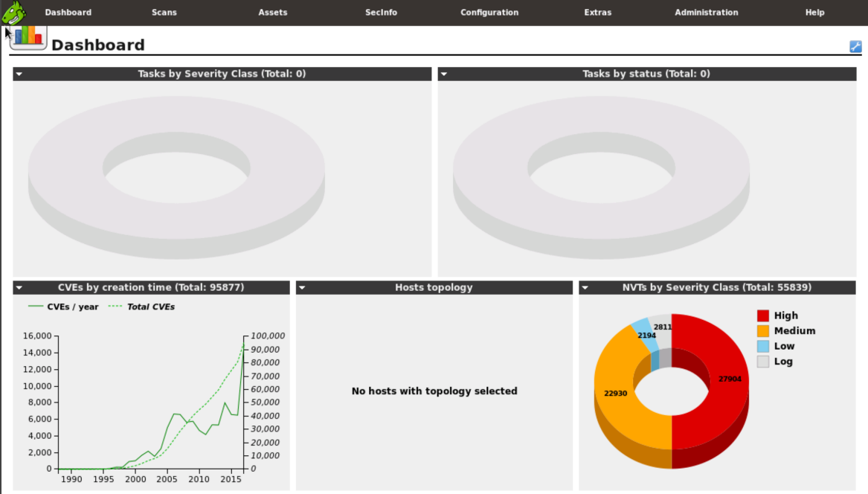

### 5.2.3 Learning GSA

This is the **Greenbone Security Assistant UI**. Although the OpenVAS framework is free and open, it has the ability to be very powerful. Greenbone provides users with efficient and effective solutions for vulnerability scanning and management. Hover over "Configuration" and click "Targets".

### 5.2.4 Creating a Target

Click the blue star icon in the upper left-hand corner to create a new target. Name this **nmap**. For hosts, click the "**From file**" radio button and "**Browse..**." for the **nmap.txt** file on the Desktop. Click "**Create**".

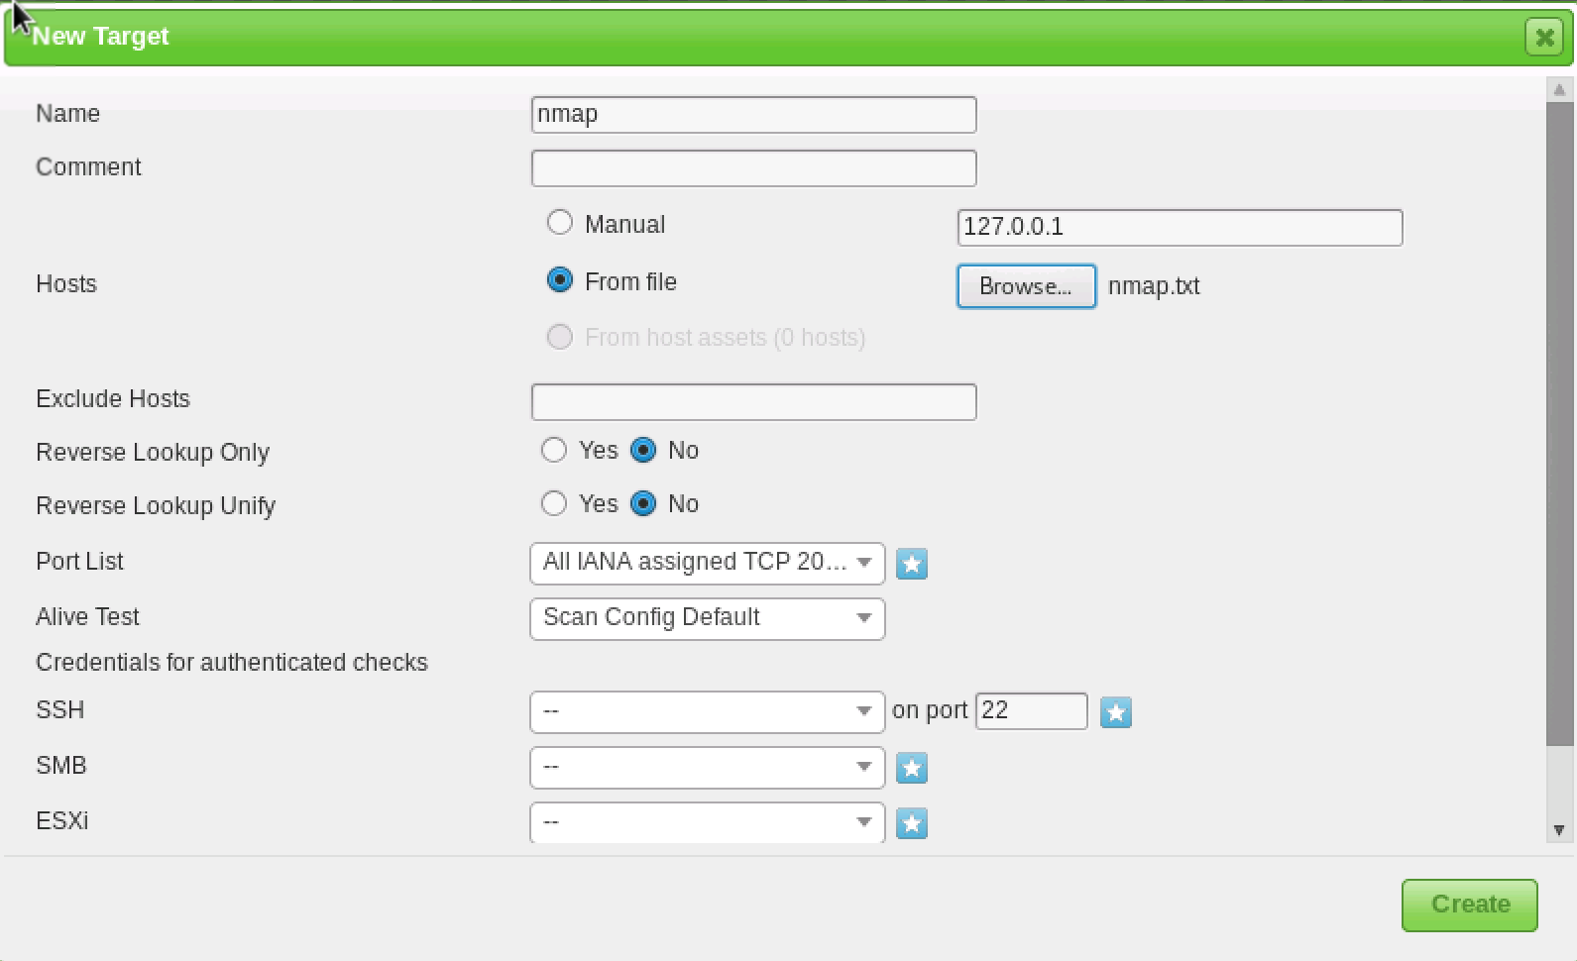

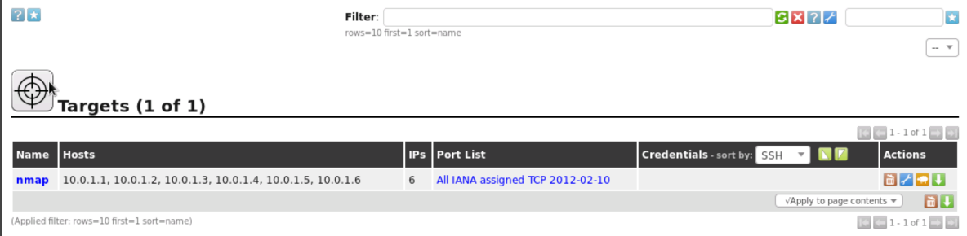

### 5.2.5 Starting a Task 1

Now that we have created a new target, hover over the "**Scans**" tab and click "**Tasks**". Read the pop-up message and wait for it to disappear. Hover over the blue star icon and click "**New Task**".

### 5.2.6 Starting a Task 2

Name this scan **LAN**. Choose the previously created nmap for "**Scan Targets**". Raise the "**Min QoD**" to **80%**. Lower the "**Maximum concurrently executed NVTs per host**" and **"... scanned hosts**" both to 1. Click "Create". This scan will be our external view of the network

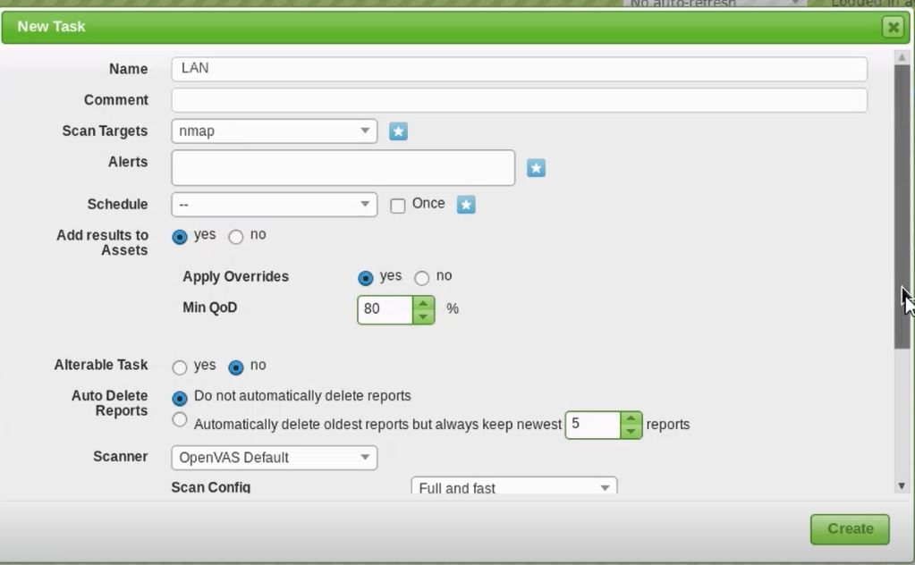

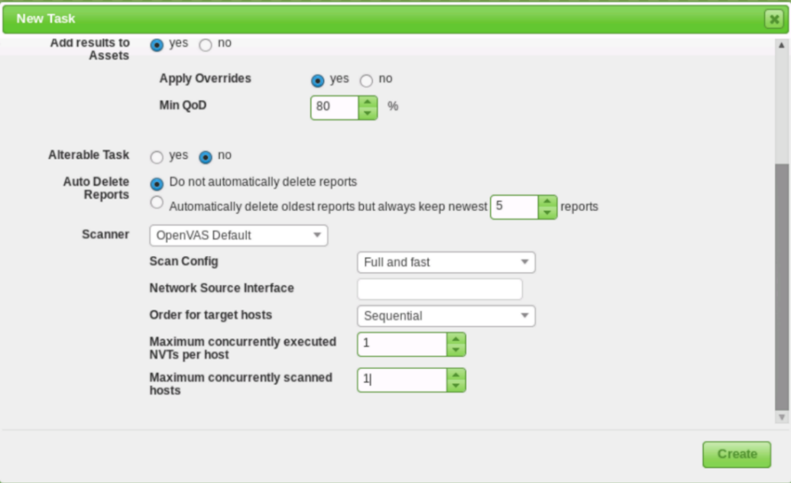

### 5.2.7 Running the Scan

On the bottom of the Tasks page, make sure to hit the play button to start the scan. This scan is going to take awhile, so let's move on to the next step.

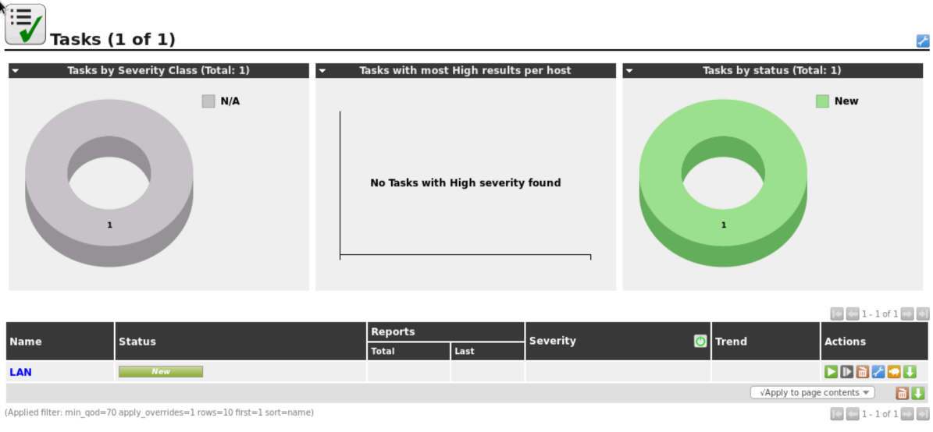

### 5.2.8 Adding Credentials 1

In our administrative notes, we have found more information on a machine placed on the LAN.

**10.0.1.4: Linux (Ubuntu).** username: **packethunter.** password: **packethunters.** We use these credentials to log in to this system remotely for our second vulnerability scan. We will be able to "dig deeper" because of this use of SSH.

### 5.2.9 Adding Credentials 2

Hover over "Configuration" and click "Credentials". Click on the blue star icon to create new credentials for our next scan. Name it **Ubuntu** with a username of **packethunter** and a password of **packethunters**. Click "Create".

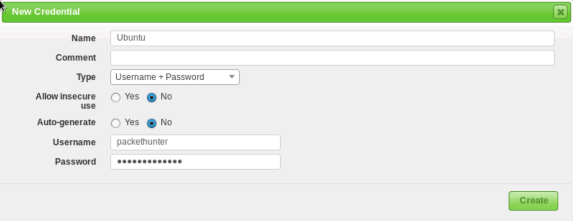

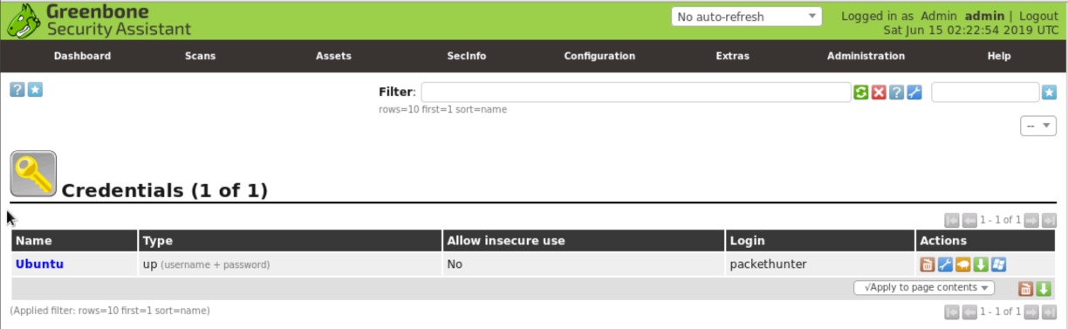

### 5.2.10 Creating Second target

Again. hover over "Configuration" and click "Targets". Click the blue star icon. Name this **Ubuntu**. For "Manual" hosts, enter **10.0.1.4**. In the SSH row, select **Ubuntu** on port **22**. Click "Create".

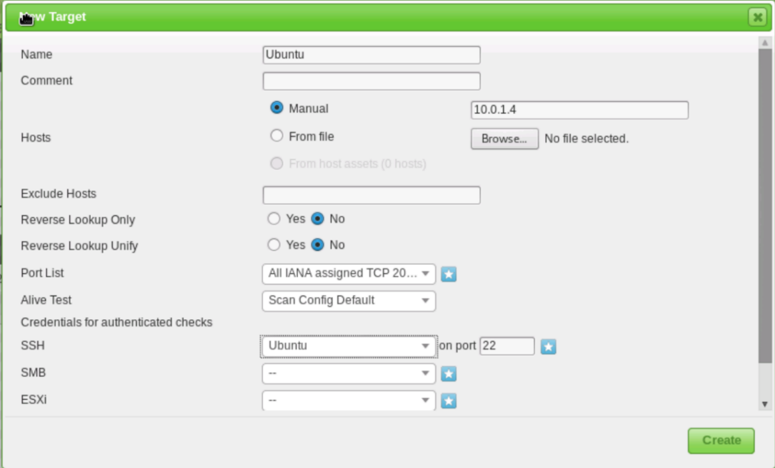

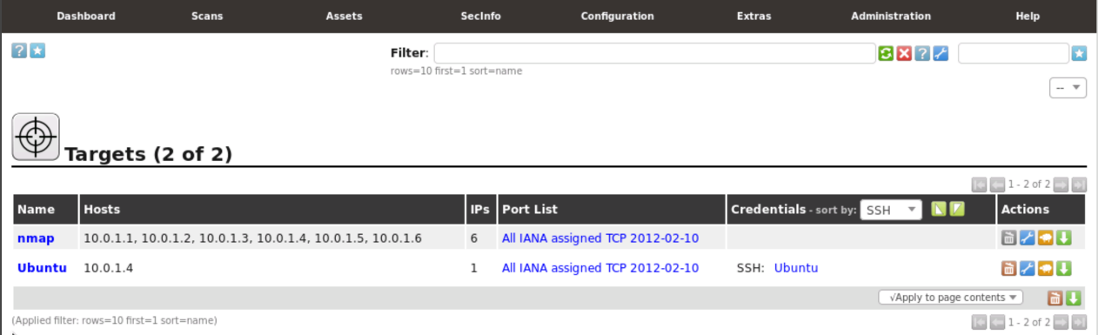

### 5.2.11 Starting Second Task 1

Again, hover over the "Scans" tab and click "Tasks". Hover over the blue star icon and click "New Task".

### 5.2.12 Starting Second Task 2

Name this scan Ubuntu. Choose Ubuntu for "**Scan Targets**". Raise the "**Min QoD**" to **80%**. Lower the "**Maximum concurrently executed NVTs per host**" and **"... scanned hosts**" both to 1. Click "Create".

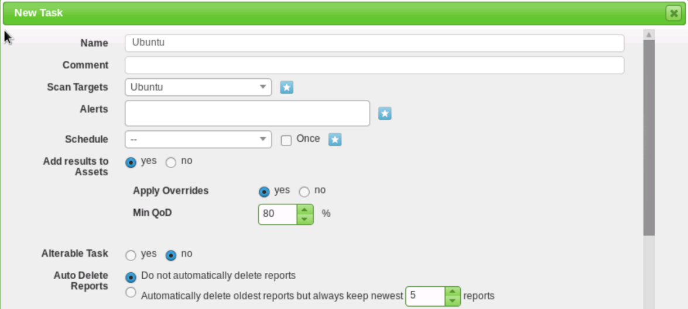

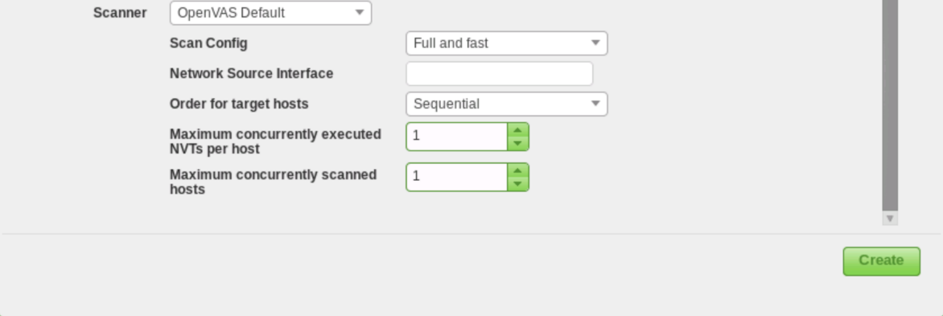

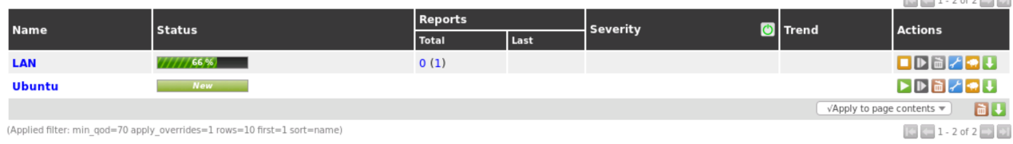

### 5.2.13 Running the Second Scan

Hit the play button to start the scan. This scan will also take awhile.

### 5.2.14 Saving Scans

For both scans, click the green download button to save the files. Keep them in the Downloads folder.

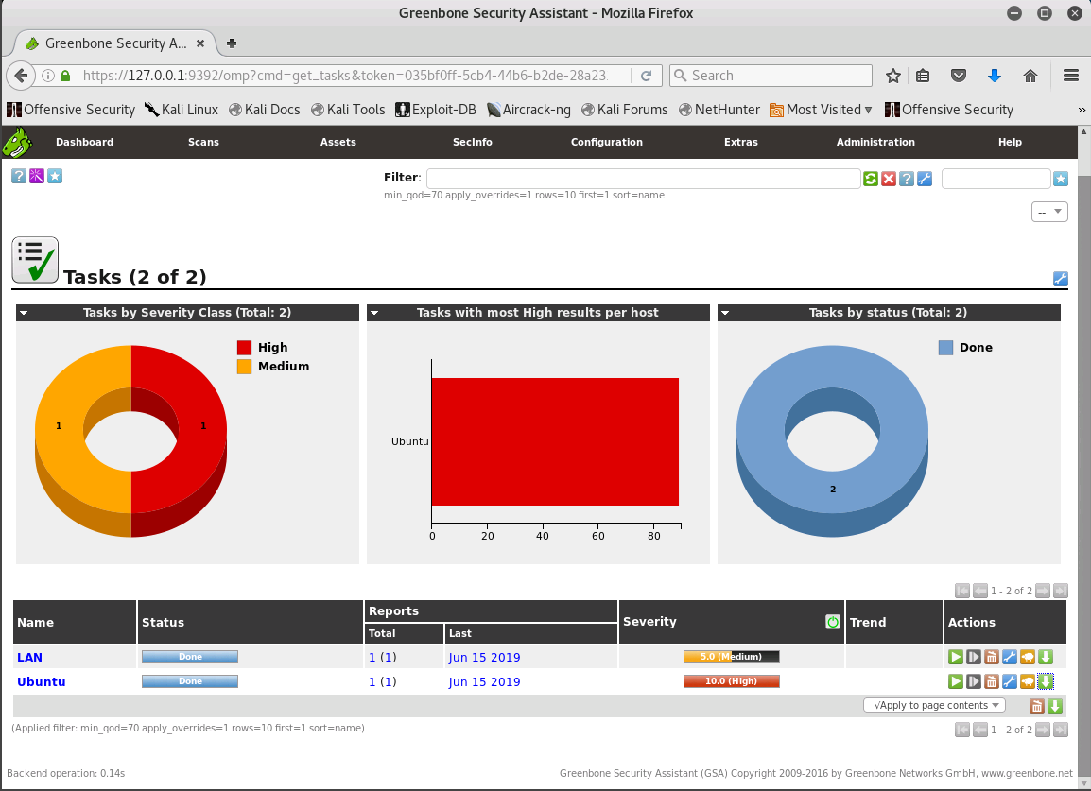

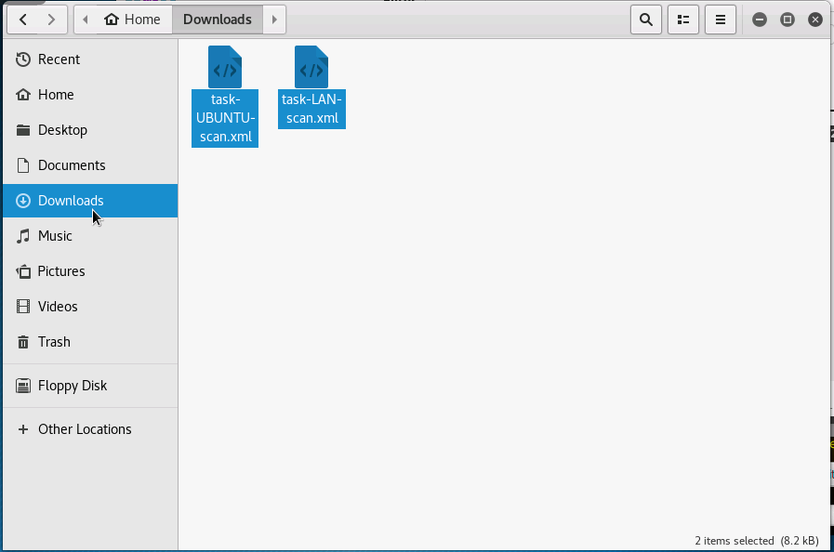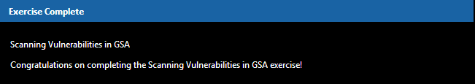

## 5.3 Observing Scan Results

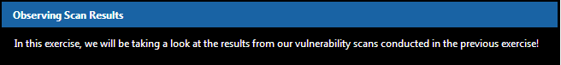

### 5.3.1 Noting LAN results 1

Let's take a look at the LAN vulnerability scan. Click the "**LAN**" task. Click on the number next to "**Results:**"

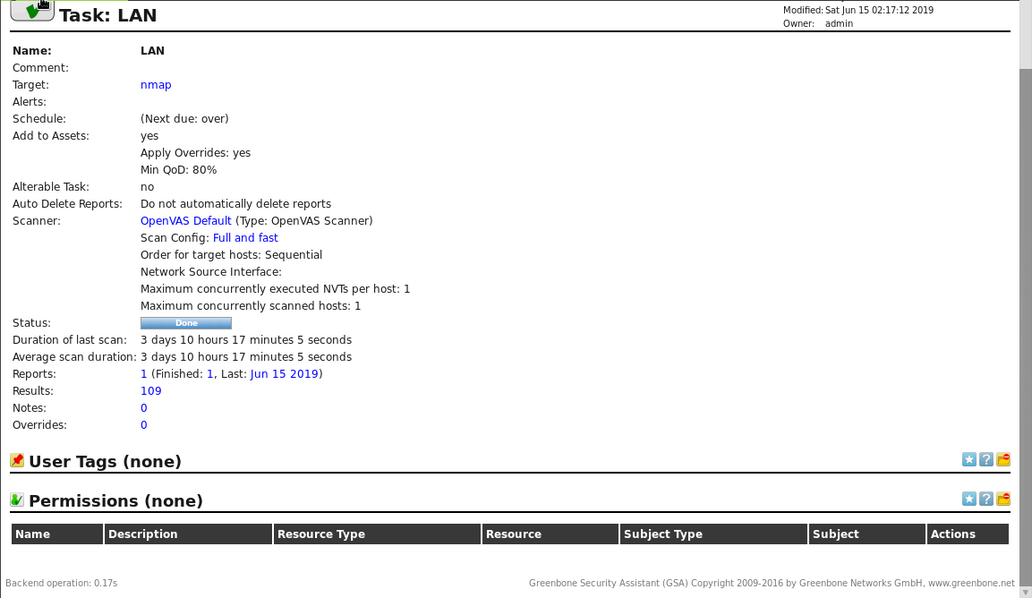

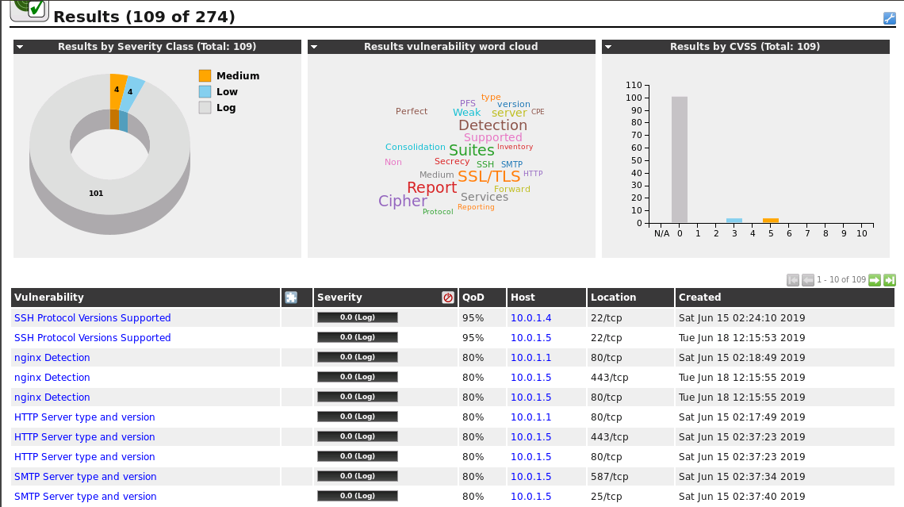

### 5.3.2 Noting LAN results 2

On this page, we can categorize the vulnerabilities by **alphabetical order, solution types, severity, quality of detection, hosts, port and protocol,** and **time**. Click on "**Severit**y" twice to sort from high to low.

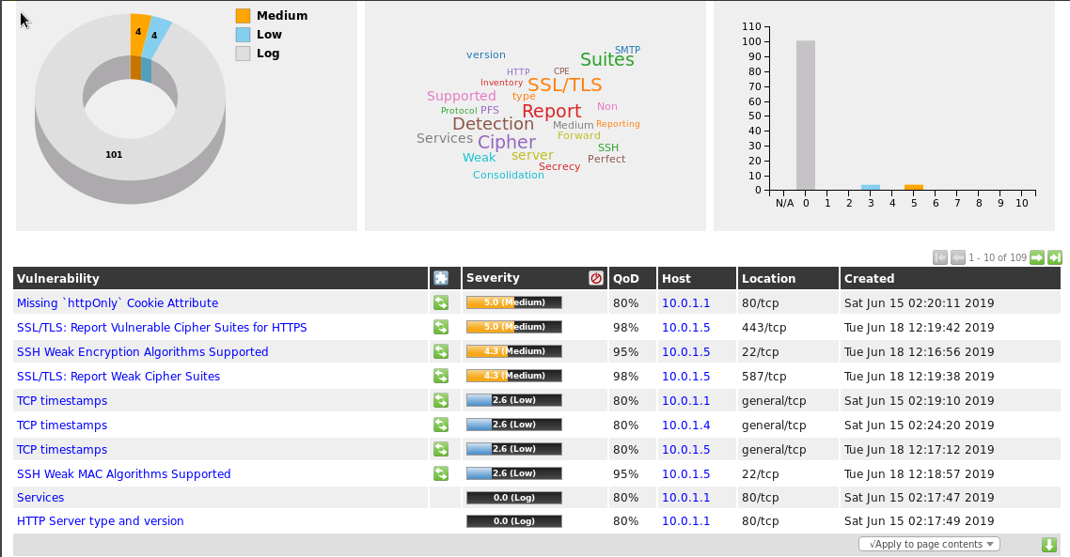

### 5.3.3 Noting LAN results 3

Note that there are no high severity ranked vulnerabilities from **10.0.1.4**. Feel free to check these vulnerabilities out by clicking on them!

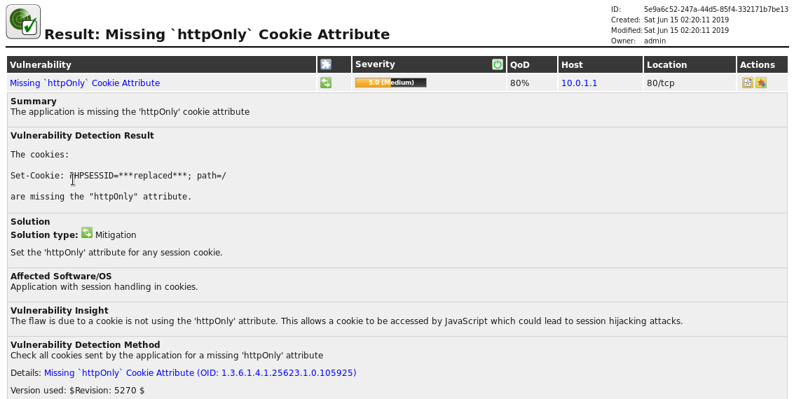



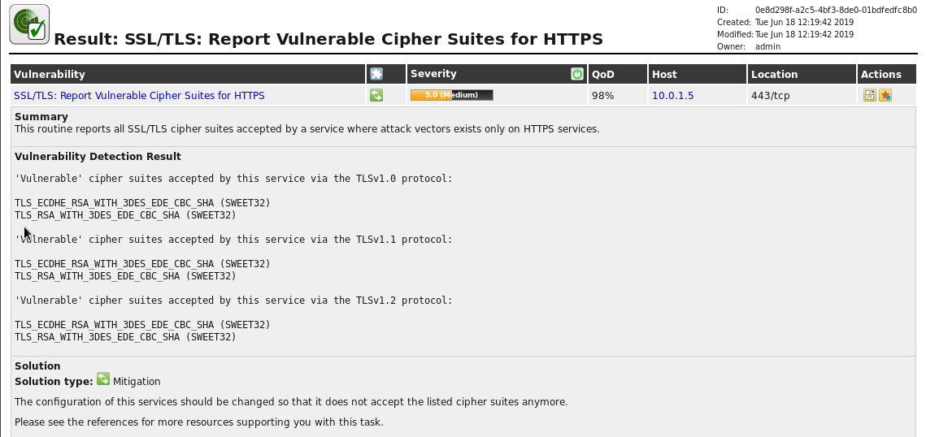

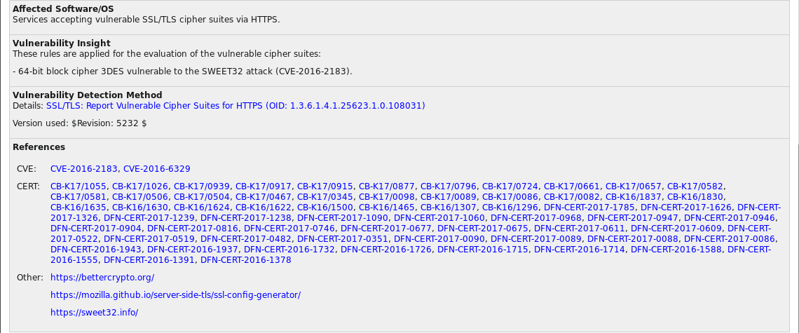

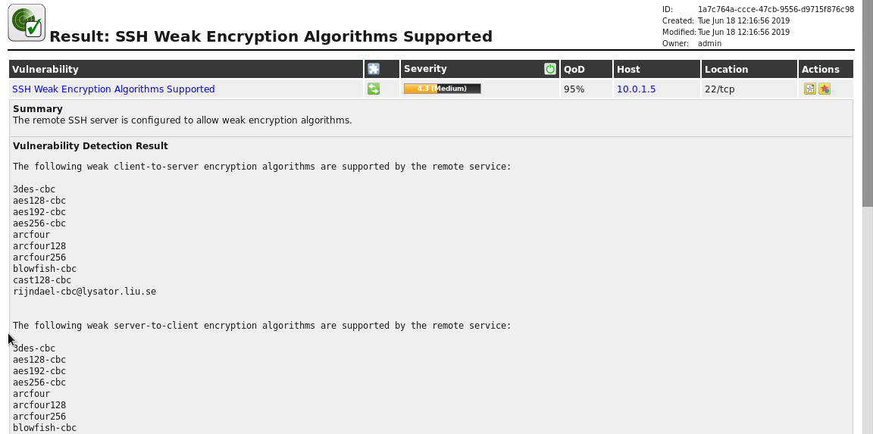

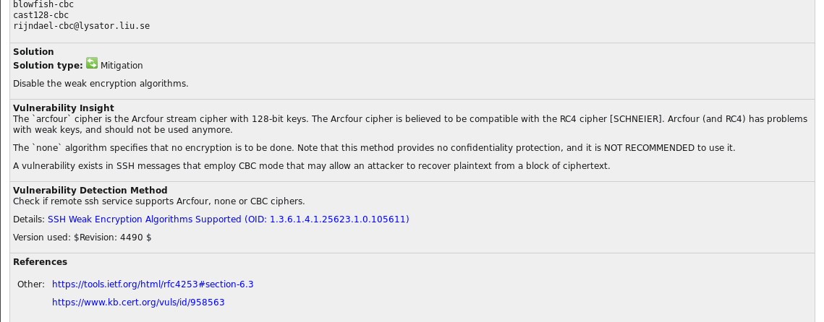

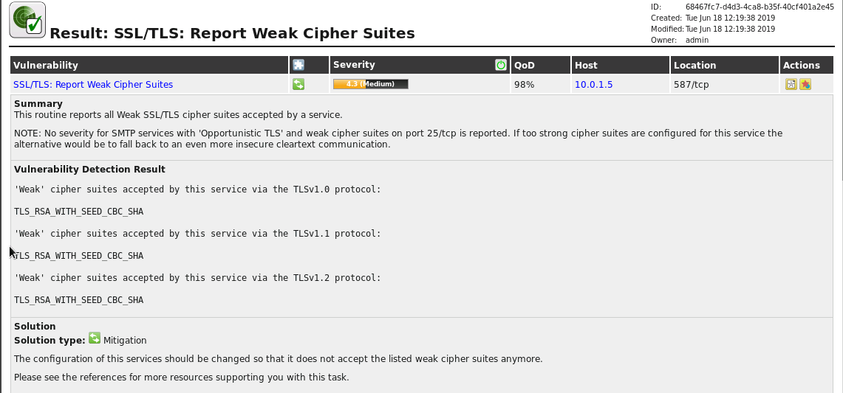

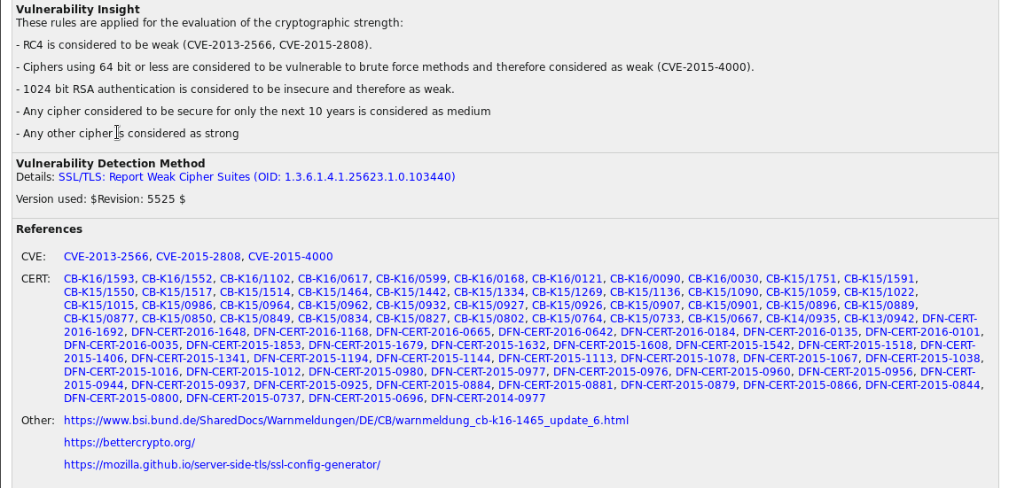

### 5.3.4 Noting UBUNTU results 1

From the previous step, we noticed that there were no major issues with the Ubuntu machine (**10.0.1.4**) from the outside looking in. However, what vulnerabilities will we find after having the login credentials? Let's find out! Go to the Tasks page and click the "**Ubuntu**" task. Click on the number next to "**Results**:"

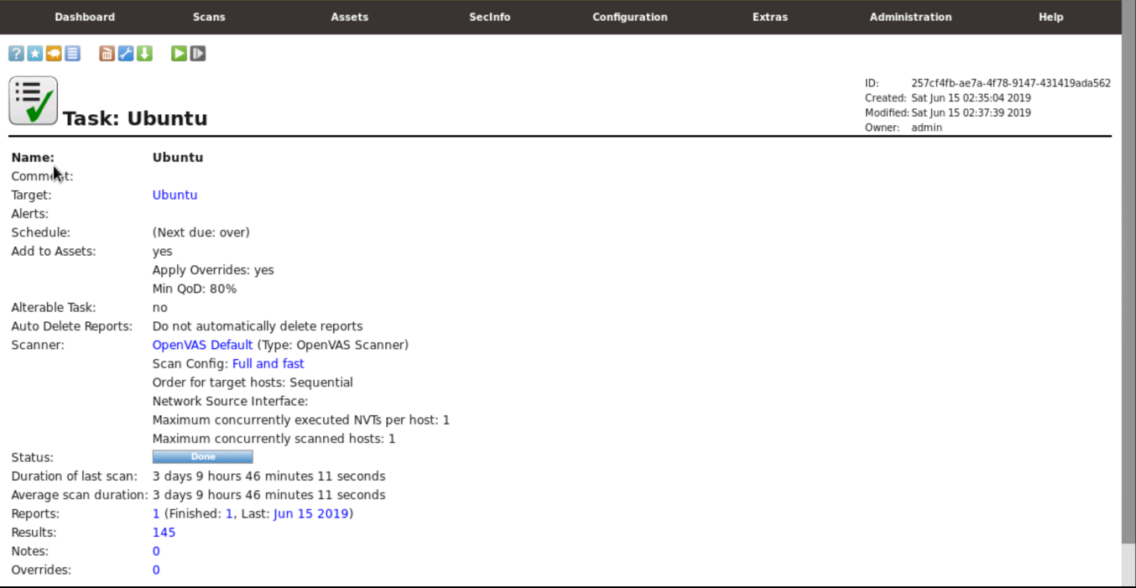

### 5.3.5 Noting UBUNTU results 2

Oh no! There are a ton of new vulnerabilities found on the **10.0.1.4** system that were not caught by the first scan. Click on "**Severity**" twice to sort from high to low. The majority of these severe vulnerabilities are due to the lack of updating. It looks like this system needs to be updated as soon as possible in order to patch these vulnerabilities!

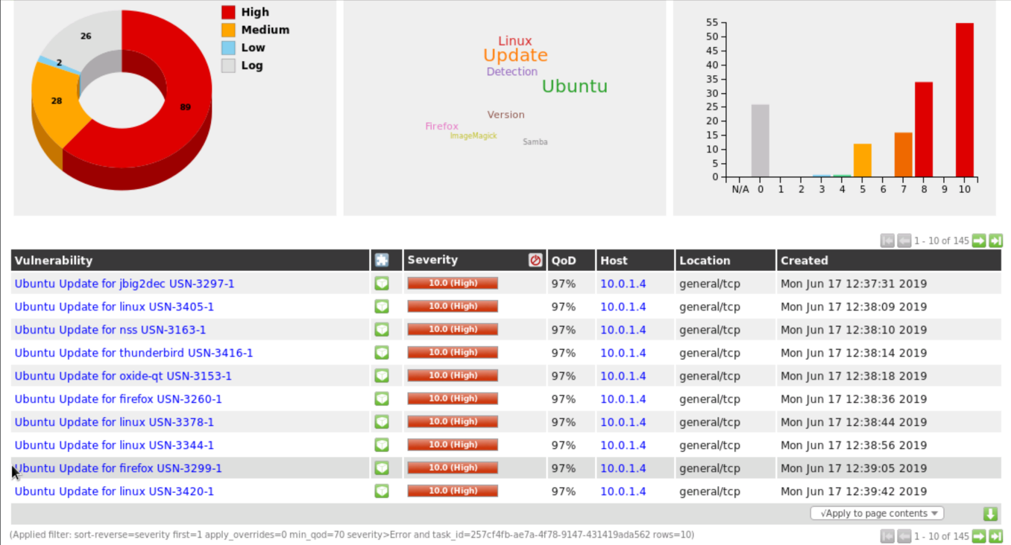

### 5.3.6 Noting UBUNTU results 3

Continue to research how these various issues are sorted by clicking on the different categories! In particular, hover over the solution types to get a sense on how to patch these vulnerabilities! Running a scan is important, but understanding the report and results is just as crucial!

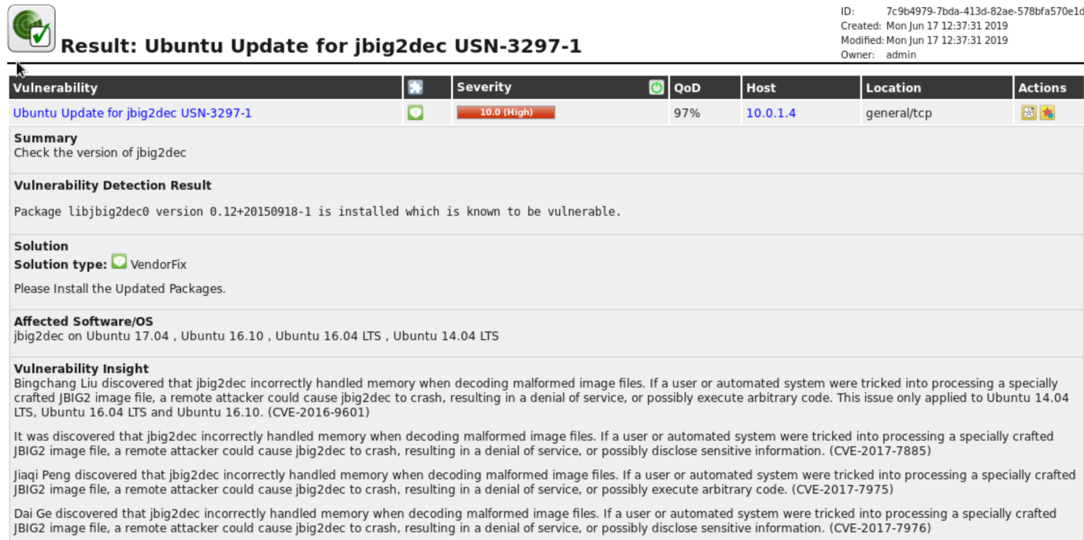

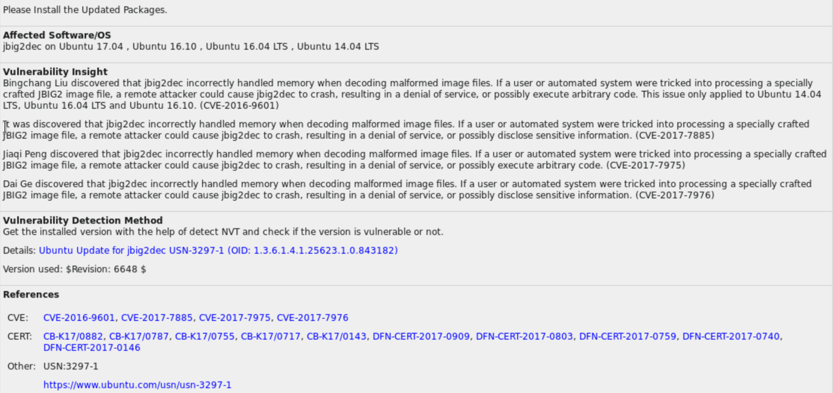

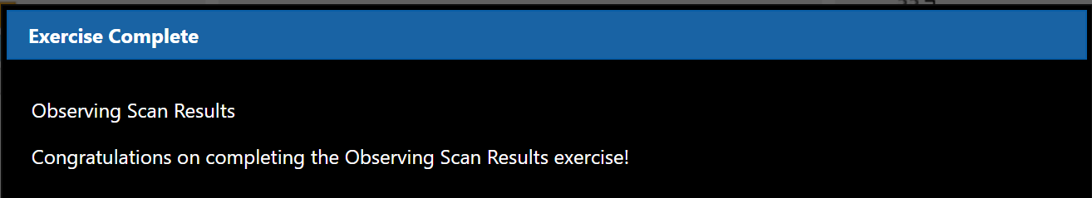

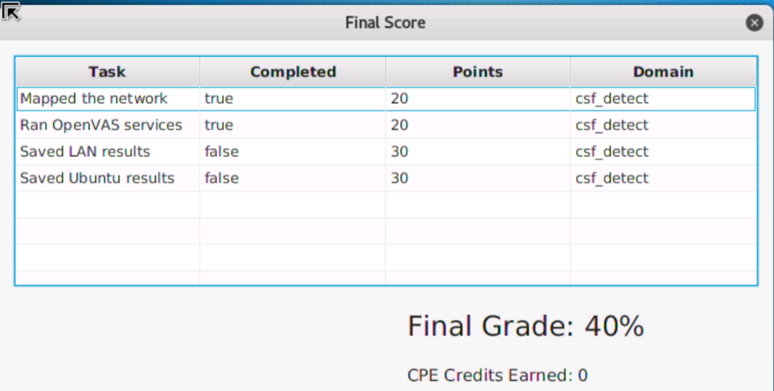

# 06 DETECT CHALLENGE

|  |  |
| --- | --- |
| TASK | KEY PERFORMANCE INDICATORS |
| Recorded IP address | **T0299**: Identify network mapping and operating system (OS) fingerprinting activities.  **T0850**: Perform or support technical network analysis and mapping.  **K0300**: Knowledge of network mapping and recreating network topologies.  **S0081:** Skill in using network analysis tools to identify vulnerabilities. (e.g., fuzzing, nmap, etc.). |
| Recorded MAC address | **S0081**: Skill in using network analysis tools to identify vulnerabilities. (e.g., fuzzing, nmap, etc.).  **K0300:** Knowledge of network mapping and recreating network topologies.  **T0850:** Perform or support technical network analysis and mapping.  **T0299:** Identify network mapping and operating system (OS) fingerprinting activities. |
| Scanned local Kali box | **S0137: Skill in conducting application vulnerability assessments.**  **A0015: Ability to conduct vulnerability scans and recognize vulnerabilities in security systems.**  **T0606: Compile, integrate, and/or interpret all-source data for intelligence or vulnerability value with respect to specific targets.**  **T0616: Conduct network scouting and vulnerability analyses of systems within a network.**  **K0013: Knowledge of cyber defense and vulnerability assessment tools and their capabilities.** |

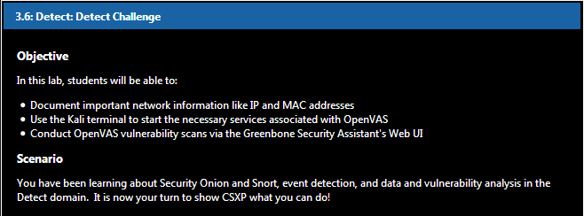

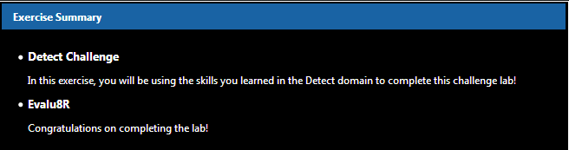

## 6.1 Detect Challenge

### 6.1.1 Starting Services

Log in to the Kali VM: username: **root** password: **isaca**. Start the challenge lab by running the OpenVAS essential services.

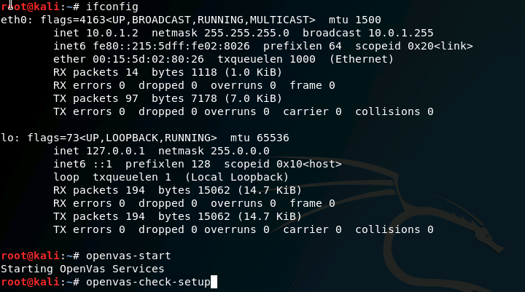

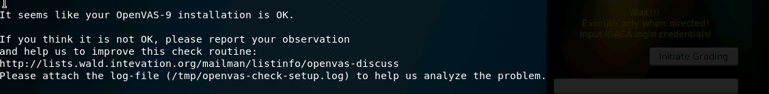

### 6.1.2 Creating a File

Open Leafpad and document your IP address and MAC address. Save the file as network.txt to your Desktop.



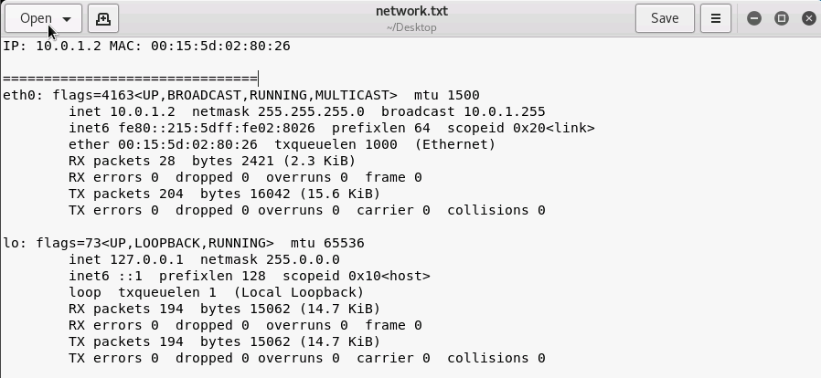

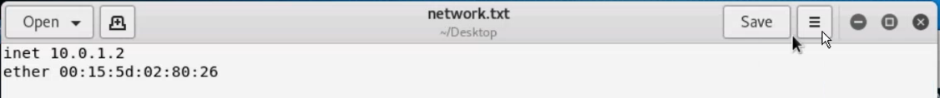

### 6.1.3 Opening the Web UI

Go to the **Greenbone Security Assistant** at **https://127.0.0.1:9392;** credentials: username: **admin** password: **admin**

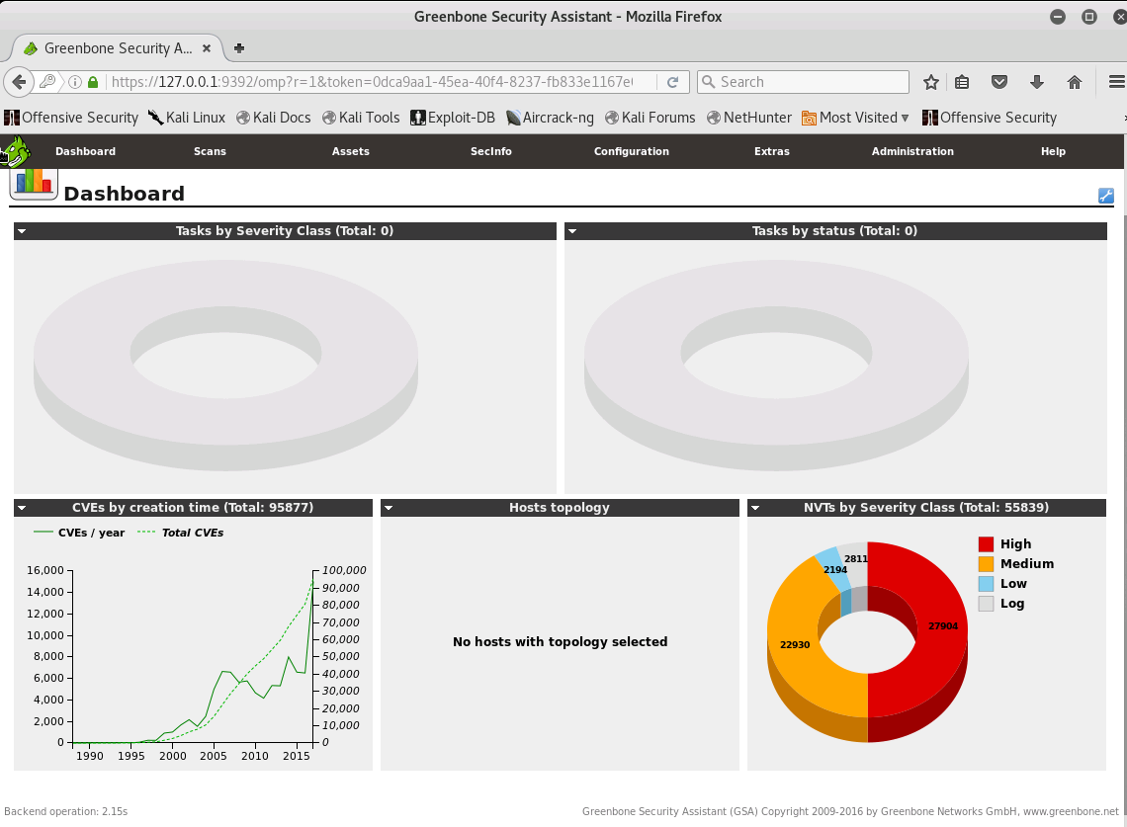

### 6.1.4 Conducting a Scan

Scan the local Kali VM (localhost) for vulnerabilities. Export the scan to an XML document. Name the **scan.xml** and save it to the Desktop. Do not forget to lower the "**Maximum concurrently executed NVTs per hos**t" and "**... scanned hosts**" both to 1.

**Create target: kali**

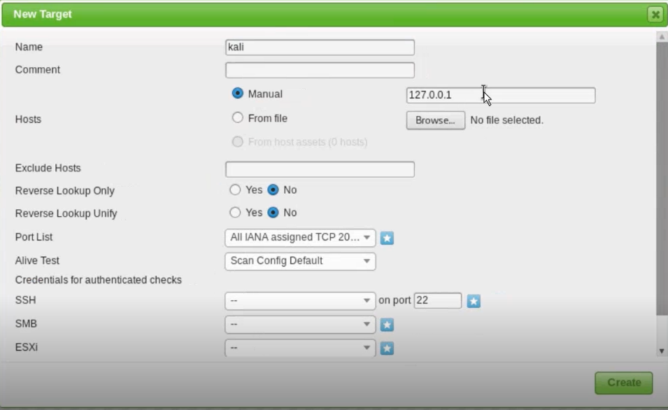

**Create task: kali**

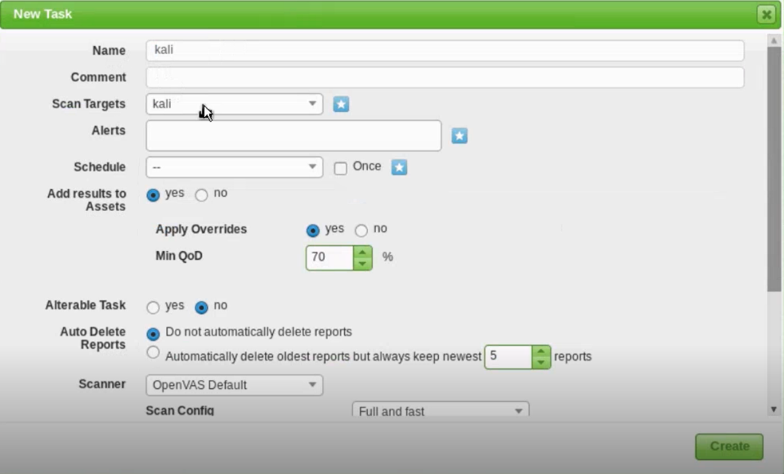

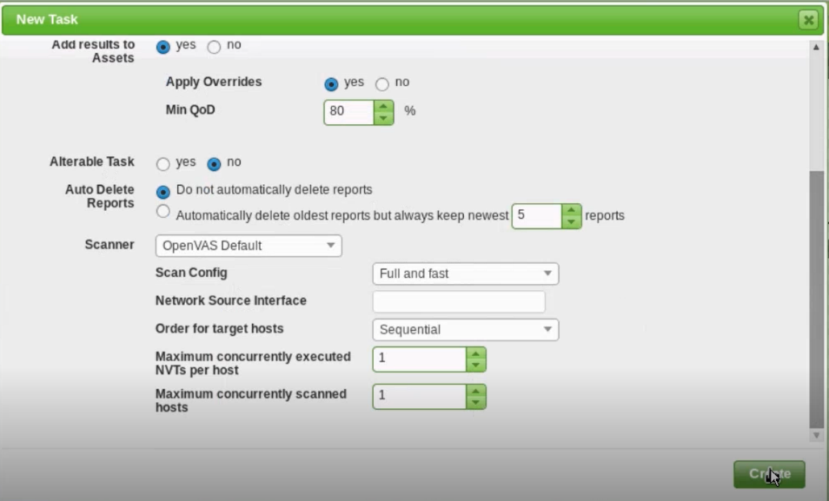

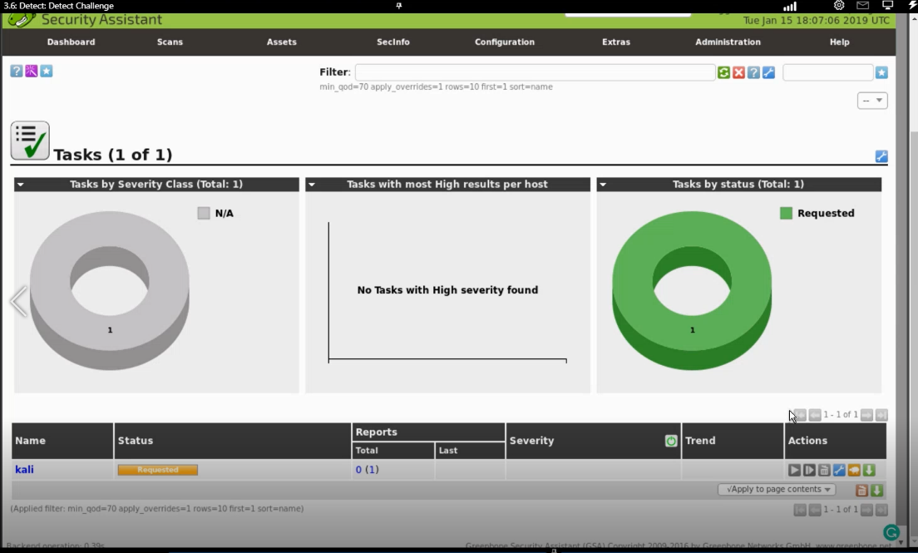

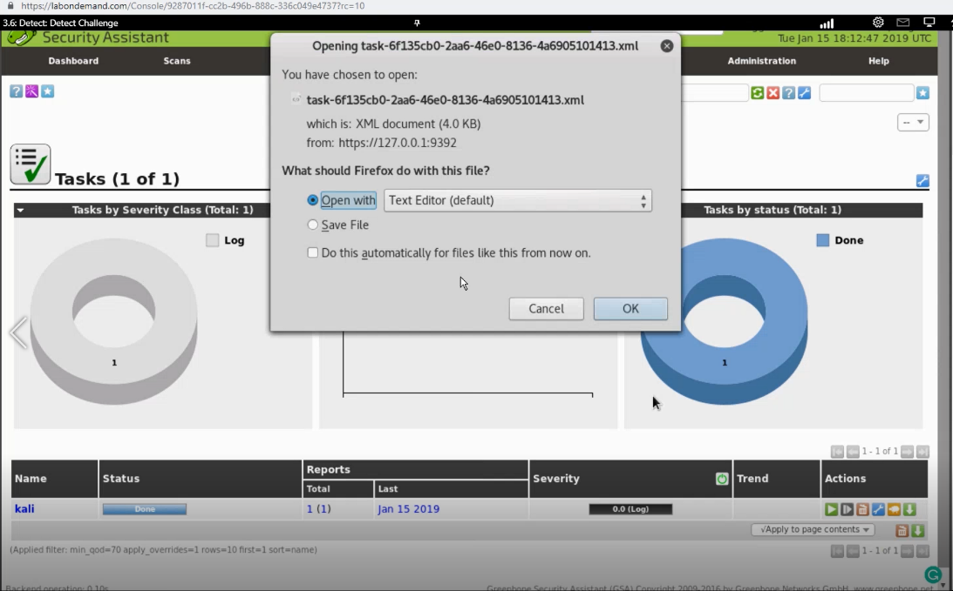

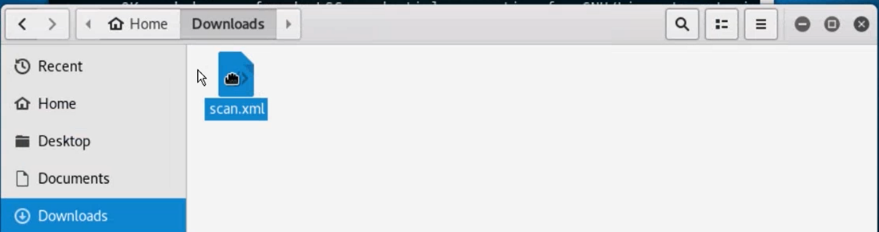

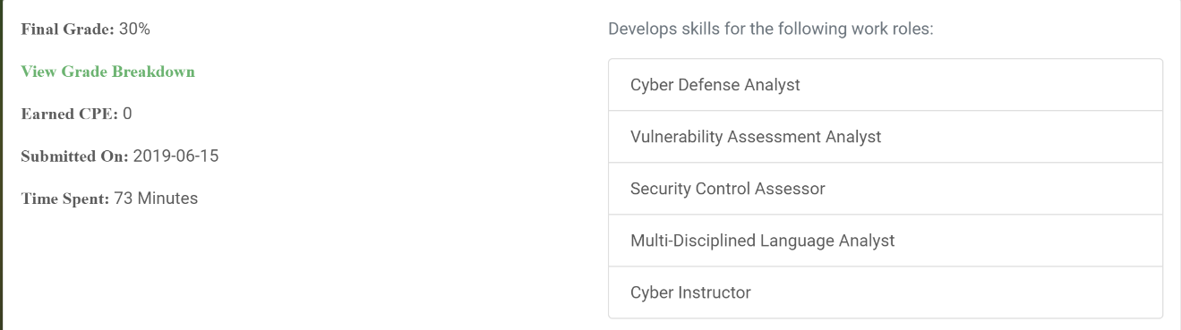

# 07 NOTIFICATION AND ESCALATION

|  |  |
| --- | --- |
| TASK | KEY PERFORMANCE INDICATORS |
| Recorded the date | **S0344**: Skill to prepare and deliver reports, presentations and briefings, to include using visual aids or presentation technology. |
| Recorded target IP | **T0295**: Validate intrusion detection system (IDS) alerts against network traffic using packet analysis tools.  **K0471**: Knowledge of Internet network addressing (IP addresses, classless inter-domain routing, TCP/UDP port numbering).  **T0278**: Collect intrusion artifacts (e.g., source code, malware, Trojans) and use discovered data to enable mitigation of potential cyber defense incidents within the enterprise. |
| Recorded port number | **T0295: Validate intrusion detection system (IDS) alerts against network traffic using packet analysis tools.**  **K0471: Knowledge of Internet network addressing (IP addresses, classless inter-domain routing, TCP/UDP port numbering).**  **T0278: Collect intrusion artifacts (e.g., source code, malware, Trojans) and use discovered data to enable mitigation of potential cyber defense incidents within the enterprise.** |
| Recorded exploit | **T0805: Report intelligence-derived significant network events and intrusions.**  **T0806: Request discipline-specific processing, exploitation, and disseminate information collected using discipline's collection assets and resources in accordance with approved guidance and/or procedures.**  **K0481: Knowledge of methods and techniques used to detect various exploitation activities.**  **S0269: Skill in researching vulnerabilities and exploits utilized in traffic.**  **A0093: Ability to identify/describe techniques/methods for conducting technical exploitation of the target.** |

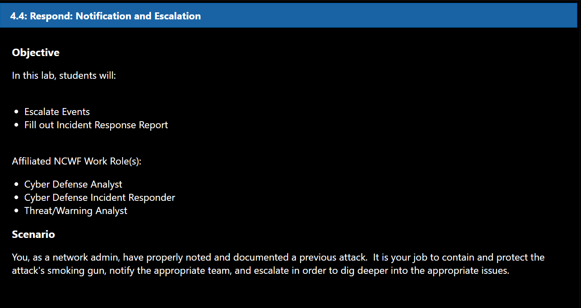

## 7.1 Escalation

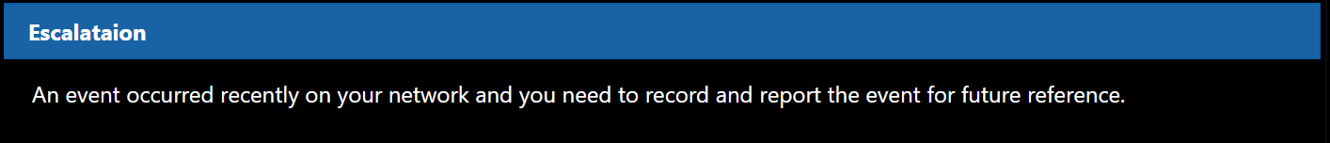

### 7.1.1 Login to SecOnion

Login to **SecOnion** VM. UN: **student** PW: **isaca**



### 7.1.2 Open SGUIL

Click on the **SGUIL** icon on the Desktop.

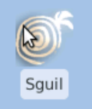

### 7.1.3 Login to SGUIL

Login to SGUIL using: Username: **student** Password: **isaca11**

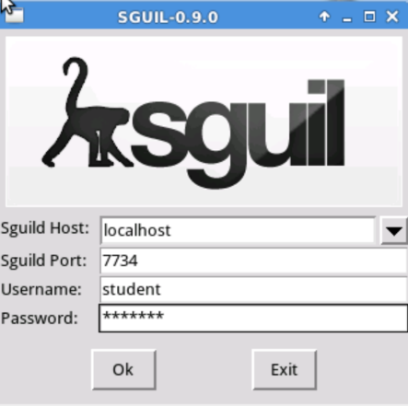

### 7.1.4 Select Sensor

Select **eth1** sensor to monitor the LAN segment of the network.

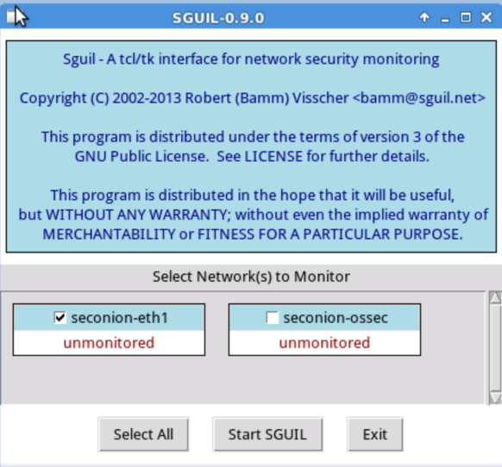

### 7.1.5 Review Attacks

Take a moment to review the reports in the queue. It's a appears to be a progression of a single attack where an Eternalblue exploit is completed successfully and a file is uploaded onto the target computer.

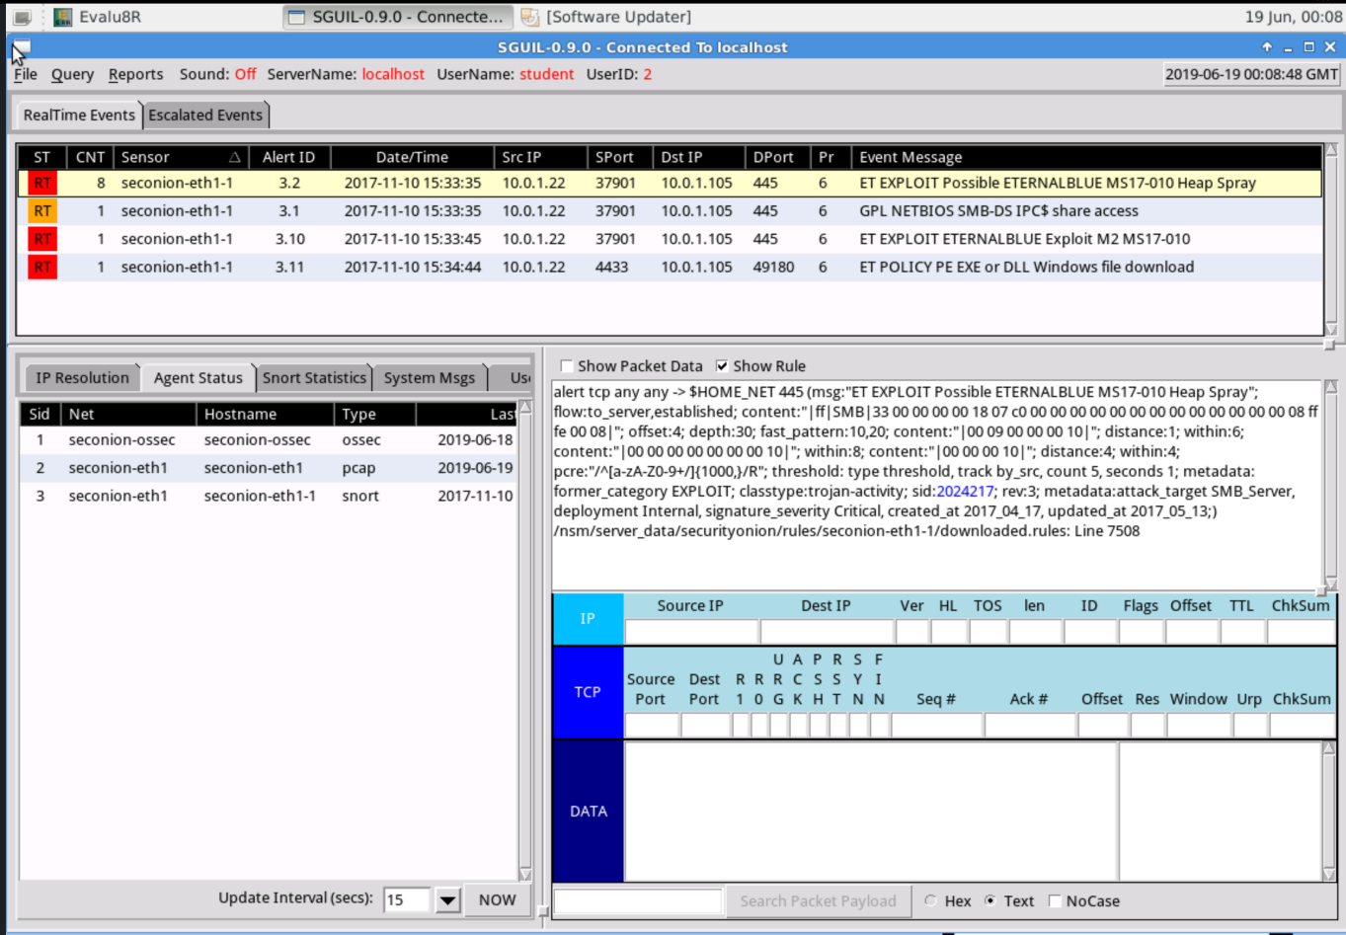

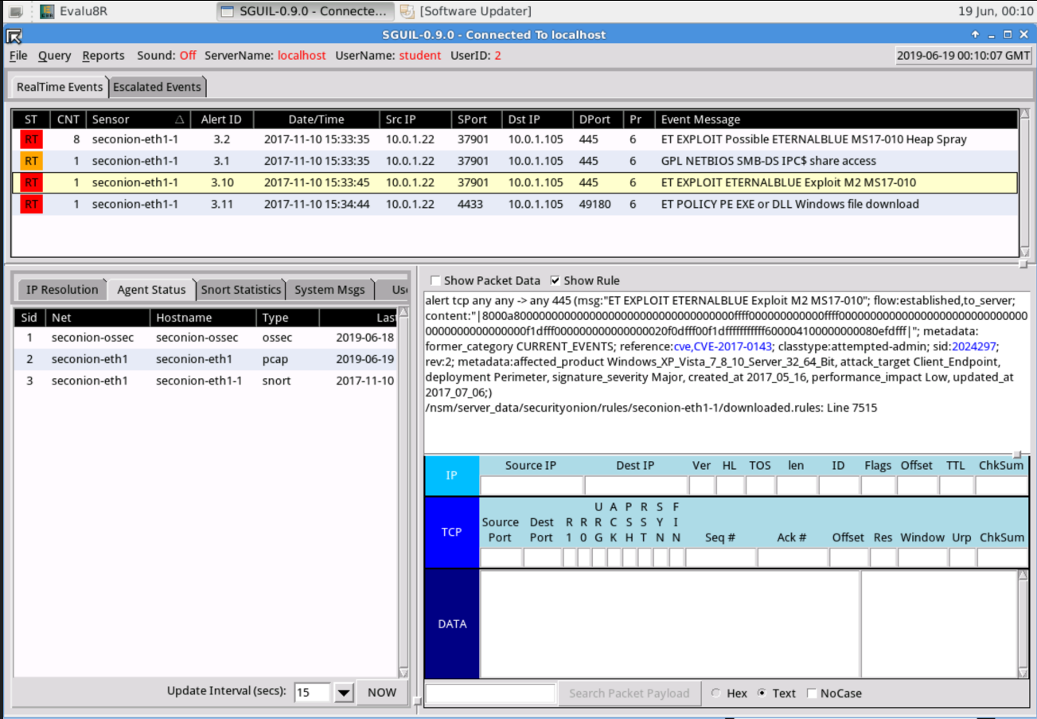

### 7.1.6 Escalate Attacks

This group of alerts should be escalated so that the cybersecurity team can properly investigate and eradicate the threat if needed. This can be done by right-clicking on the **ST** column next to the alerts clicking on **Update Event Status** and selecting **Escalate(F9)** or by highlighting the incident and selecting **F9**.

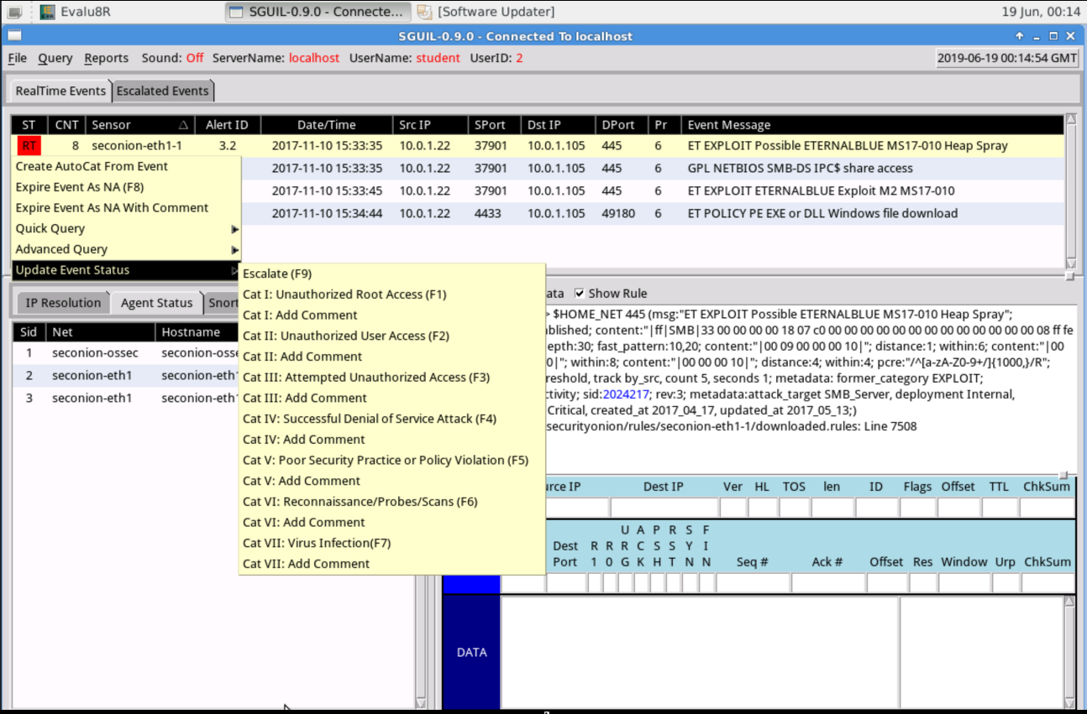

### 7.1.7 Add Comments

Add the comment "**Possible Eternalblue Exploit**" to each escalated event.

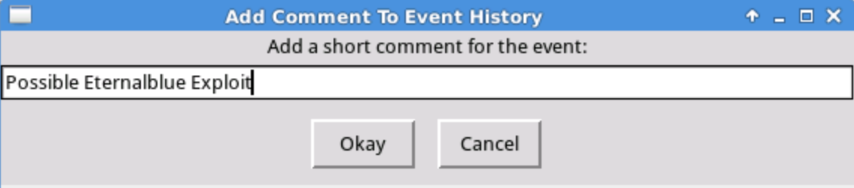

### 7.1.8 View Escalated Alerts

Click on the **Escalated Events** tab to view the alerts that you just escalated.

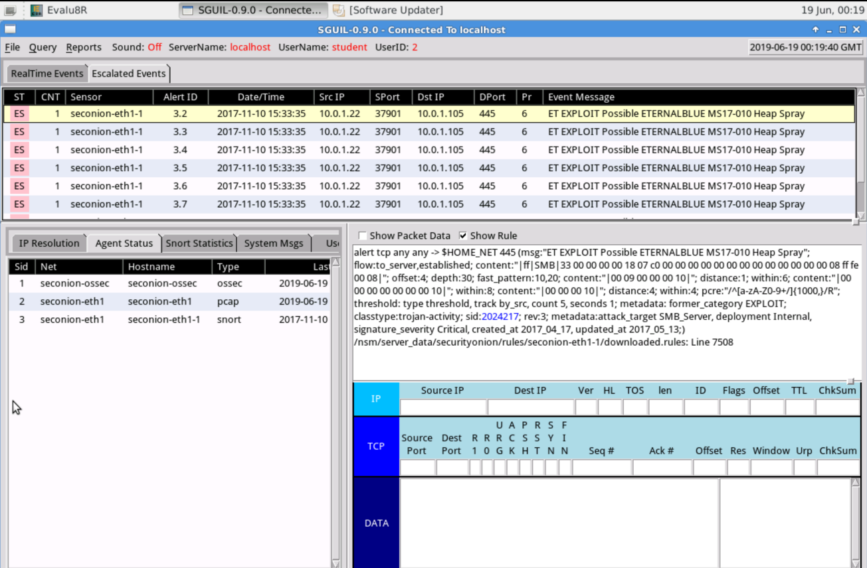

## 7.2 Report

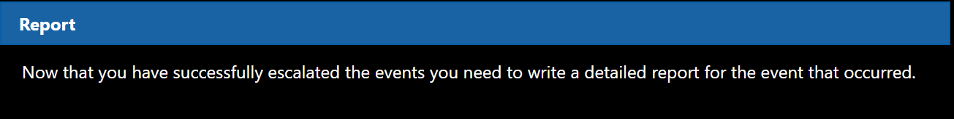

### 7.2.1 Open the Template

Double click on the report template on the desktop.

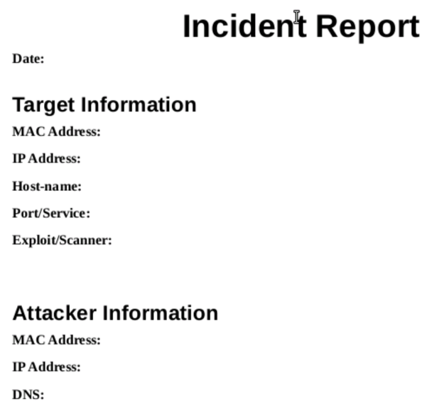

### 7.2.2 Date

Using the information provided by **SNORT** and **SGUIL** fill out the information in the template. The fist is the **Date** of the attack. Use the information in the Date/Time column of SGUIL. **2017-11-10**

### 7.2.3 Wireshark

SGUIL doesn't show all of the needed information for the report. We have to open the packet capture to get some of the information. Right-click on the **Alert ID** column of the first event and select **Wireshark**.

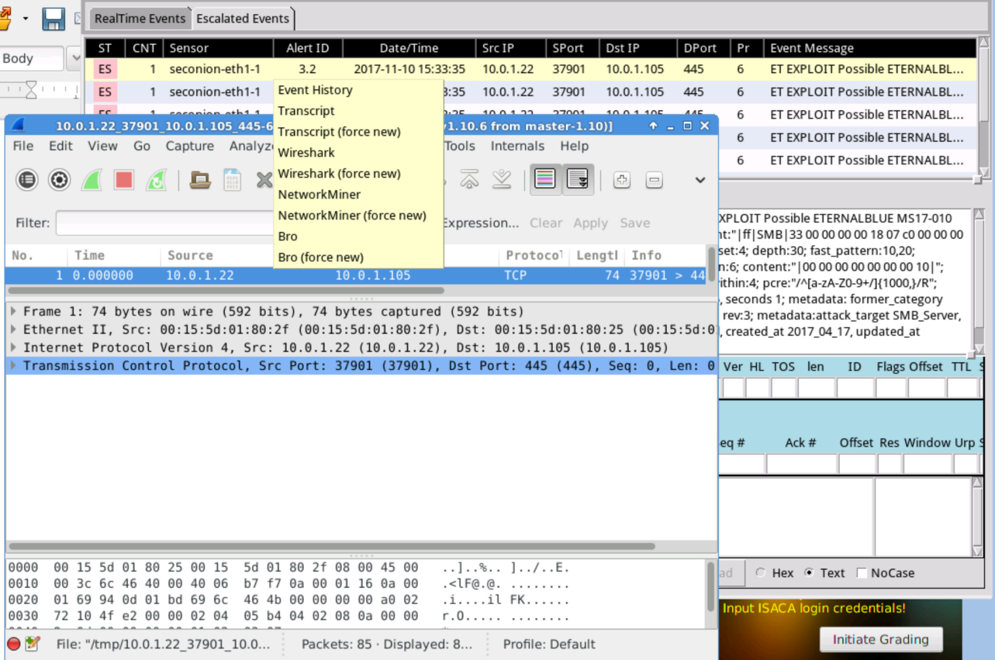

### 7.2.4 MAC Address

To get the MAC address of the target device click on the first packet in the packet collect and look at **the Ethernet II Dst:** address of the packet: **00:15:5d:01:80:25.** Also look at the Source in the packet for the attackers MAC address: **00:15:5d:01:80:2f**. Record these values into the appropriate place in the incident report.

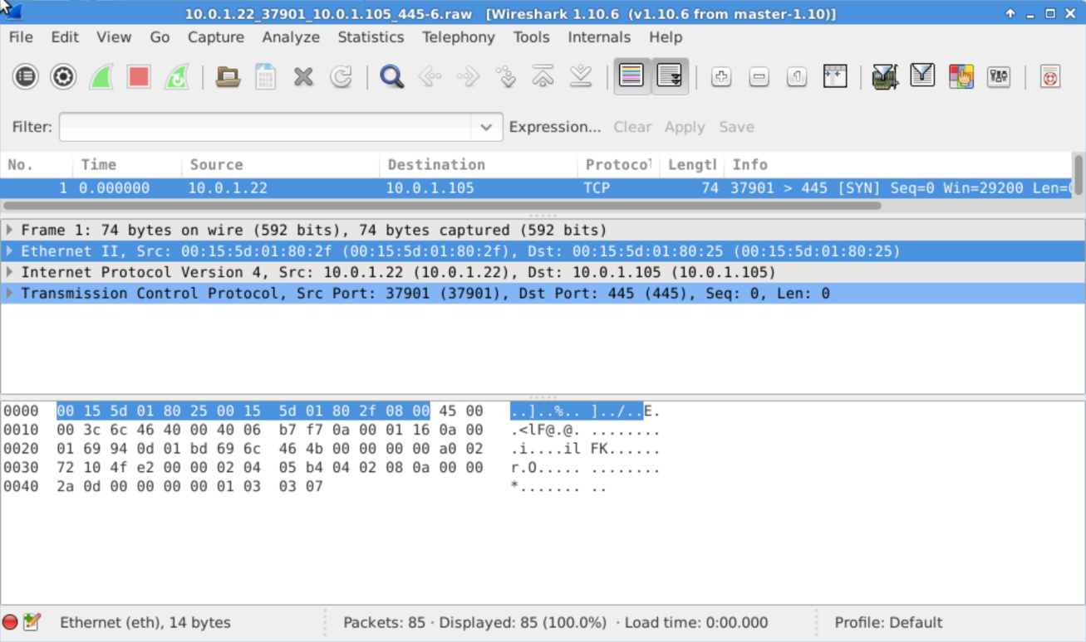

### 7.2.5 IP Address

he IP address of the devices involved can be found in either Wireshark or SGUIL. Record both the victim device and the attackers IP addresses in the appropriate place in the report.

Target IP: 10.0.1.105

Attacker IP: 10.0.1.22

### 7.2.6 Host-Name

The hostname is not available in this instance. Depending on the type of attack and the setup of the IDS/IPS you may not always get all of the information needed. Your job at this point in the attack process is to fill in as much information as possible.

### 7.2.7 Port/Service

he port or service utilized during this attack should be reported. This information can be found in Wireshark or in SGUIL. Port/Service: **445/SMB**

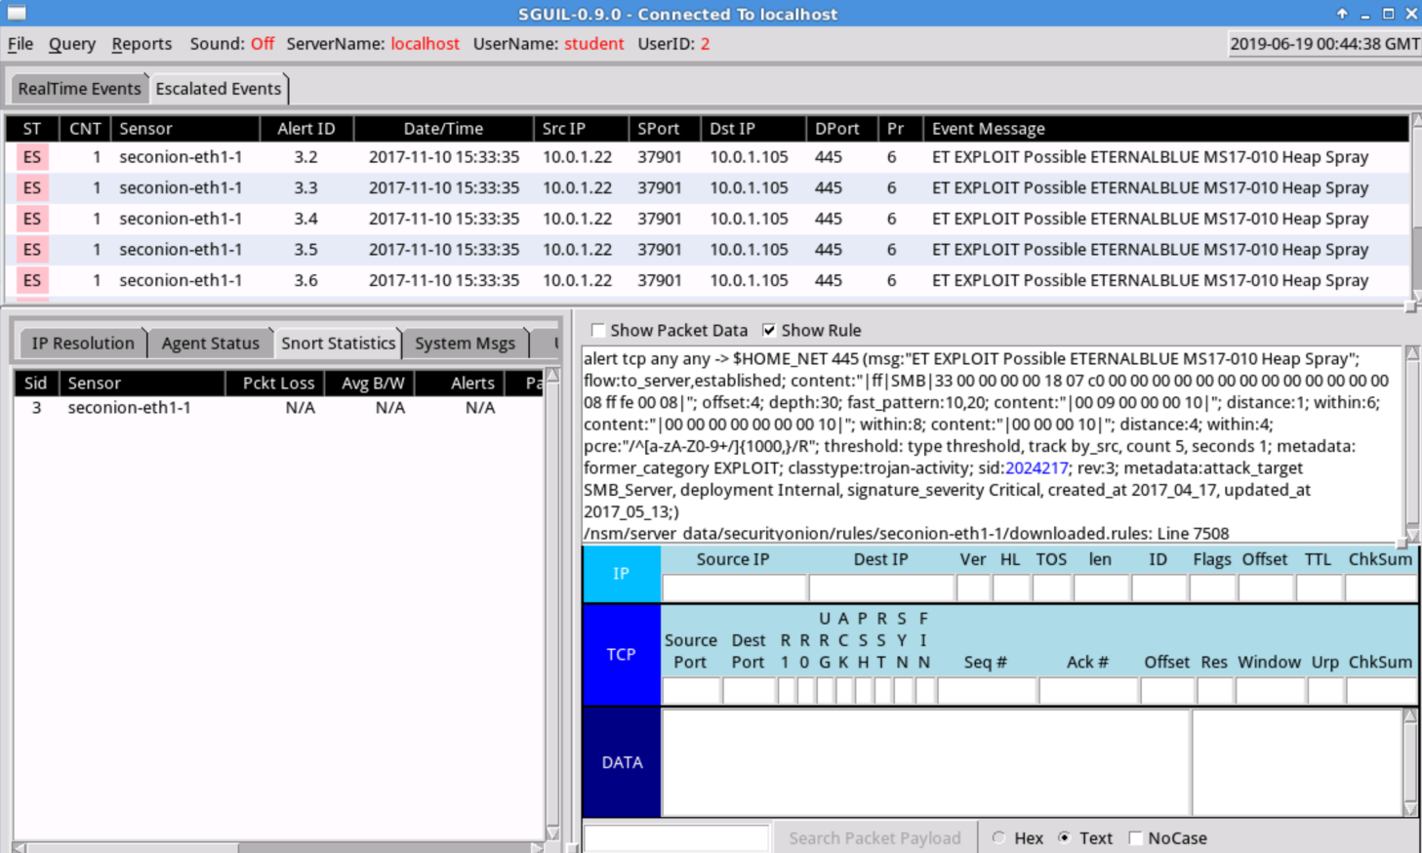

### 7.2.8 Exploit/Scanner

The type of scanner or exploit used in the attack needs to be recorded. This information can be found in the **Snort alert** that was tripped in **SGUIL**. Look in the **Event Message** column next to the alerts in SGUIL. An **MS** or **CVE** number is sufficient for reporting the type of exploit attempted. Select the **Alert 3.10** and click the **"Show Rule**" checkbox in the lower right-hand corner.

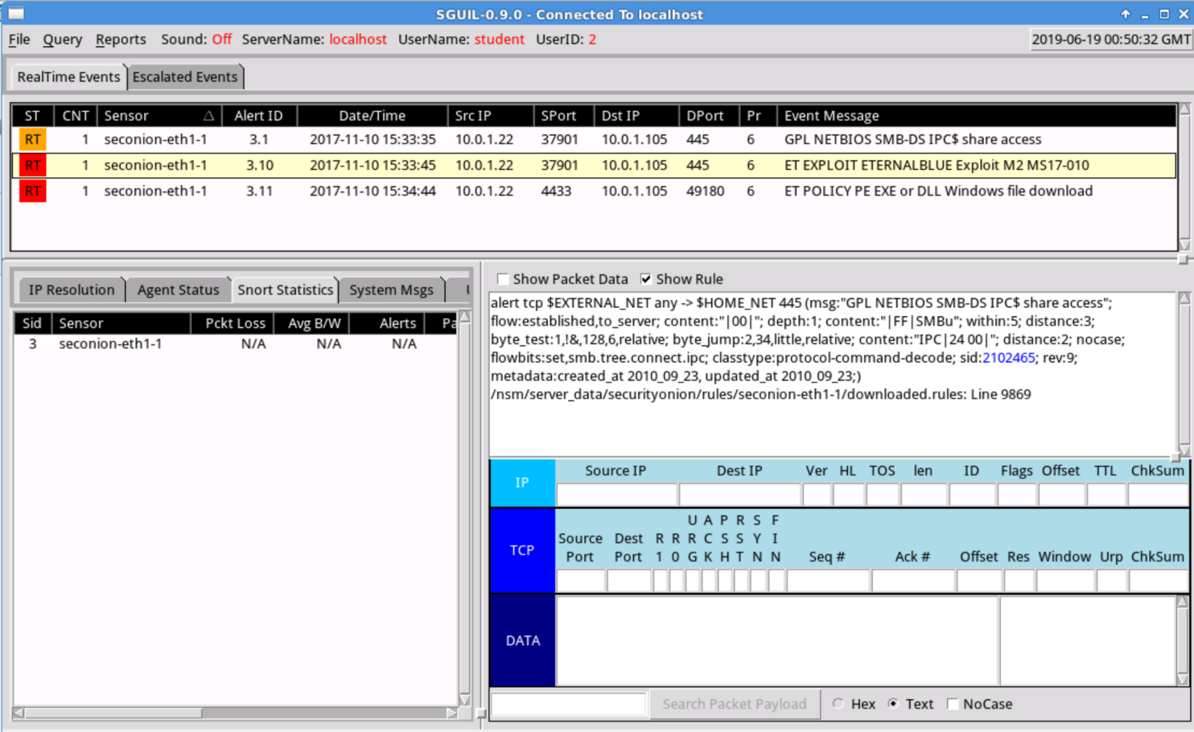

### 7.2.9 Exploit Continued

Review the Rule and find the **CVE** and **MS[1]** numbers referenced for the attack. Record them in the proper field.

**CVE-2017-0143** and **MS17-010**

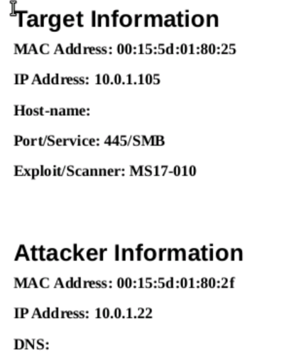

### 7.2.10 Save the Report

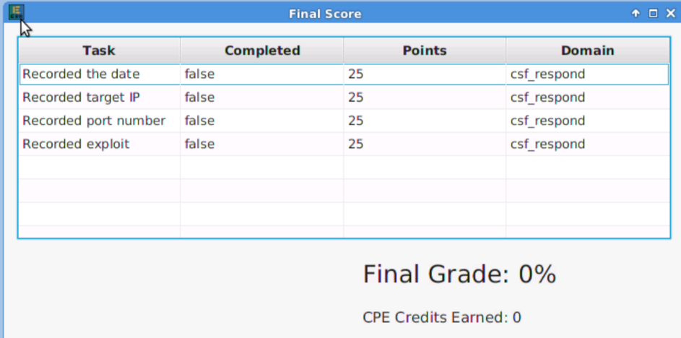

# 08 RESPOND CHALLENGE

|  |  |
| --- | --- |
| TASK | KEY PERFORMANCE INDICATORS |
|  |  |
|  |  |
|  |  |
|  |  |

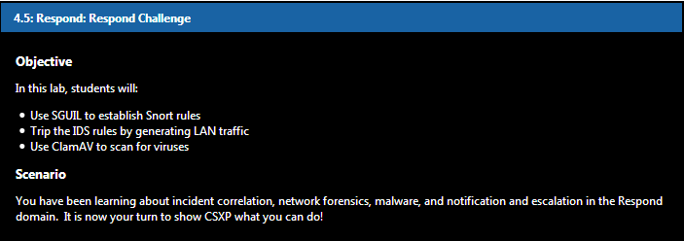



## 8.1. Respond Challenge

### 8.1.1 Adding IDS Rules

Do not forget to update the rules !!! Log in the to the Security Onion VM with the following credentials:

username: **student** password: **isaca**. Add a snort rule for all ICMP traffic.

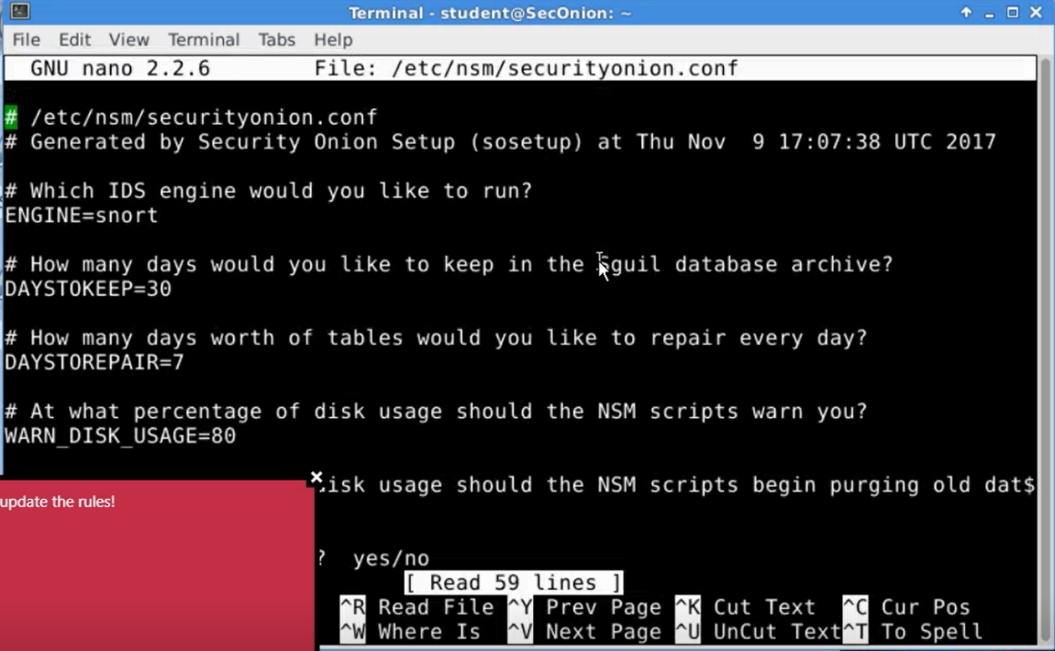

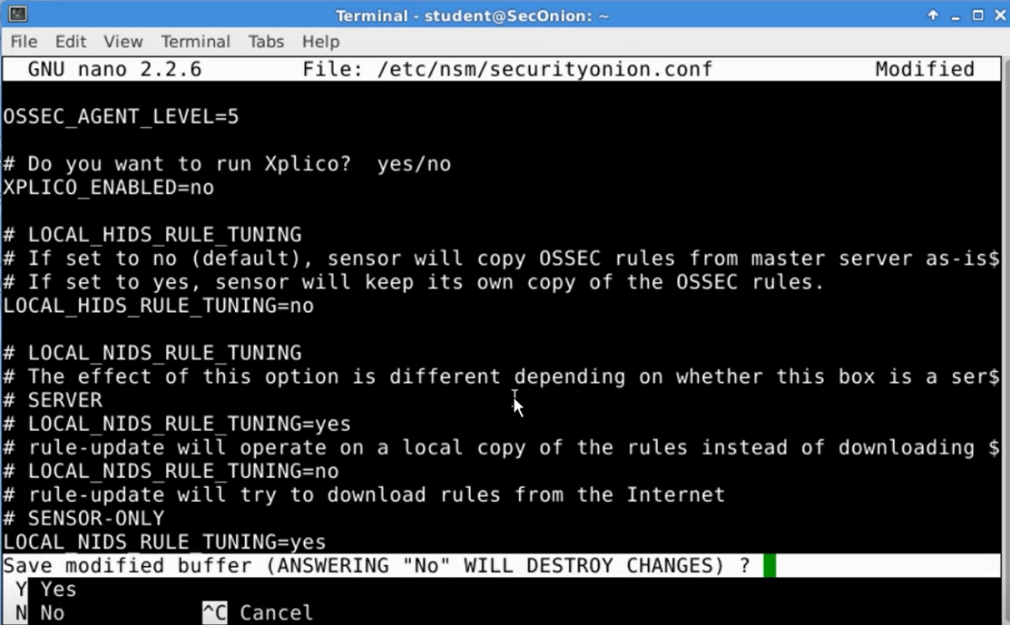

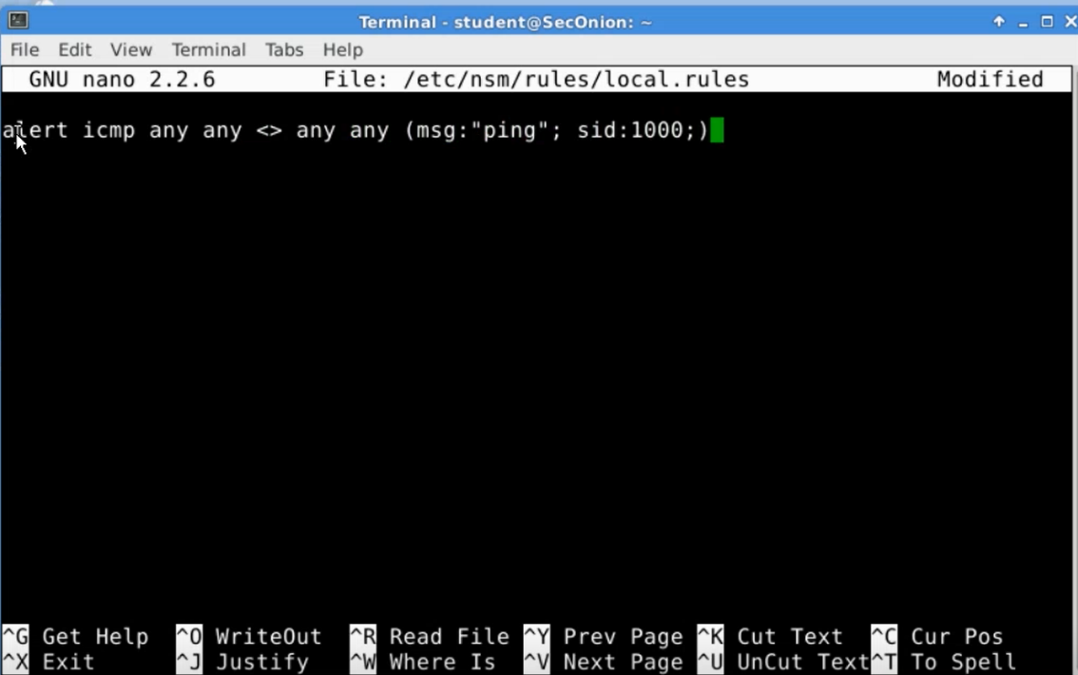

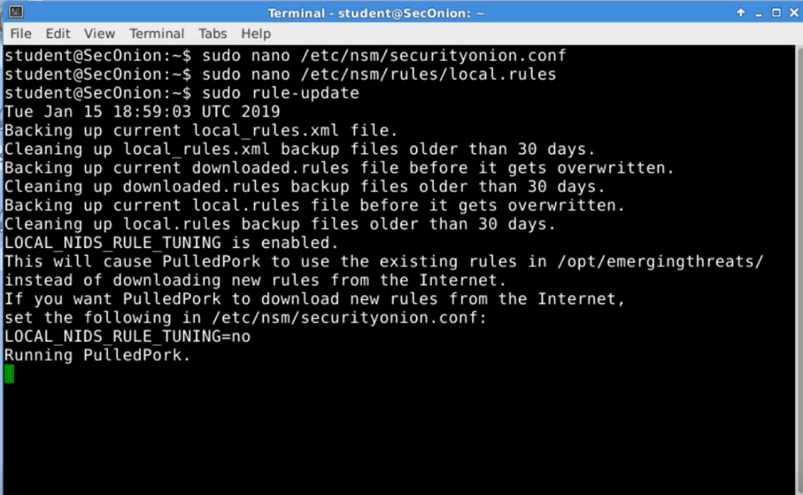

### 8.1.2 Login to Kali

Go to the machine tabs and click on Kali. Login to Kali. Username: root Password: isaca. DO NOT LOG OUT

### 8.1.3 Utilizing Kali via SSH

Change back to the SecOnion VM. Use **SSH** to remotely log in to the Kali VM at 10.0.1.2 with the following credentials: username: root password: isaca

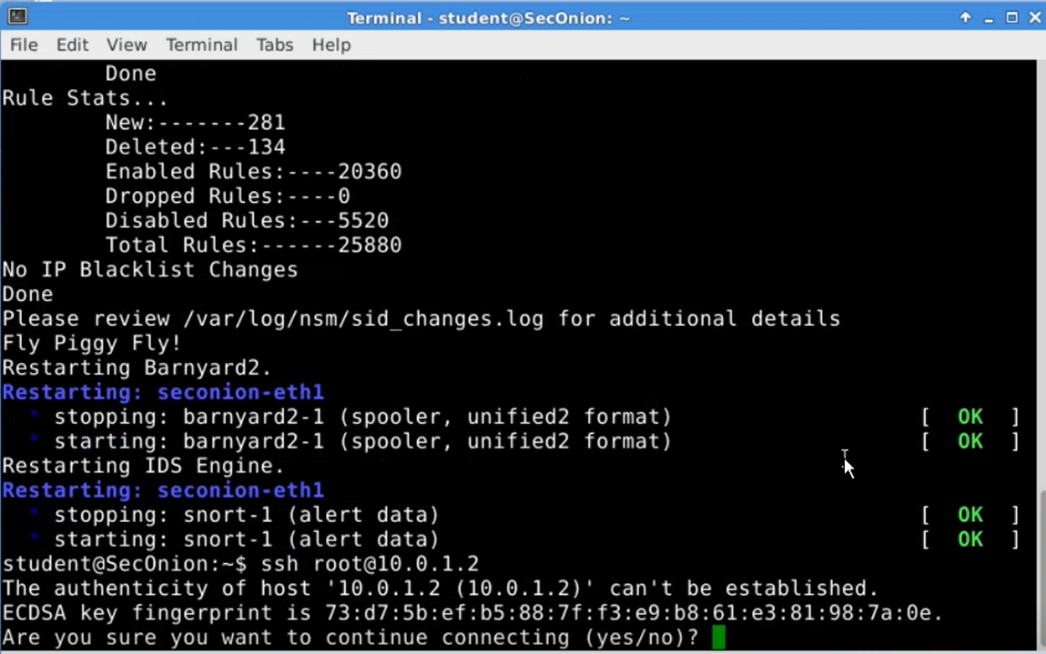

### 8.1.4 Tripping the IDS

Send **ICMP** echo requests to the **Security Onion VM** to trip the IDS.

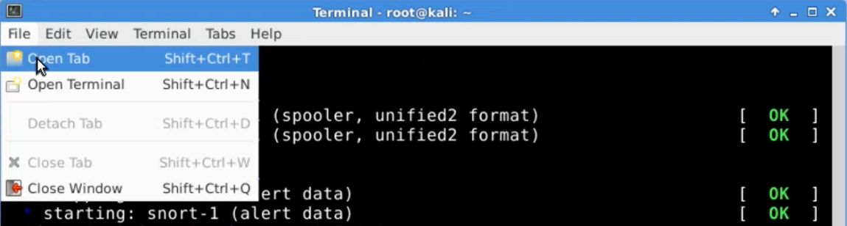

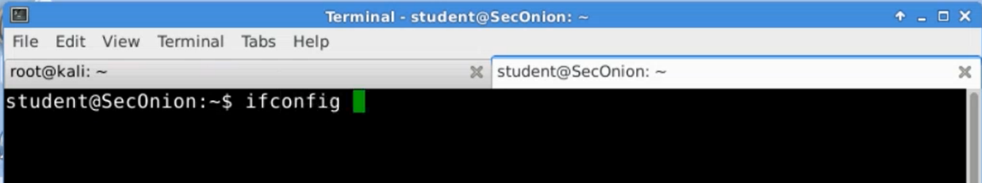

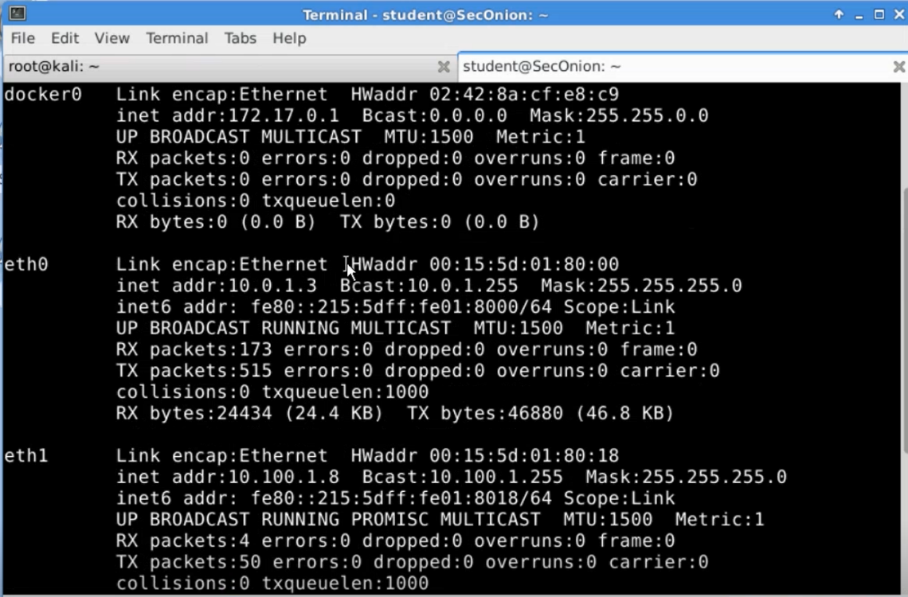

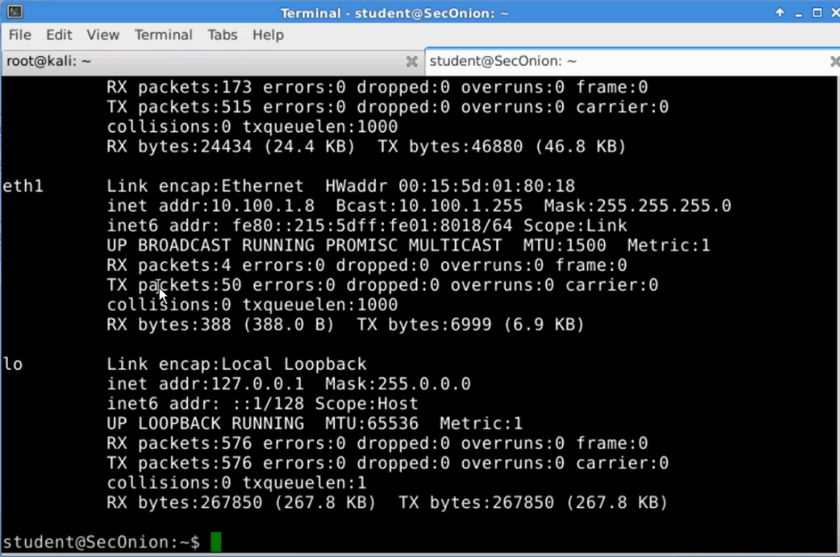

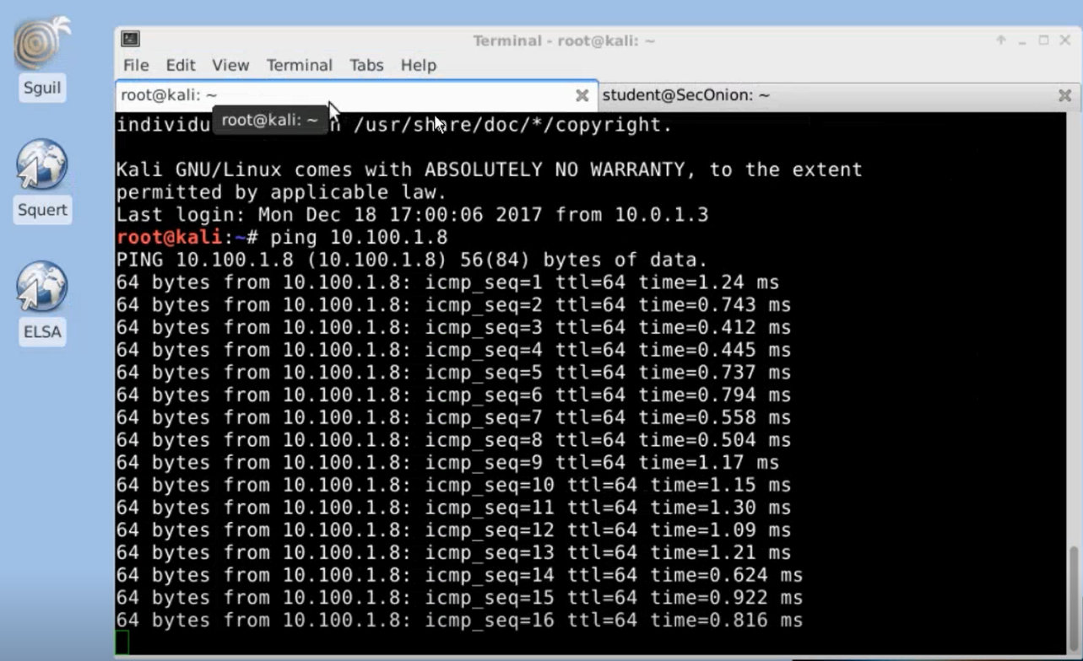

### 8.1.5 Checking SGUIL

Log in to **SGUIL** with the following credentials: username: **student**; password: **isaca11** - Check to make sure the ICMP echo requests tripped the new snort rules.

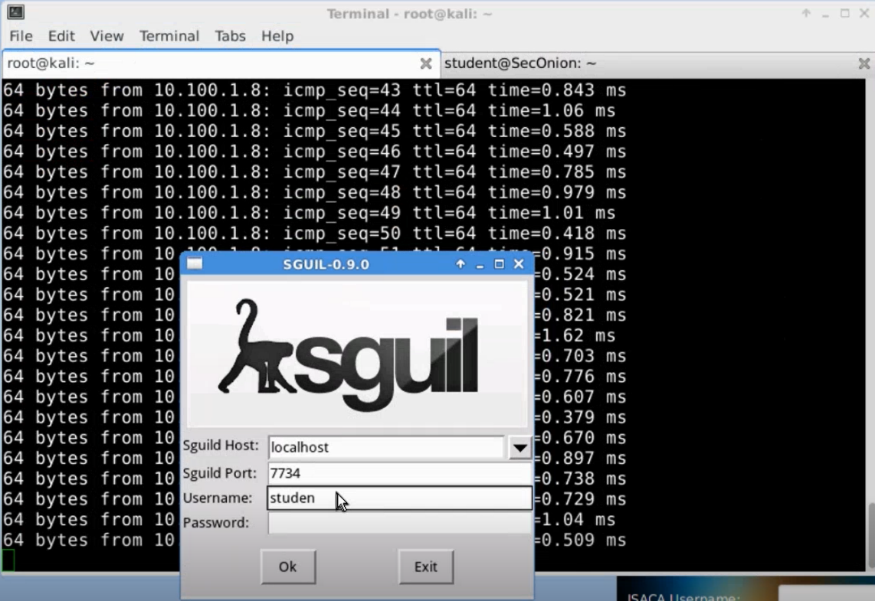

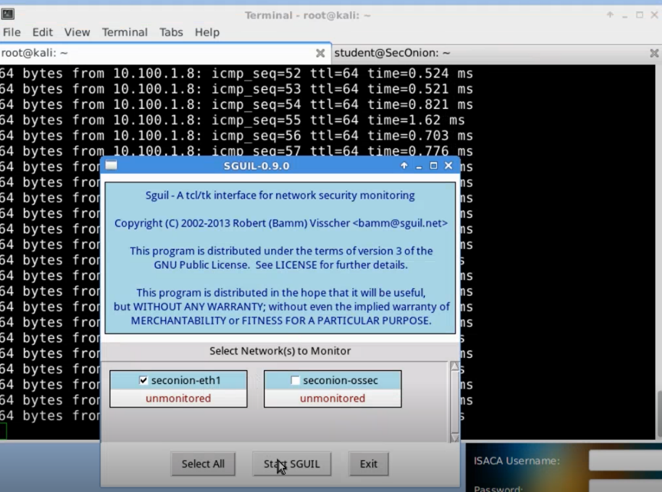

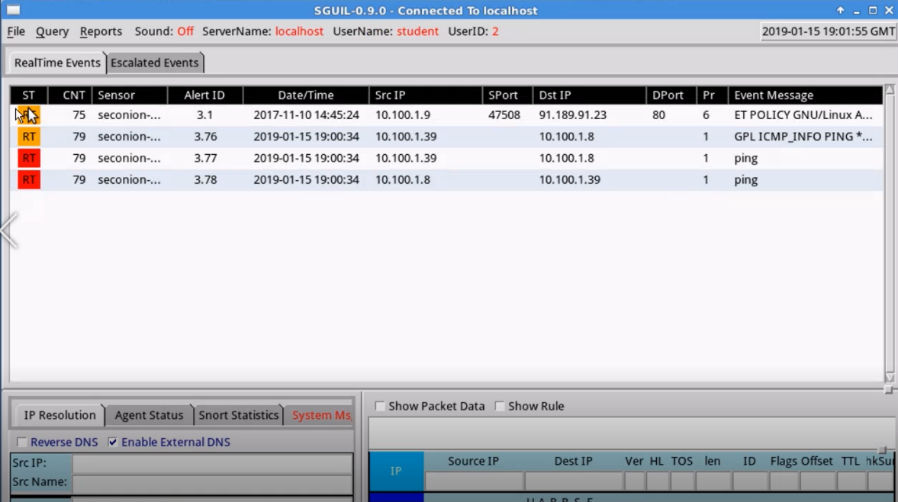

**Orange color**: alerts are generic from snort - **Red color**: custom (done with ping)

### 8.1.6 Scanning for Virus

In Kali, find **script.sh** and **malware.sh;** run **ClamAV** scan against each of them. No matter the results, delete both files.

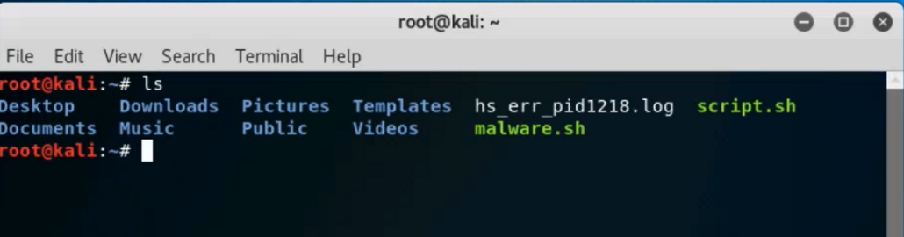

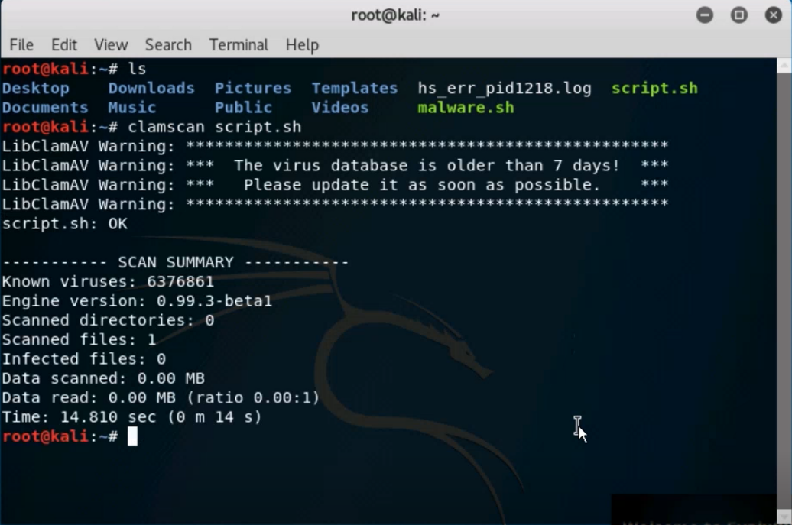

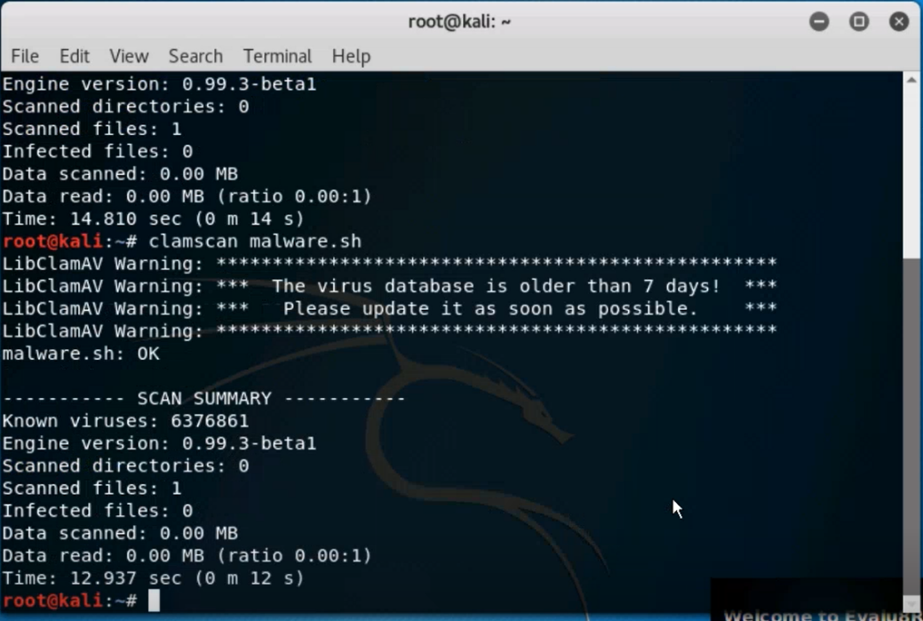



### 8.1.7 Exiting

In Kali, close terminal. In Security Onion, close SSH connection. Exit terminal session. Close SGUIL window

# 09 RE-IMAGING

|  |  |
| --- | --- |
| TASK | KEY PERFORMANCE INDICATORS |
|  |  |
|  |  |
|  |  |
|  |  |

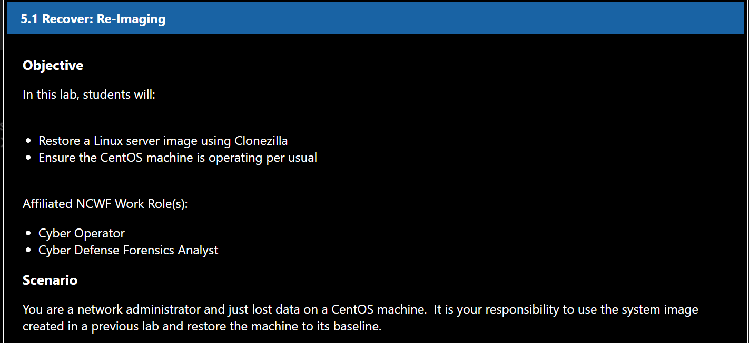

## 9.1 Full Server Restore

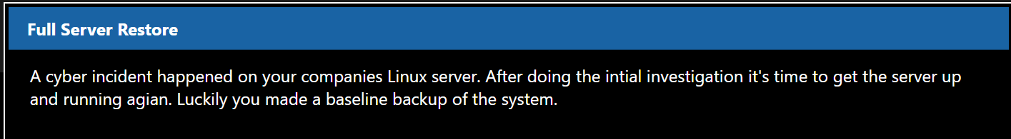

### 9.1.1 Clonezilla DVD

Select the **Clonezilla** DVD image under the DVD Drive dropdown menu.

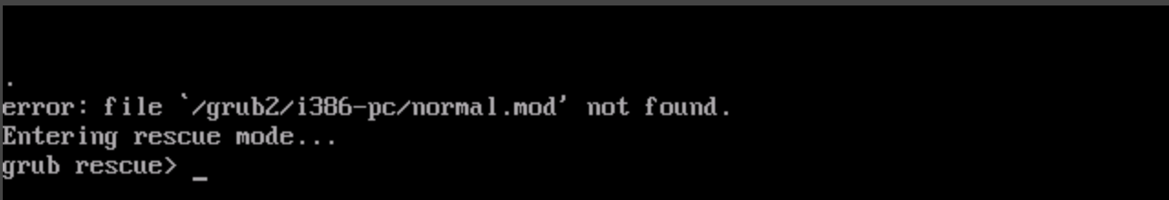

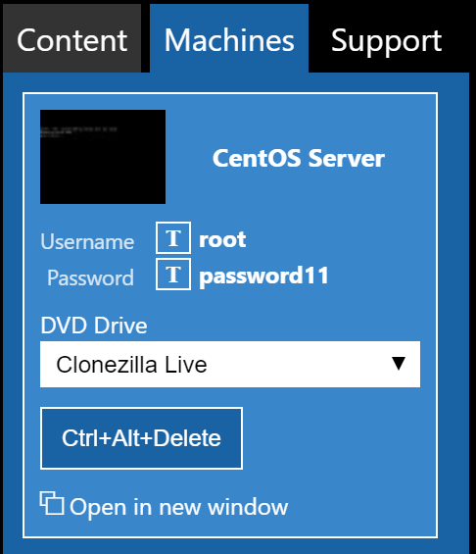

### 9.1.2 Reset CentOS Machine

Reset the CentOS machine by clicking on the following in the upper right-hand corner of the screen:

Lightning Bolt -> Power -> Reset/Reboot Machine

### 9.1.3 Boot Clonezilla Live

Allow Clonezilla Live to boot.

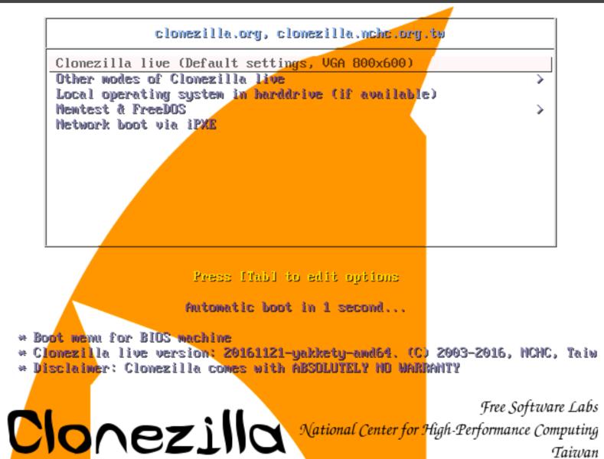

### 9.1.4 Select Language

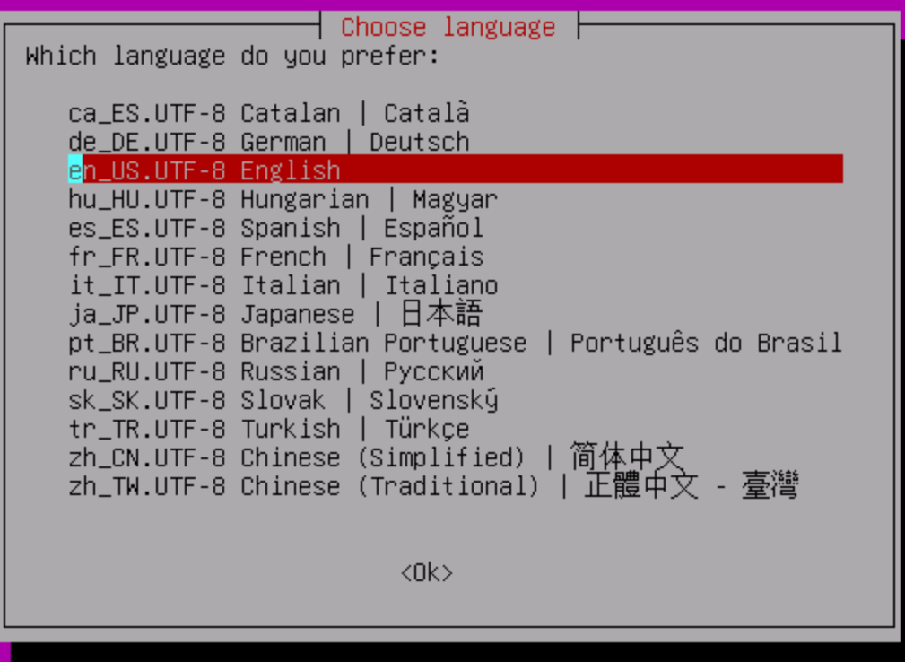

### 9.1.5 Keymap

Select the default keymap settings.

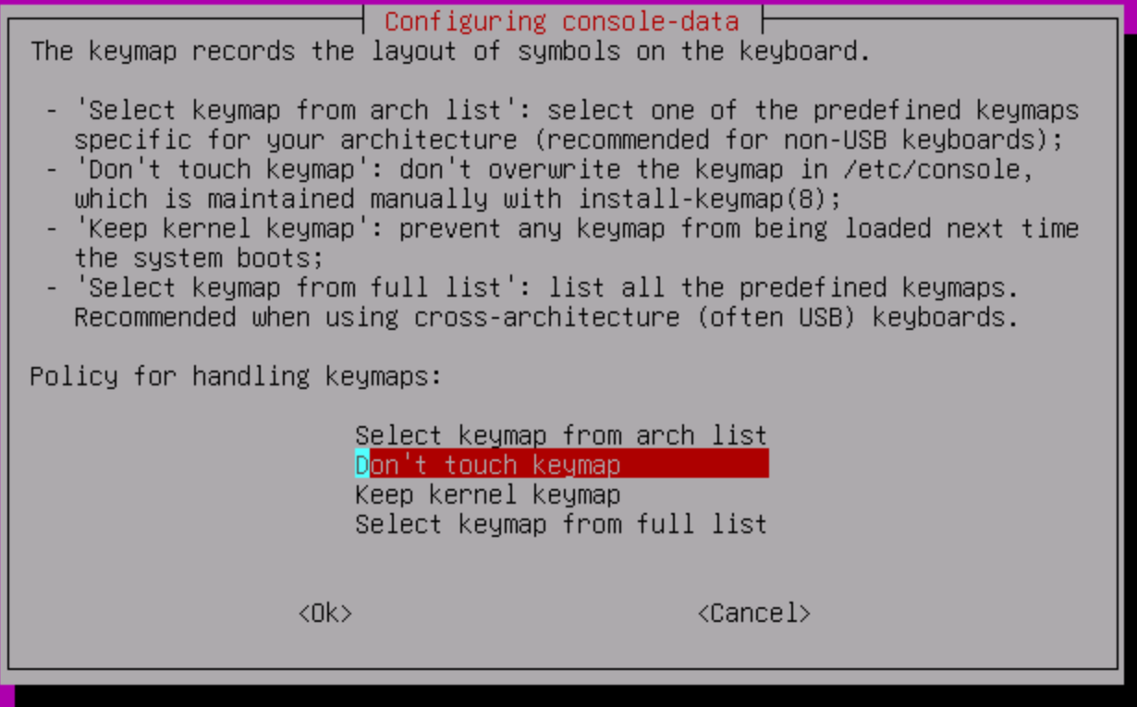

### 9.1.6 Start Clonezilla

Start the Clonezilla menu driven application by pressing enter on **Start Clonezilla**.

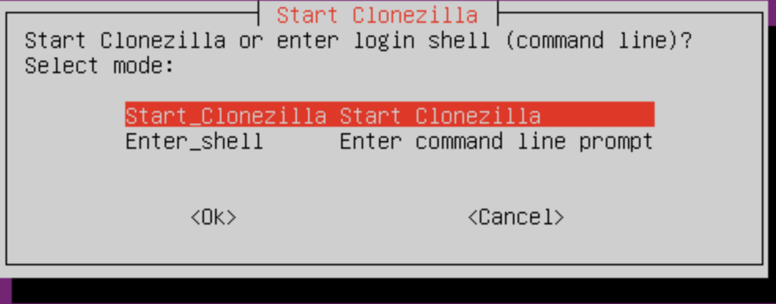

### 9.1.7 Device to Image

Select Device->Image. This allows you to save the contents of a disk to a file as opposed to cloning to another drive.

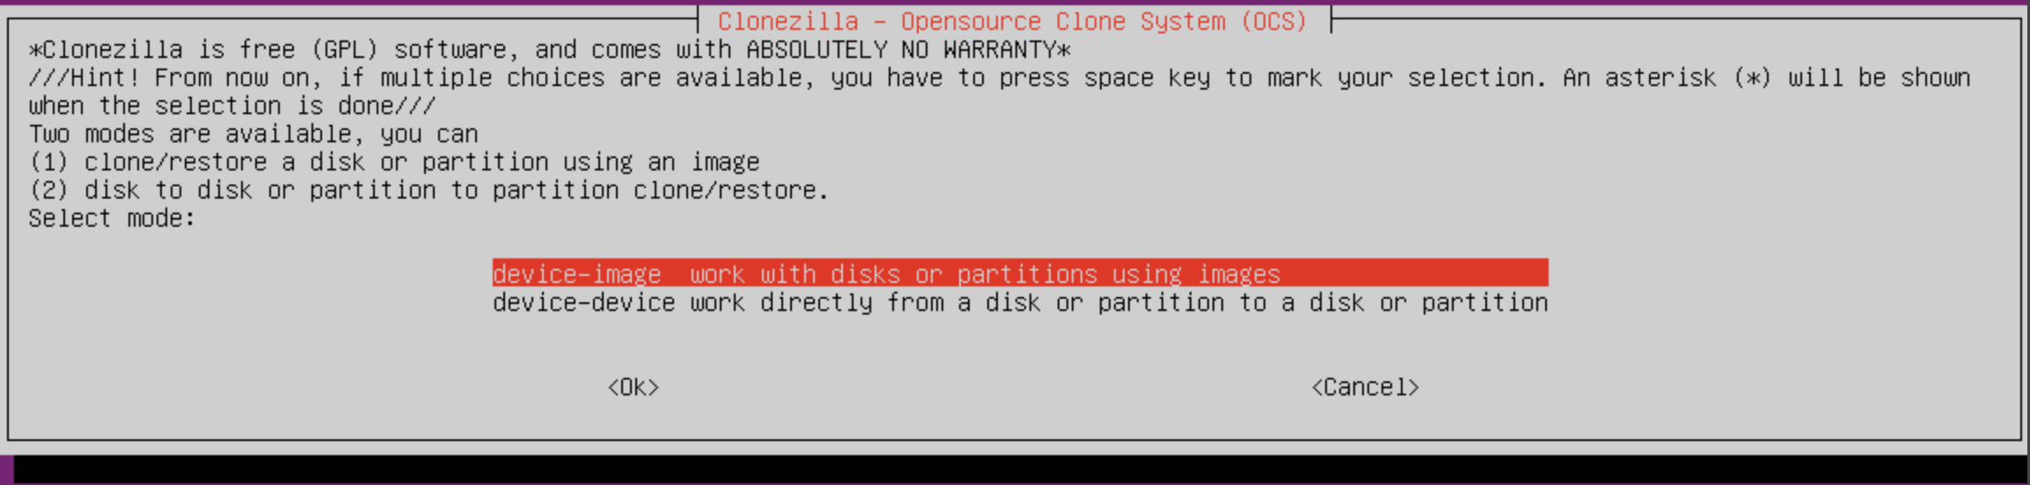

### 9.1.8 Connect to Windows File Server

Select **Samba Server** from the list. This will allow you to connect to a Windows File Server to save the image to.

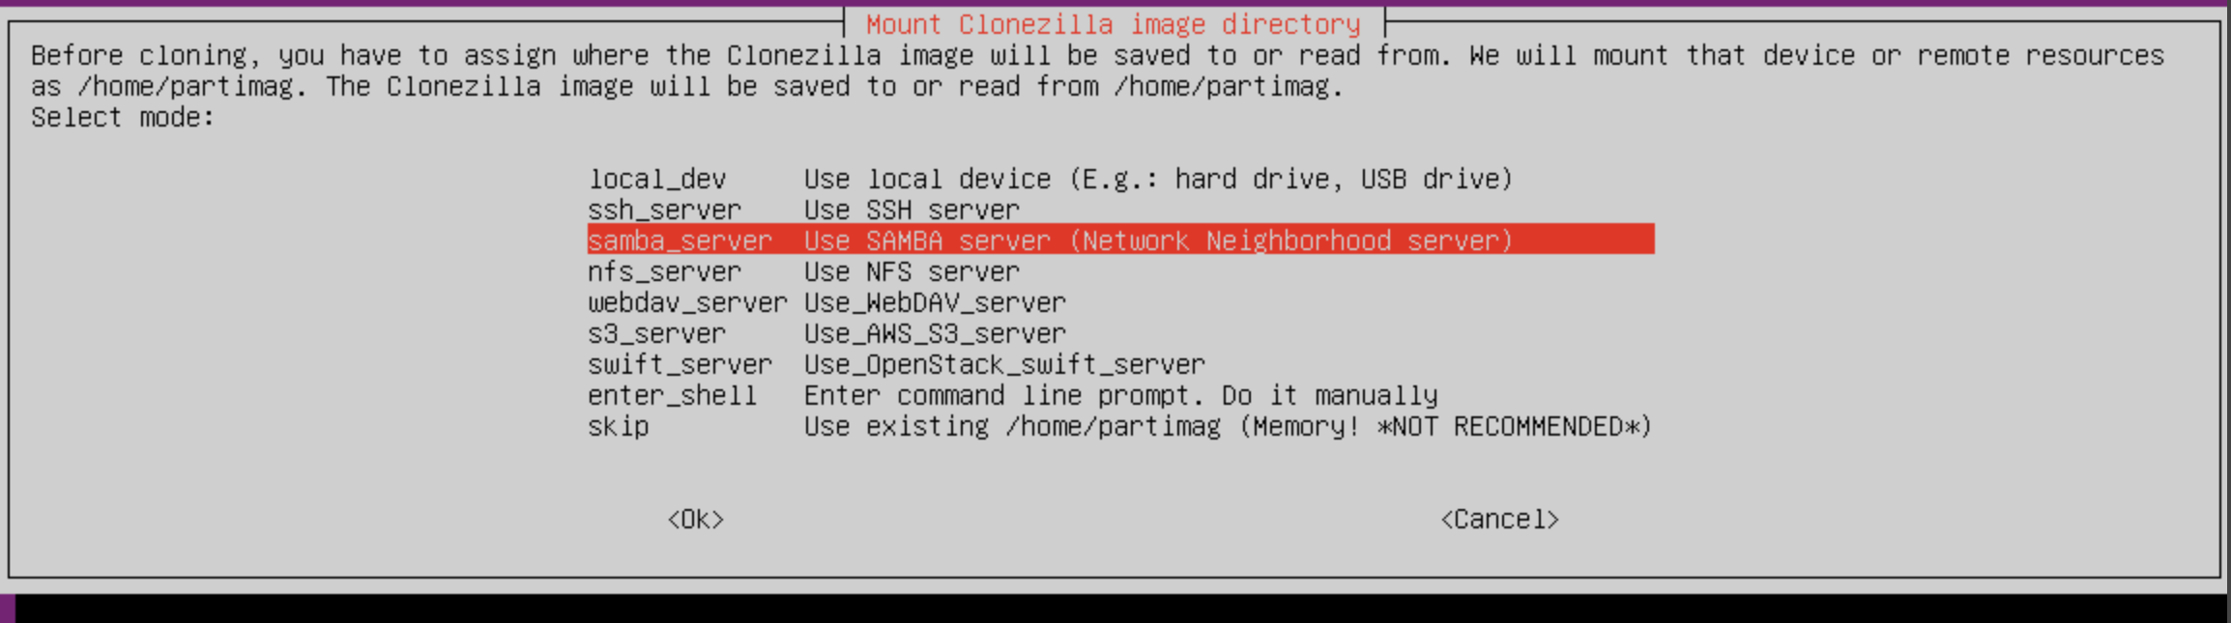

### 9.1.9 Setup Network

We need to setup our NIC to communicate on the LAN network. Select **eth1** from the list of NIC devices to set up the static IP address.

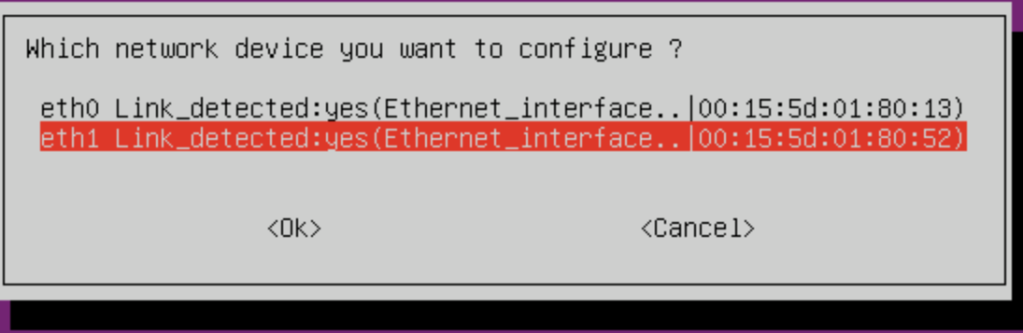

### 9.1.10 Static

Select Static to setup a static IP.

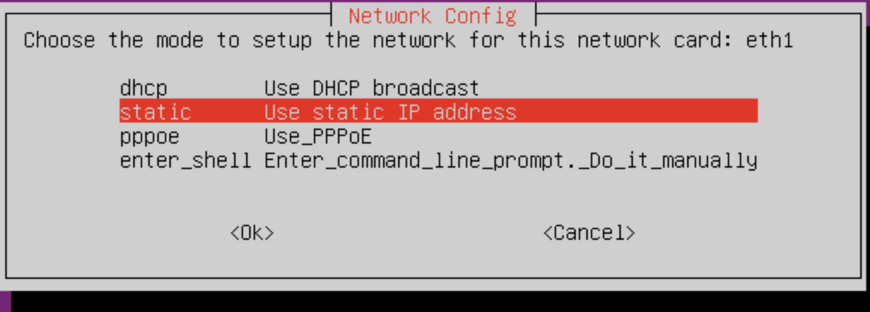

### 9.1.11 IP Address

Set the IP address to **10.0.1.99**. No significance to this IP address: it is only an unused IP address on our LAN network.

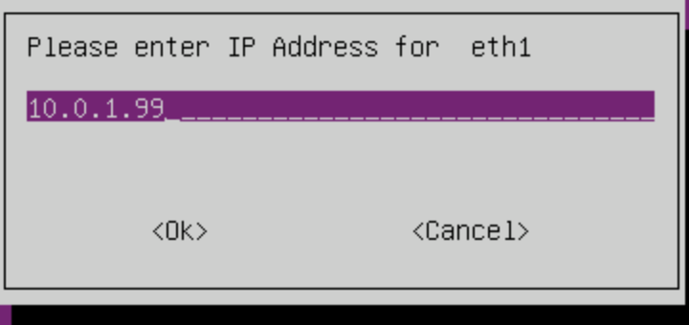

### 9.1.12 Subnet

Keep the subnet at **255.255.255.0**.

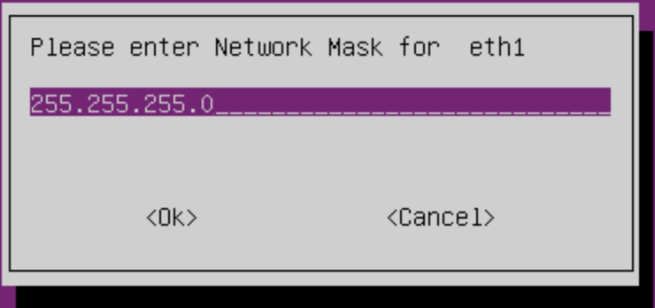

### 9.1.13 Default Gateway and DNS

Set the Default Gateway to **10.0.1.1**. Set DNS (Name Server) to **10.0.1.1**.

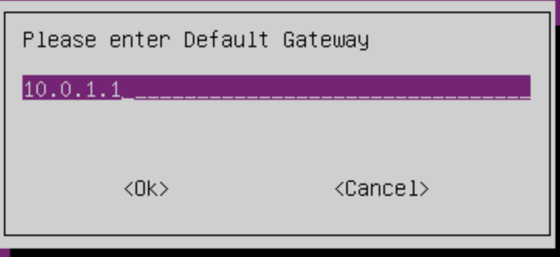

### 9.1.14 Connect to File Server

Enter **10.0.1.5** as the IP address of the File Server.

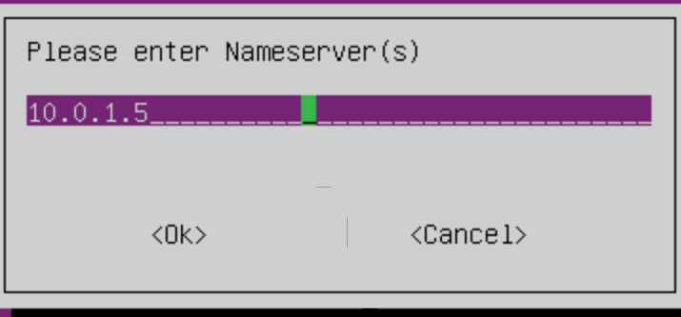

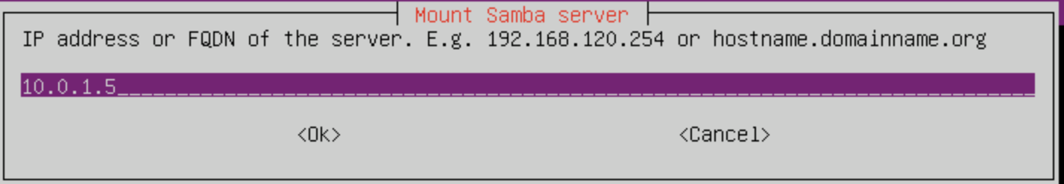

### 9.1.15 Domain

Enter **ISACA** for the domain.

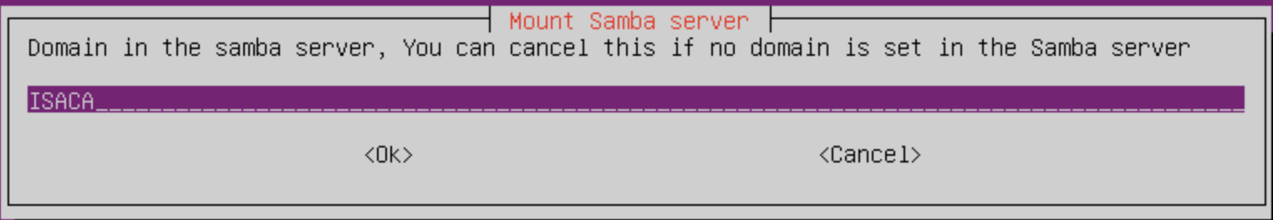

### 9.1.16 Username

The username for the file server is: **itadmin**

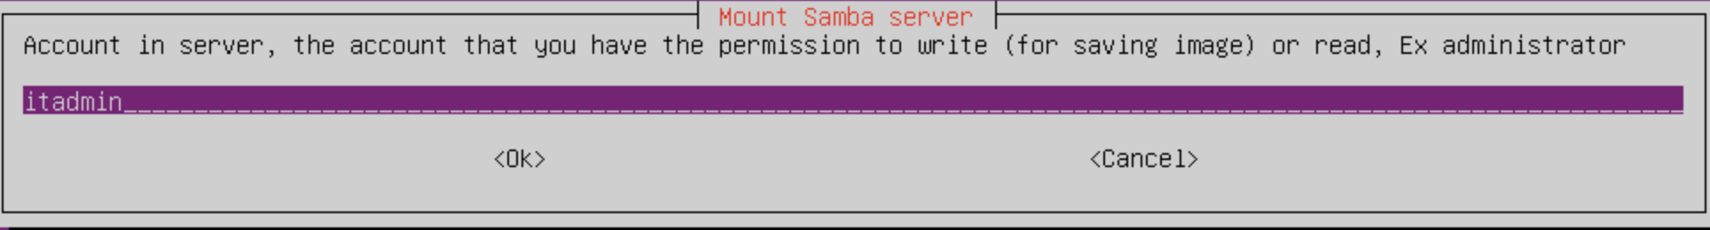

### 9.1.17 Image Directory

Keep the image directory as the default: /images

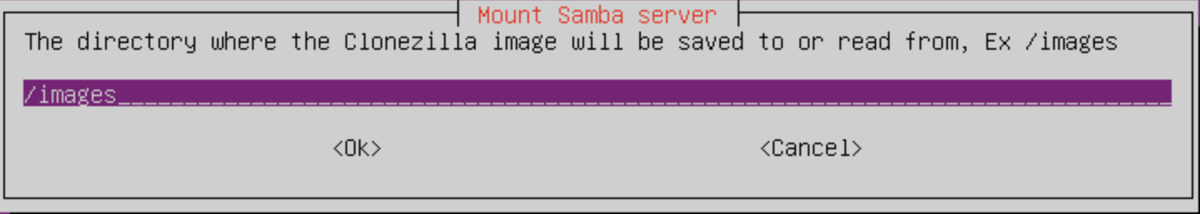

### 9.1.18 Security Mode

Select auto for the login security mode.

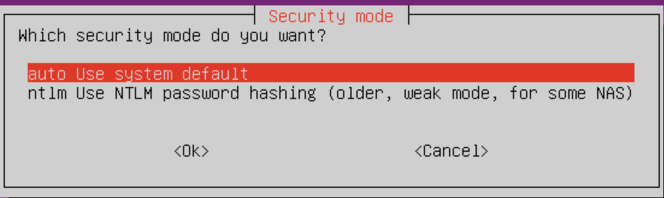

### 9.1.19 Password

The GUI will drop into a console for you to enter the password. Enter the password: **IamanIT!**

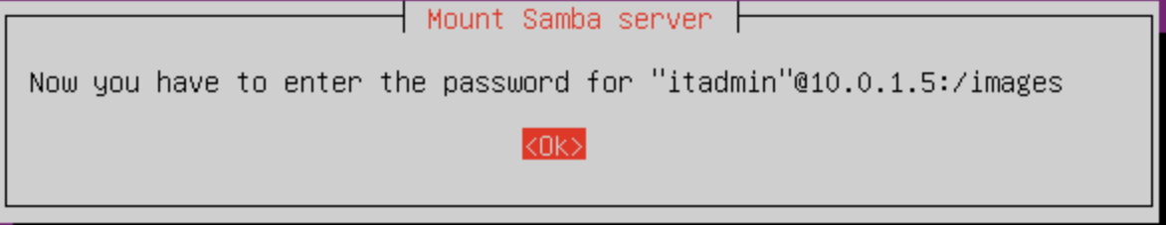

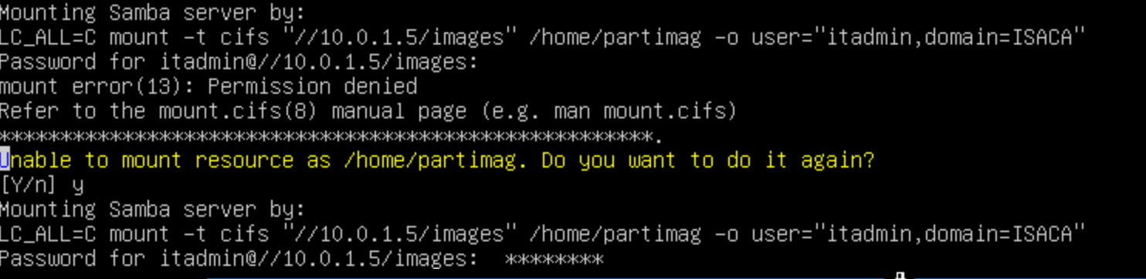

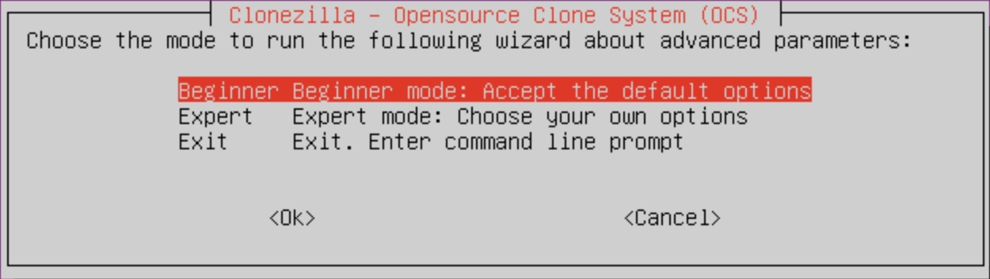

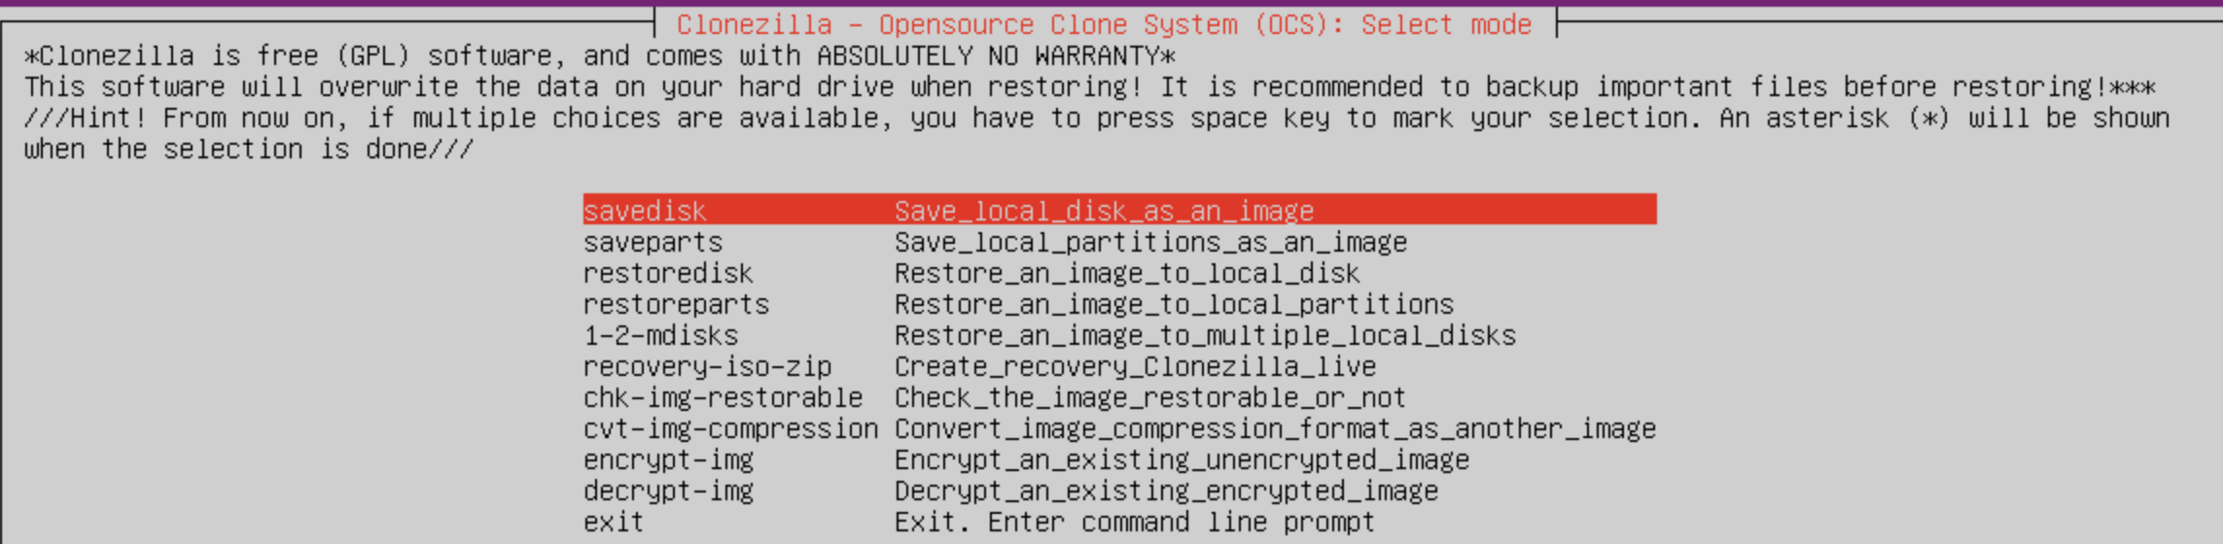

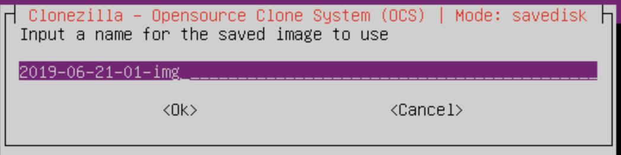’



### 9.1.20 Connection Confirmation

Once connection is completed a summary windows will pop up with disk usage information of the file server.

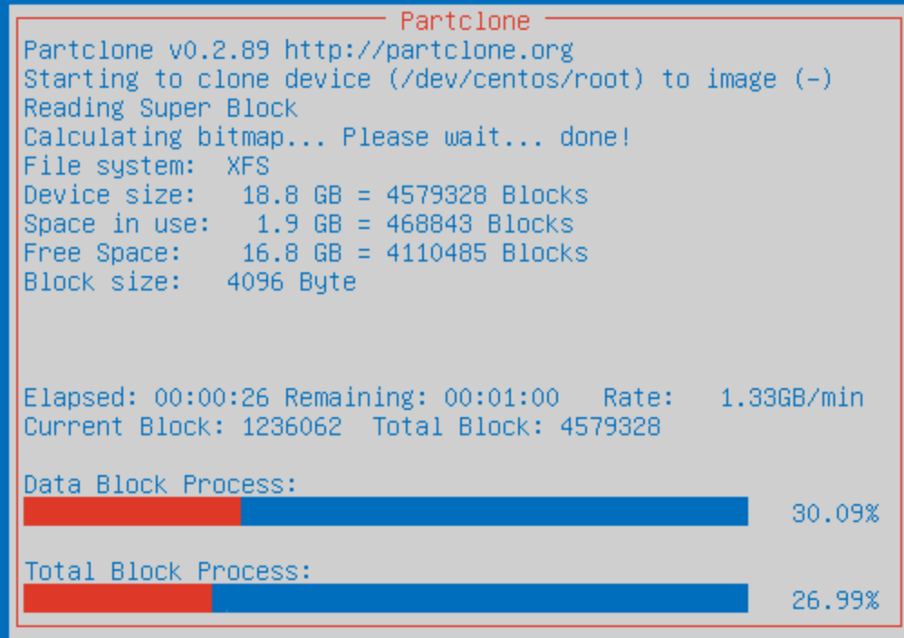

### 9.1.21 Beginner Mode

Select **Beginner mode** to continue.

### 9.1.22 Restore Disks

Select **Restore Disk** to start the imaging process.

### 9.1.23 Choose the Image

Choose the CentOS Image: **CentOS_Server_Baseline**

### 9.1.24 Select Drive

Select the drive to image. There is only one on this VM so select sda and continue.

### 9.1.25 Skip Checking

Select **Skip Checking** to skip the checking of the file system.

### 9.1.26 Skip Checksum

Select **Skip to skip the checksum** of the image file.

### 9.1.27 Select Reboot

Select **Skip to skip the checksum** of the image file.

### 9.1.28 Final Options

Clonezilla wants to make sure that the user understands that the entire hard drive is about to be overwritten.

Press Enter. Press Y and Enter to let Clonezilla know that you understand the risk.

Press Y and Enter to let Clonezilla know that you REALLY understand the risk.

### 9.1.29 Wait

Congratulations the device is being restored! This will take a few minutes.

### 9.1.30 Completed

When the imaging has been completed the server should reboot and boot into your fresh CentOS Baseline Image!

# 10 RESTORE POINTS AND PASSWORD RECOVERY

|  |  |
| --- | --- |
| TASK | KEY PERFORMANCE INDICATORS |
|  |  |
|  |  |
|  |  |
|  |  |

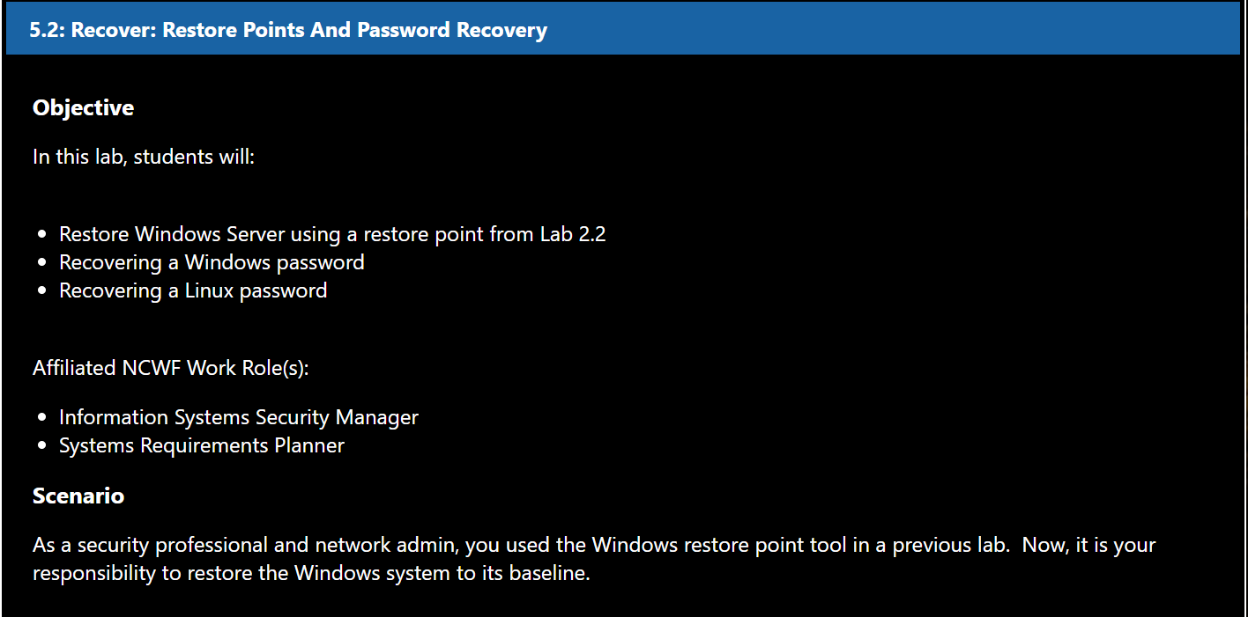

## 10.1 Windows Restore Point



### 10.1.1 Login

Login to the Windows 10 VM as employee. Use password **employeepassword**.

### 10.1.2 Open Restore Point

Type "**Restore Point**" in the Windows search bar. Select "Create a Restore Point".

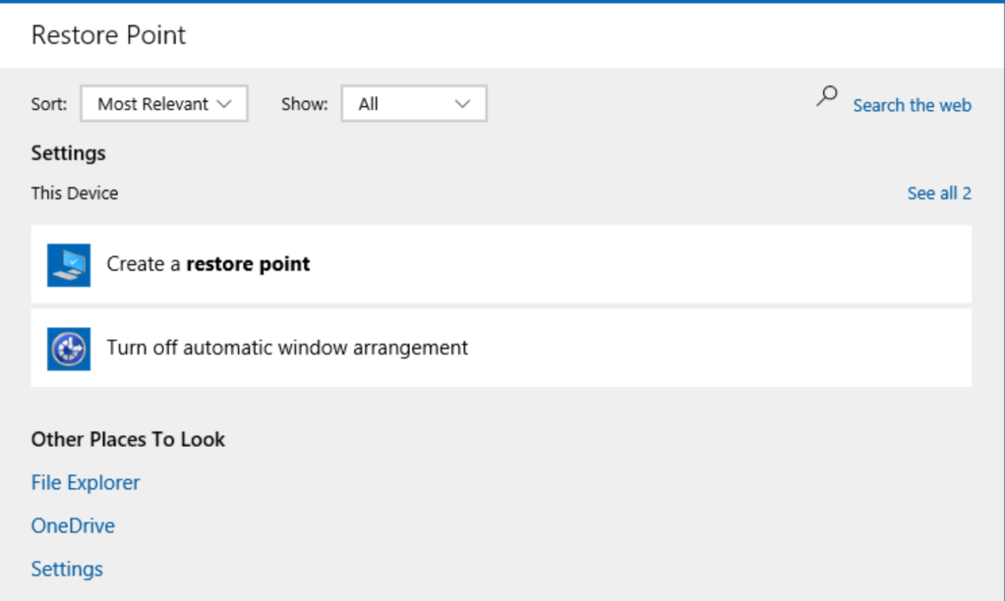

### 10.1.3 System Restore

From the menu select System Restore. In the new window, hit Next.

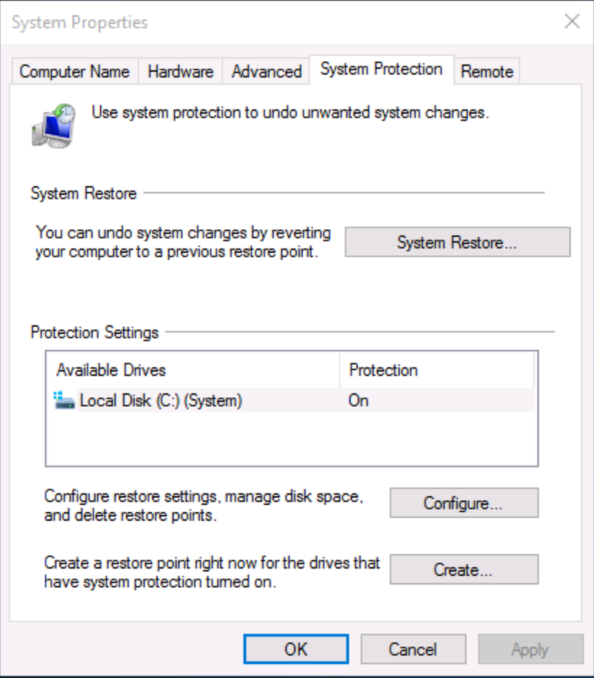

### 10.1.4 Restore Selection

From the next menu, highlight the "Baseline" restore point. Click Next.

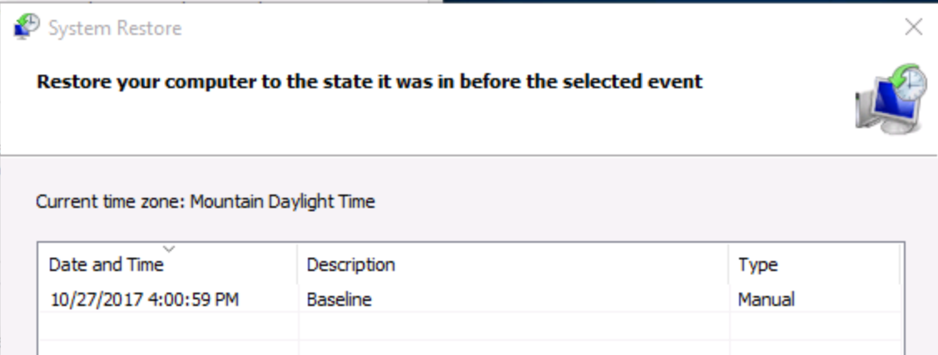

### 10.1.5 Confirmation

On the confirmation page, select Finish. In the pop-up asking if you want to continue, select Yes.

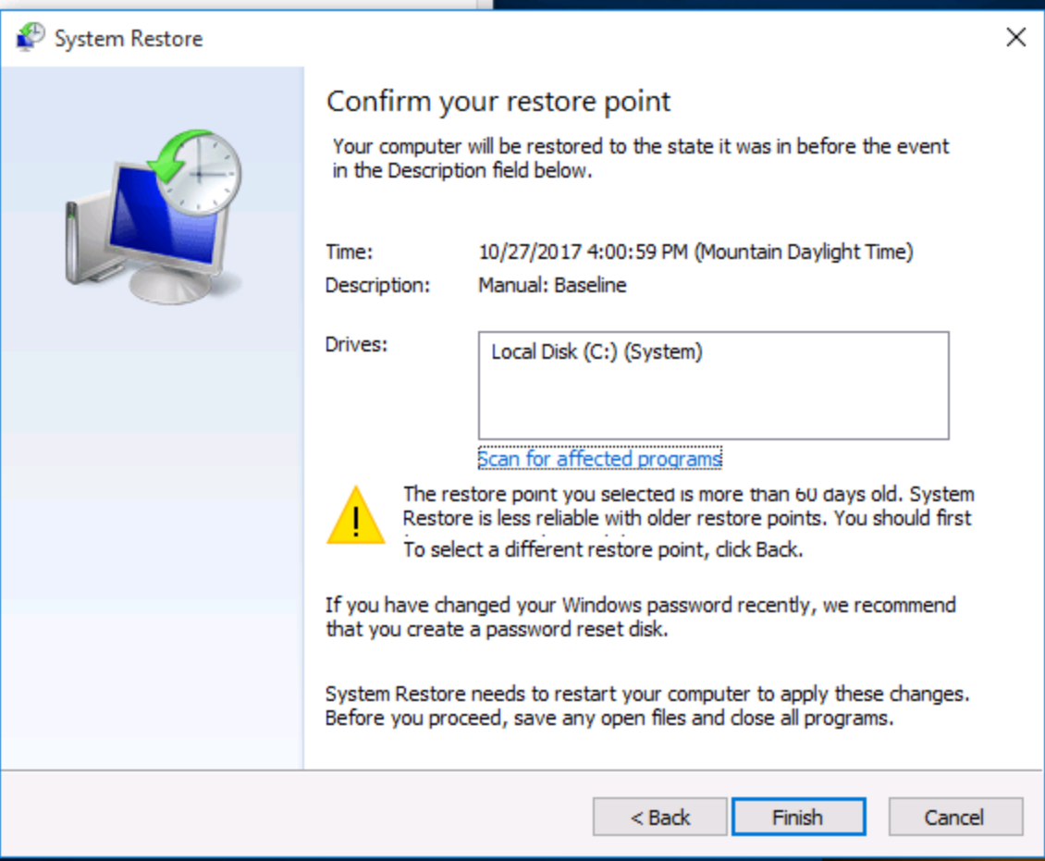

### 10.1.6 Restoration

Your Windows VM should now be restarting. This process will take 4-5 minutes, so please be patient. When the installtion has completed, log back into the VM with the same password as before. You should see a message saying the restoration was successful.

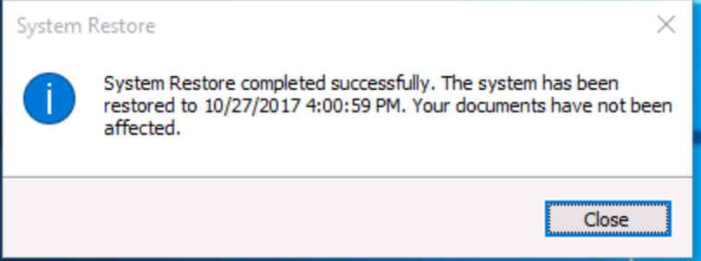

### 10.1.7 Turning off the firewall

Go to the Control Panel. Click **System and Security > Windows Firewall > Windows Turn Firewall on or off**. Turn off the firewall for both public and private network settings. Click OK and close the window.

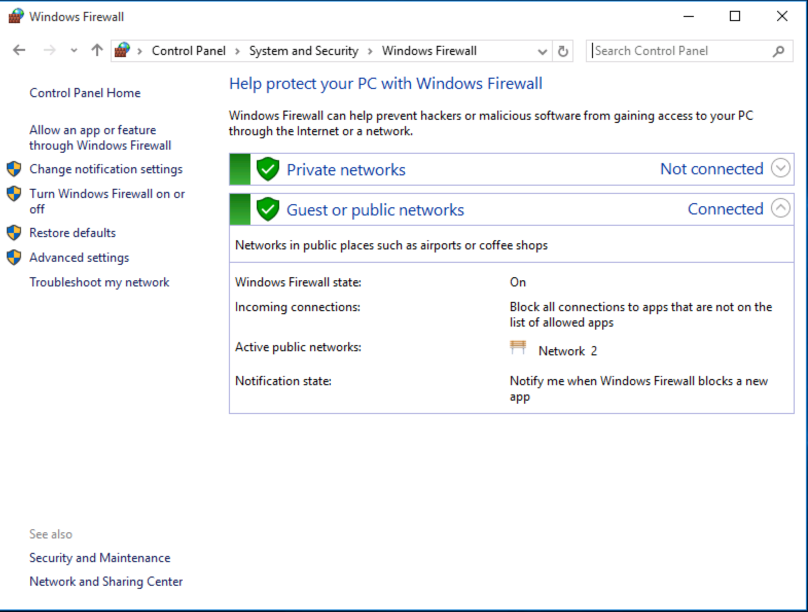

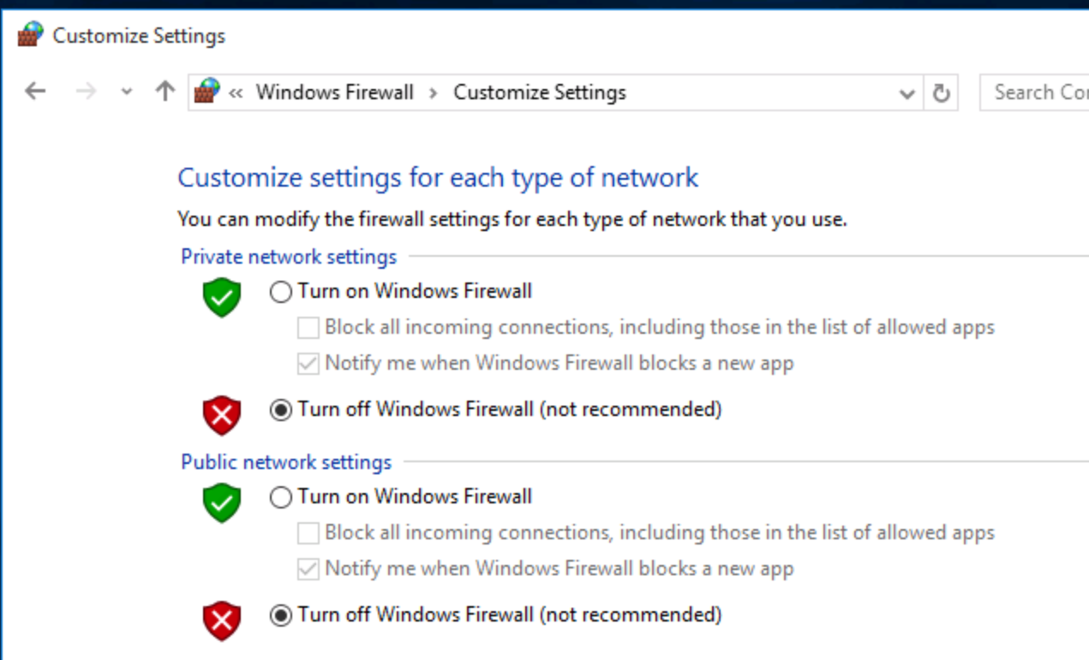

## 10.2 Windows Password Recovery

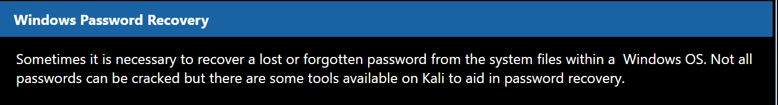

### 10.2.1 Login to Kali

Login to the Kali box.

### 10.2.2 Review the files

Navigate to the /root/Desktop/Windows directory via the CLI. Here you'll see the system file and SAM database file for a Windows XP machine. These are located in the C:\Windows\System32\config folder.

These are the two files that are necessary for cracking this specific OSs password.

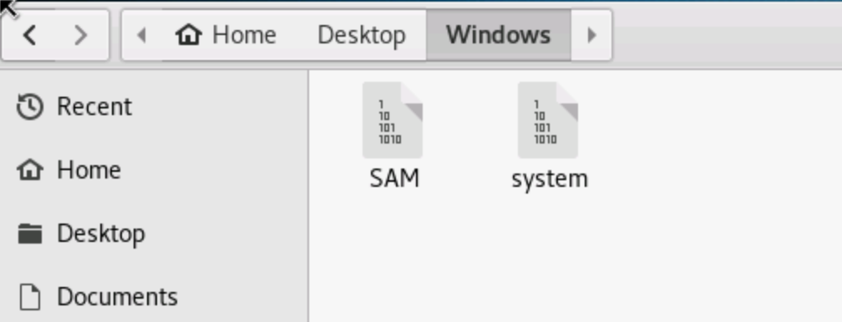

### 10.2.3 samdump2

The samdump2 application is a **Windows SAM** database dump that requires both the SAM and system files to render the Usernames and hashes of the passwords in the SAM file. Type samdump2 into the CLI and press enter for instructions on how to execute this program.

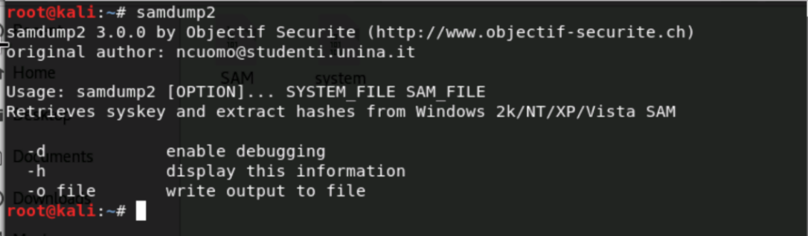

### 10.2.4 Extracting Hashes

The **samdump2** command has an input of **samdunp2 [system file] [SAM file]**. In the CLI from the **/root/Desktop/Windows** directory run: **samdump2 system SAM**. This will display a list of usernames with hashes.

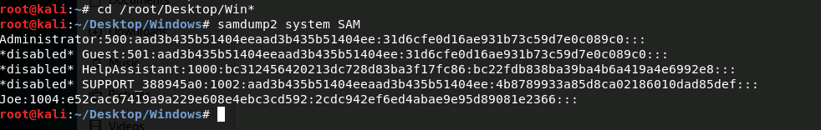

### 10.2.5 Redirecting Output

We want to redirect the output of this to save the hashes to a file so we can crack it. Run:

**samdump2 system SAM > hashes.txt**. This will place the output of samdump2 into the hashes.txt file

### 10.2.6 Crack the Hash

Now that we have extracted the hashes from the SAM file we can attempt to crack them with a password cracking program. **John the Ripper** is open source password cracking tool available in Kali. To run it on the hashes.txt file type:

**john hashes.txt**

### 10.2.7 Analyze

Notice from the output that you have a user, Joe, and that Joe's password is separated into two different fields:

PASSWOR and D11. Putting these two together shows that Joe's password is PASSWORD11. Note that while cracking some hashes it is presented in all capital letters even though this may not be the case for the actual password. But hopefully this will jog Joe's memory and he can log into his terminal now.

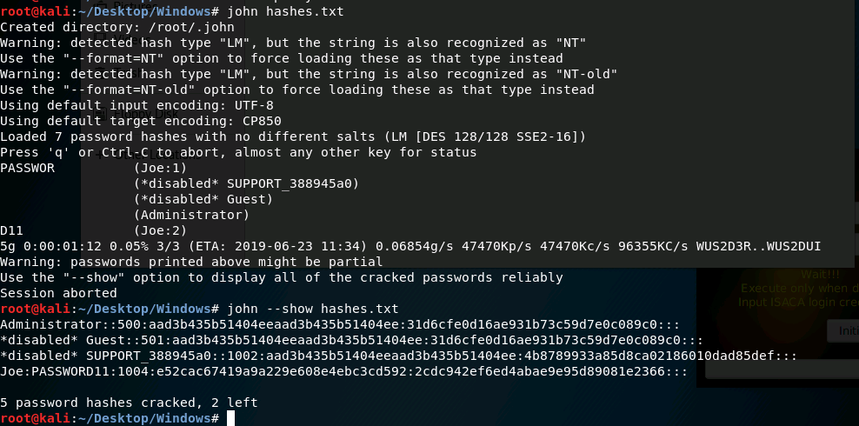

## 10.3 LINUX Password Recovery

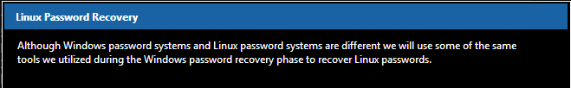

### 10.3.1 Review the Files

Navigate to /root/Desktop/Linux

### 10.3.2 shadow Files

Use the cat program to show the contents of the shadow file: cat shadow. This will show a list of users for this particular Linux system.

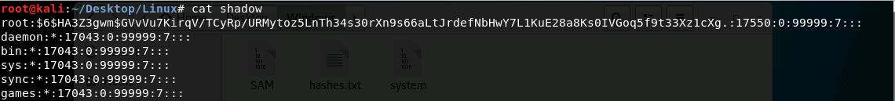

### 10.3.3 unshadow

The **unshadow** command requires the **passwd** file and the **shadow** file from the Linux system. These files are usually located in the **/etc/ folder**. Run the command: **unshadow passwd shadow**. This will display an unshadowed hash of the users' passwords.

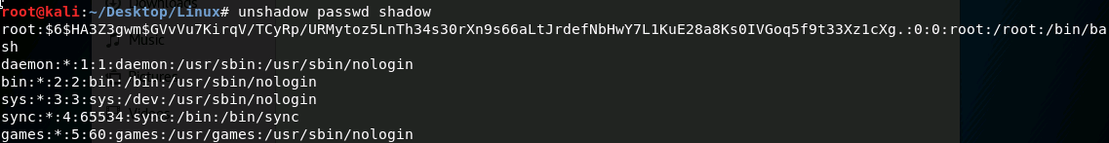

### 10.3.4 Redirecting Output

Save the unshadowed hashes to a file for processing. Run: **unshadow passwd shadow > hashes.txt**. This will save the output to the file hashes.txt.

### 10.3.5 Crack the Hash

Crack the Linux password hashes: **john hashes.txt**

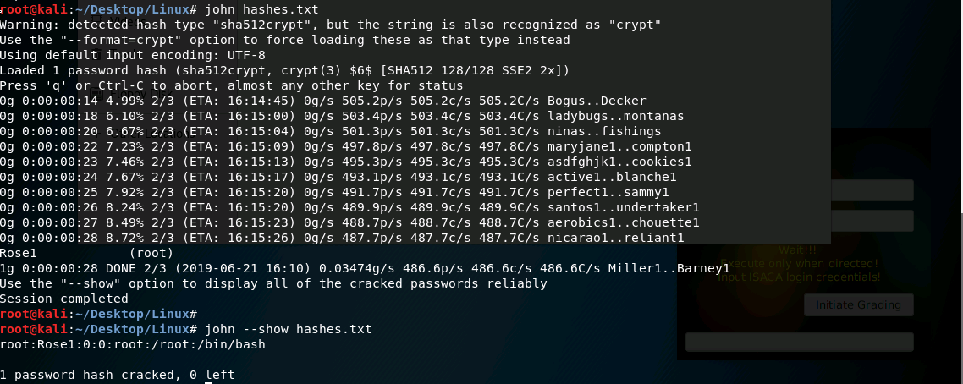

### 10.3.6 Analyze

Note that after this is cracked it showsthe password and the user Rose1 (root). Rose1 is the password for the root user on this system.

### 10.3.7 Shadow File Permissions

The shadow file along with the Windows password files have very specific permissions to prevent any user from accessing them. Take a look at the permissions for the shadow file by running the following command:

**ls -lah /etc/shadow.** Note that the owner of the file can read and write and group users can read the file.

# Appendix

# INDEX

ClamAV, 44

Clonezilla, 46

CVE and MS, 37

GSA Greenbone Security Assistant, 15

**ifconfig**, 12

John the Ripper, 57

**nmap**, 13

OpenVAS, 13

openvas check setup, 14

openvasmd, 13

Pfsense, 8

samdump2, 57

Security Onion, 30

**Server Manager**, 4

SGUIL, 43

SNORT, 34

unshadow, 58

Windows SAM, 56

Wireshark, 34

1. CVE (Common Vulnerabilities & Exposures) - <https://cve.mitre.org/data/refs/refmap/source-MS.html>